

**1**

**2**

**4**

**3**

**Life Cycle of a Plant**

Colour and cut out pictures. Glue the life cycle in order on to the numbered boxes.

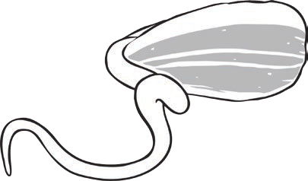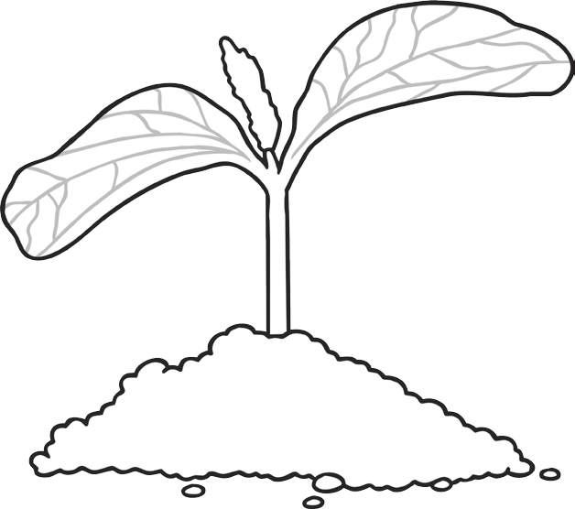

**Seedling with leaves**

**Shoots and roots**

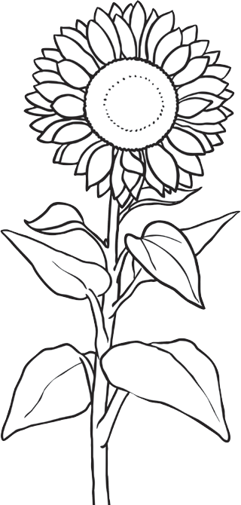

**flower**

**seed**