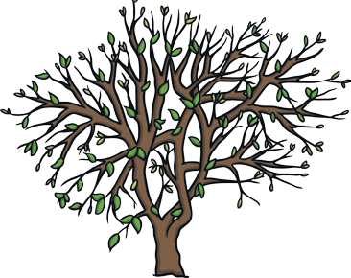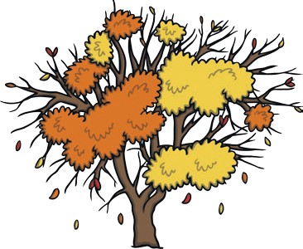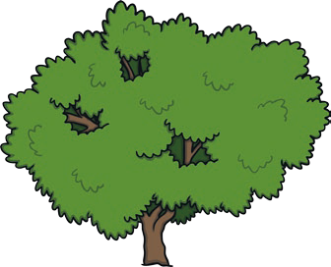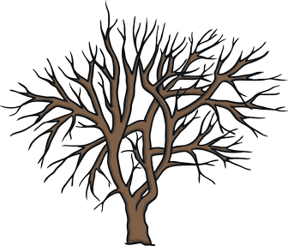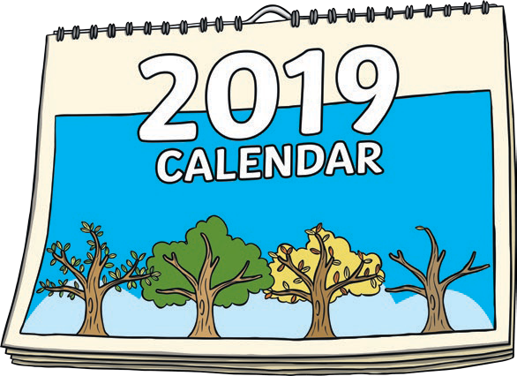

**Months of the Year**

**Practise writing the months of the year:**

January

July

February

August

March

September

April

October

May

November

June

December

There are months in the year.

I was born in .

My best friend was born in .

My favourite month is .

Halloween is in .

New Year’s Day is in .