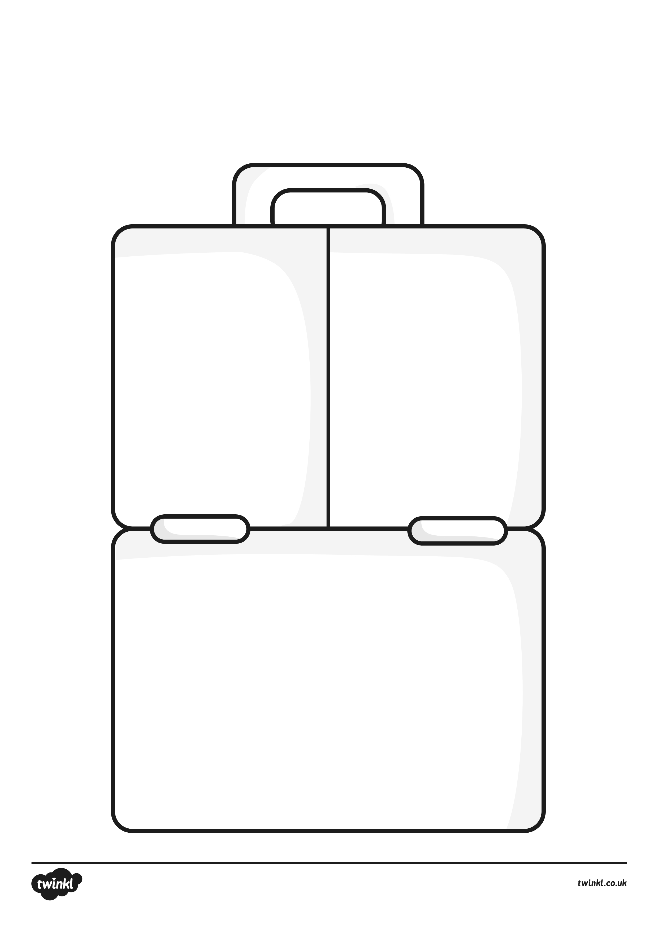
Healthy Eating Lunch Activity
Draw pictures of the food you would like to eat as part of a healthy lunch. Remember to include food that will give you energy, plenty or fruit or vegetables and only one treat food.

