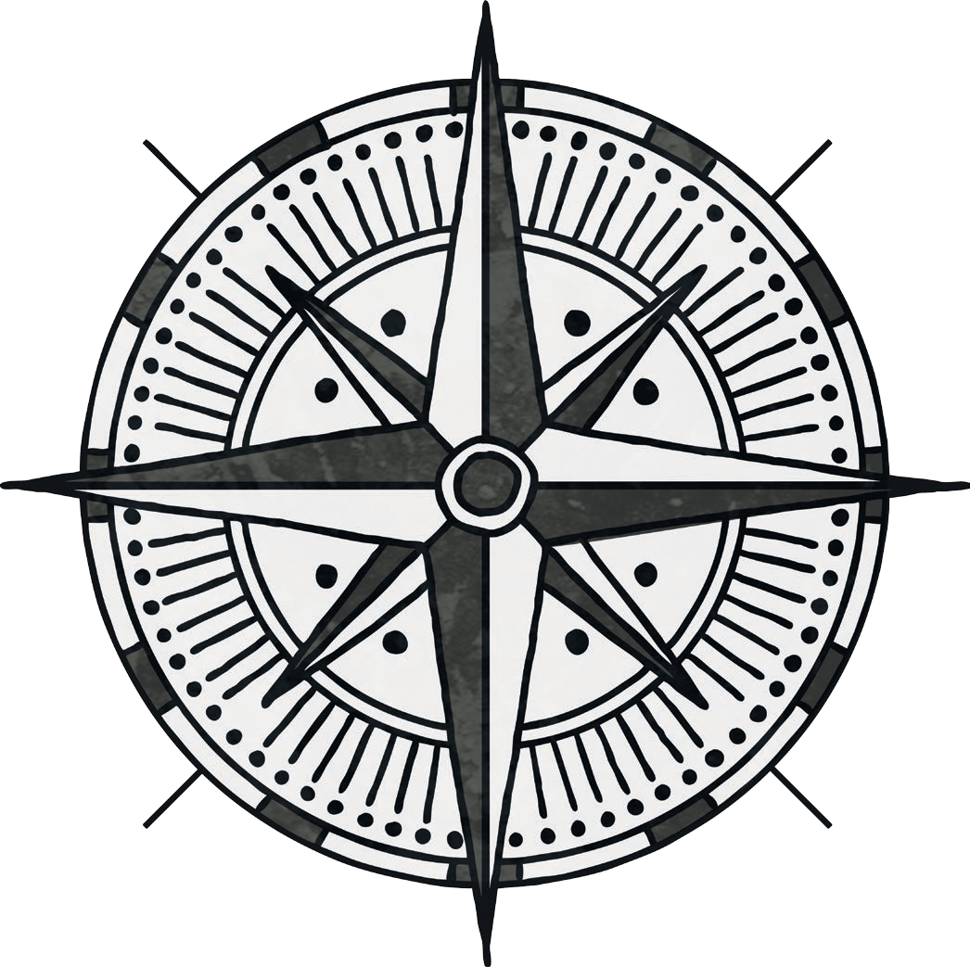

**north**

**west**

**east**

**south**