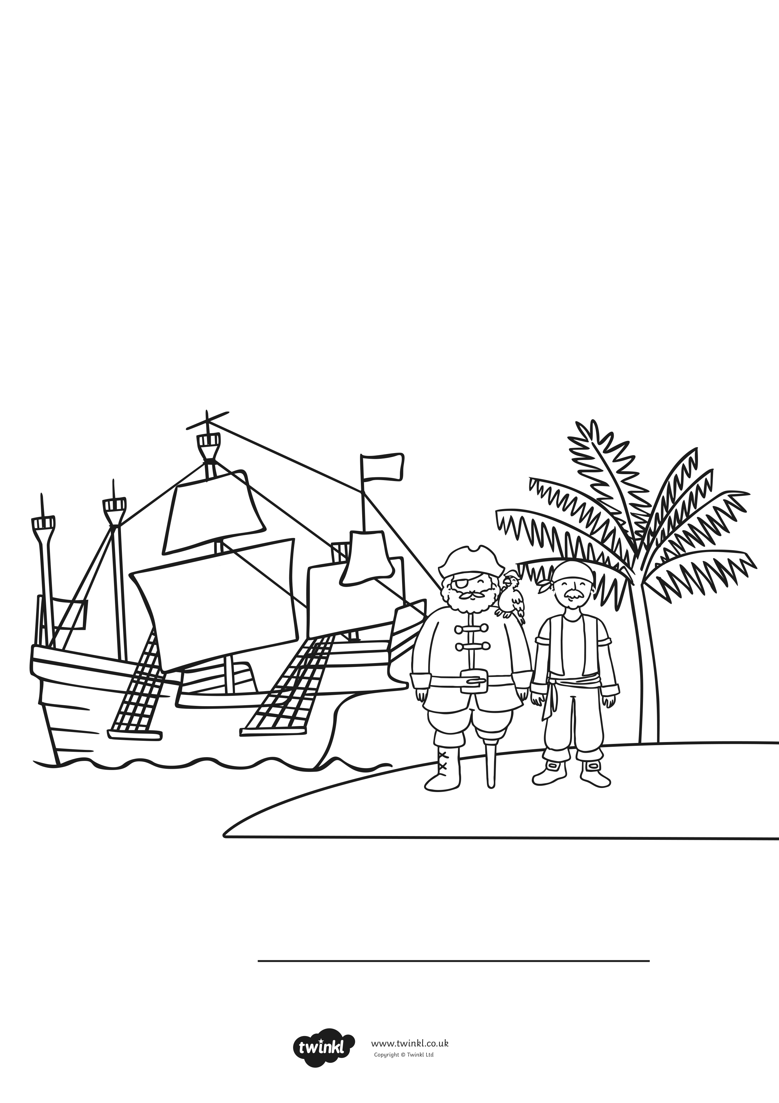
Bears Pirate Themed Maths Activity Book
My Name is
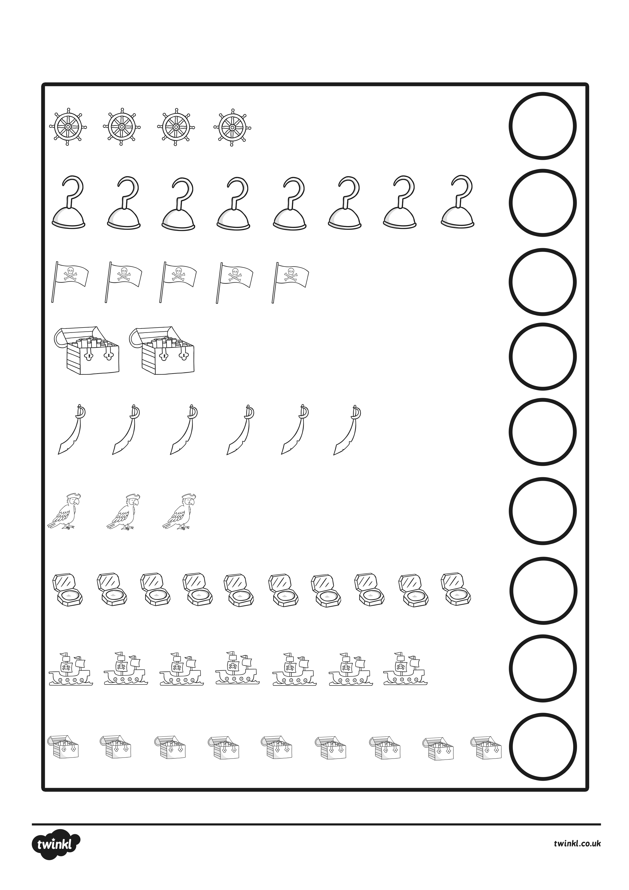
Write how many items there are in the circle.
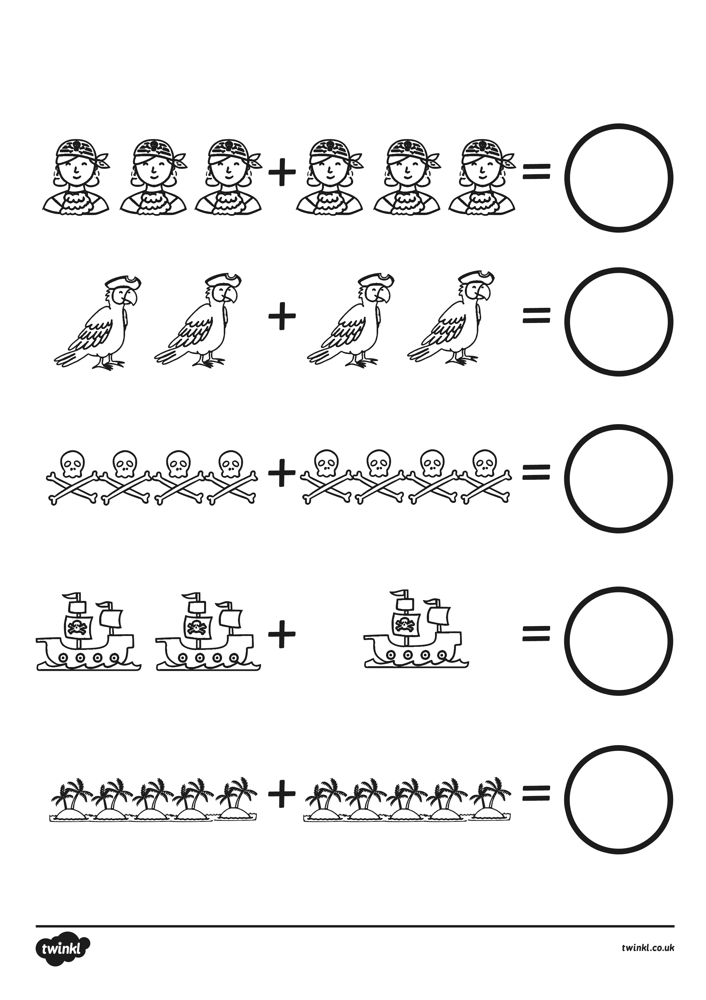
Write the answers in the circle.
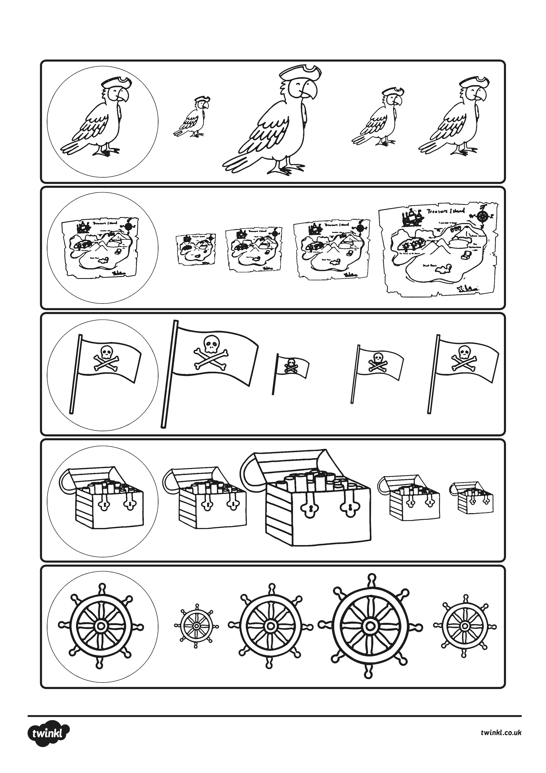
Circle the picture that is the same size as the first picture.
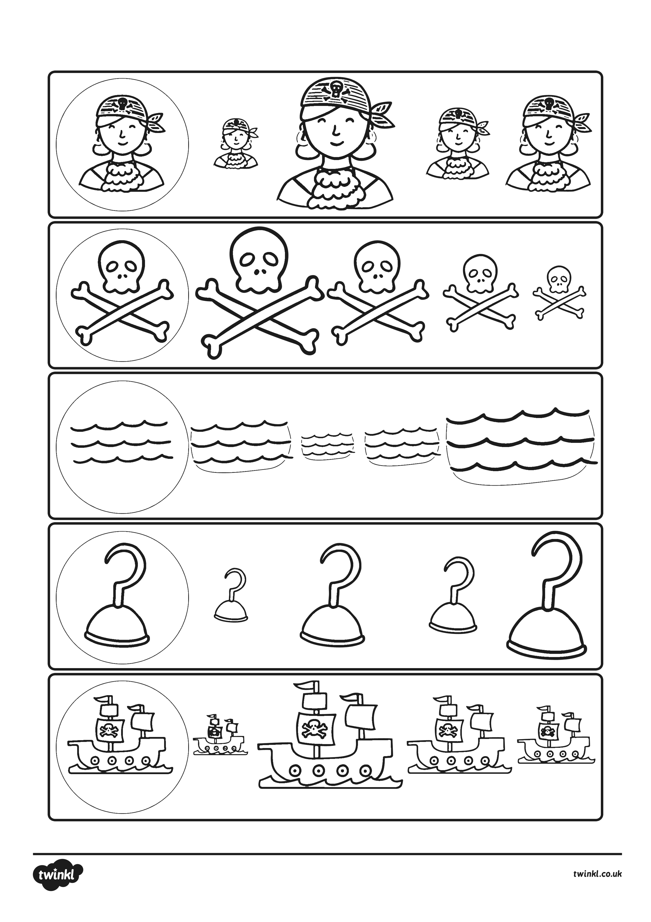
Circle the picture that is the same size as the first picture.
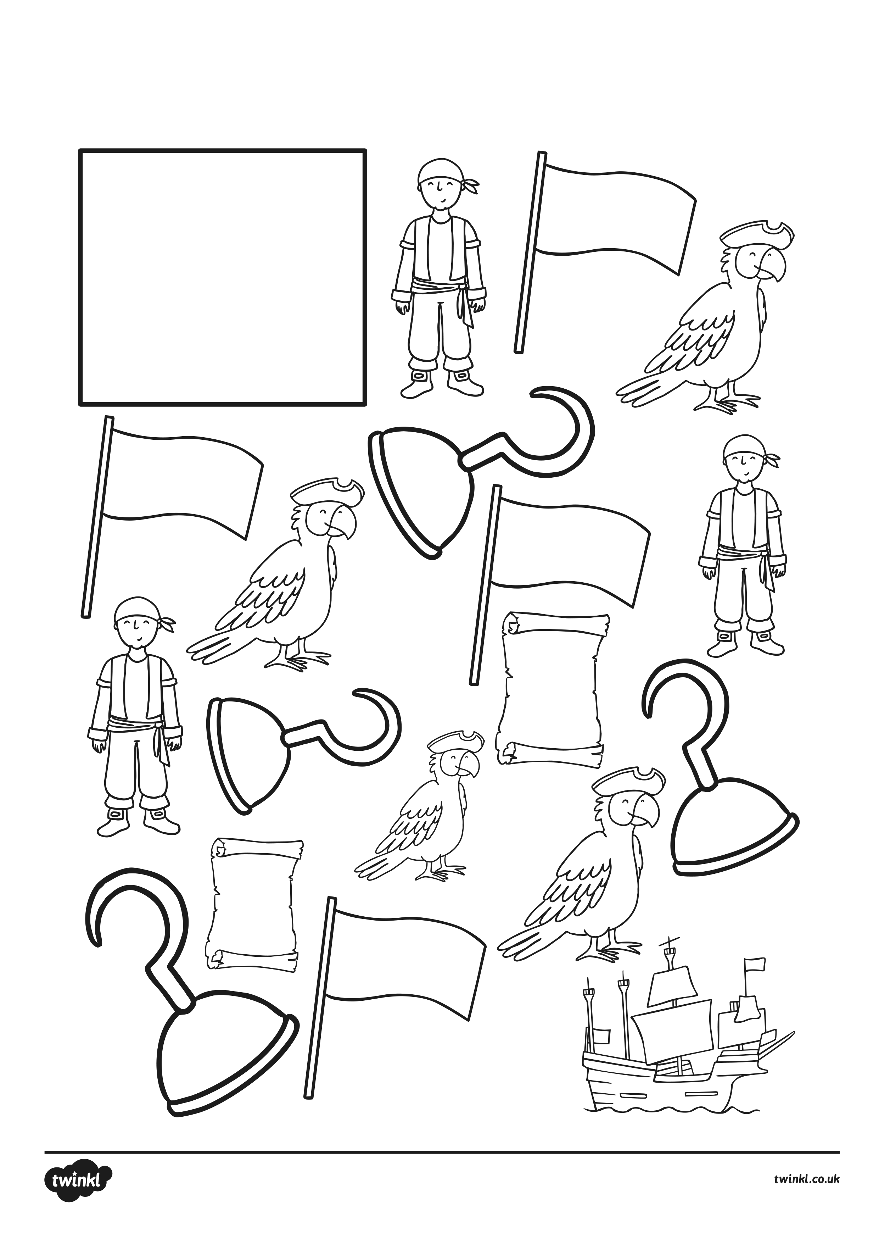
Roll, add and colour!
Instructions;
1. Roll two dice.
2. Add the numbers together.
3. Colour the answer!
Two player:
Each player choses a colour. The winner is the one with the most pirate images in their colour at.
4
9
6
8
10
11
7
3
6
5
7
2
12
4
10
9
5
7

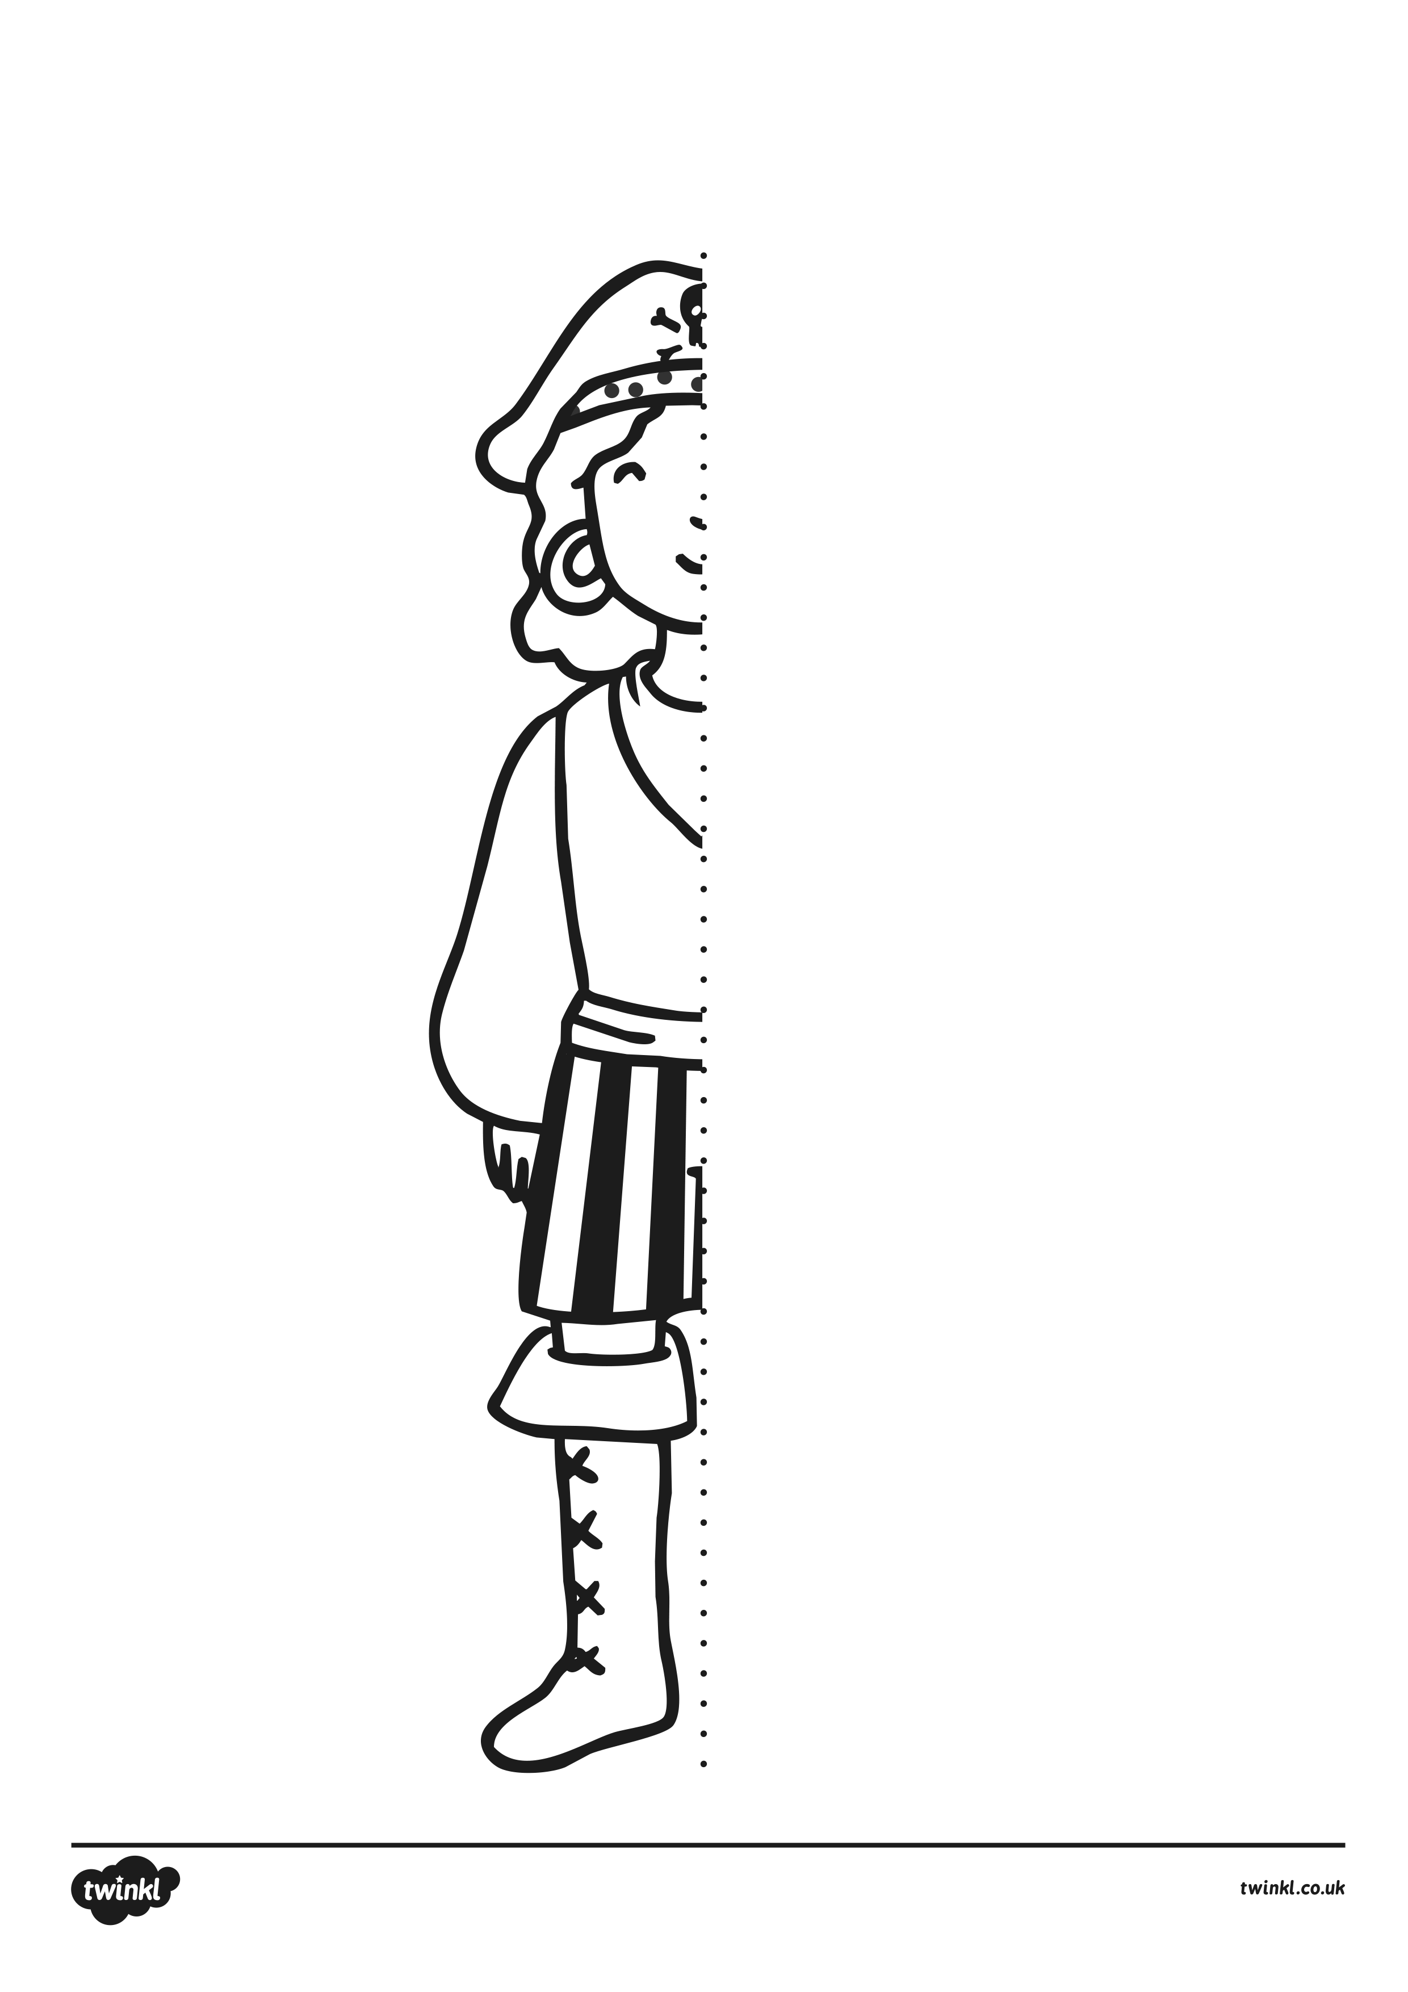

Ahoy matey! Can you draw the other half of this pirate? When you can see the full pirate, colour in your picture.

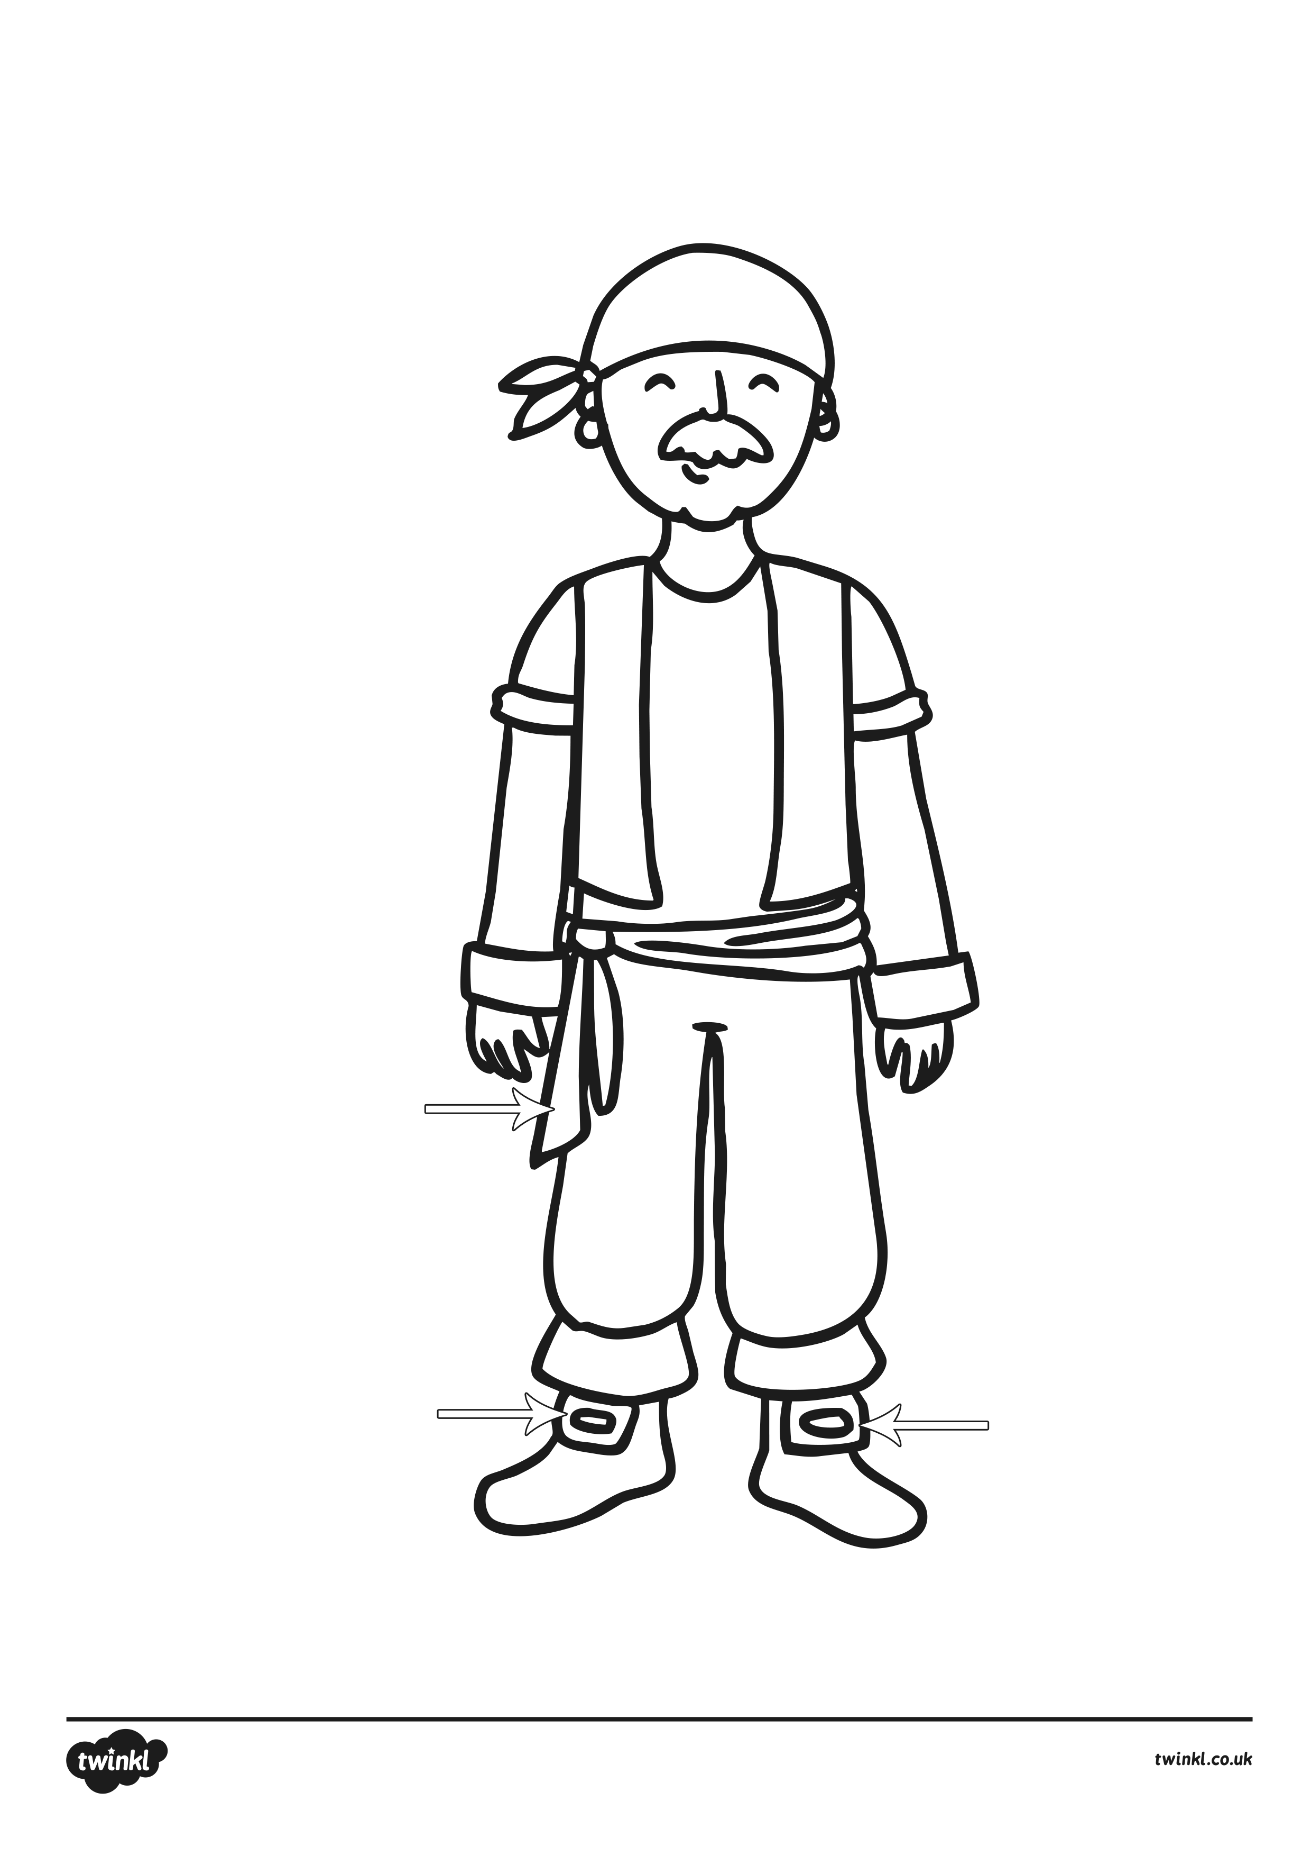
9 - 6
1 + 2
5 + 4
8 + 1
6 + 1
3 + 4
3 = Brown
4 = Red
7 = Black
9 = Yellow
2 + 2
5 - 1
7 - 4
6 - 2
2 + 7
8 + 1
Solve the calculations in the picture to work out what colours they should be!

