June - Early Level Maths Calendar
1. If I bought a sweet at 4p, how much change would I get from 10p? | 2. How many? (Without counting the dots!) | 3.Share these dots into 2 equal groups: | 4. What season comes after Spring? | 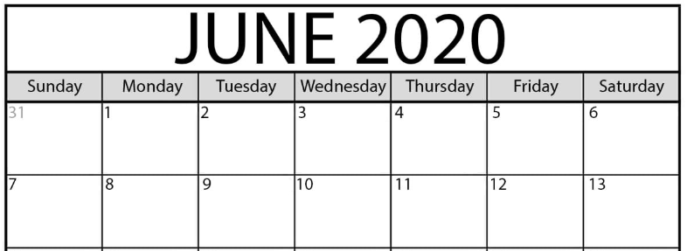  5. What day is 12th June?  6. What is the date of the first Tuesday?
7. How many edges does a triangle have? | 8. 7 + 6 = | 9. How many fingers? (Without counting in ones.)  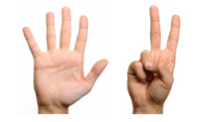 | 10. What is the number before 18? | 11. What number is in between 22 and 24? | 12. What is the value of the missing number?  10 + = 14
13. Measure the width of 2 different sized plates using small objects like Lego or spoons. Which one is the narrowest? | 14. What time is this?  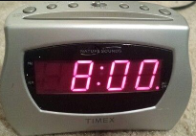 | 15. Which of these glasses is half full? | 16. How many? How many more to make 20?  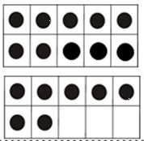 | 17. Which snake is the shortest?  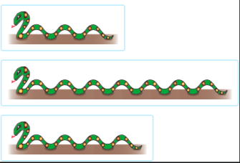 | 18. What number is the minute hand pointing to?  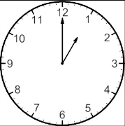
19. What month comes before August? | 20. How many 2p’s are in 8p? | 21. What are the 3 numbers after 29? | 22. Write eleven as a number. | 23. What is the day after Sunday? | 24. Half of 6?
25. Double 10? | 26. What’s the missing number in the sequence?  20, ?, 18, 17, 16. | 27. What colour would be next? | 28. What comes next in the sequence?  2, 4, 6, 8, ? | 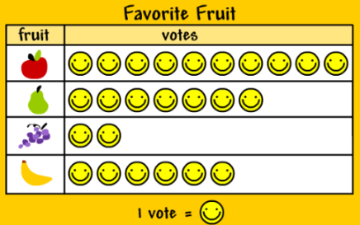 | 29. How many apples?  30. How many of bananas?

