May - Early Level Maths Calendar |  |  |  |  | 1. 9 - 5 = 4
2. What coin is this? 2p  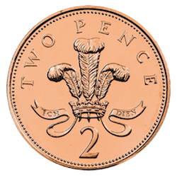 | 3. How many dots? (Without counting) 6 | 4.Write these numbers in order from smallest to biggest:  3,7,12,19,21,29 | 5. What day comes after Friday?  Saturday | 6. What time is this?  5 o’clock  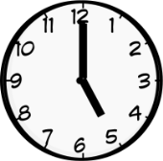 | 7. I have 2 tubs of 7 sweets. How many do I have altogether? 14
8. How many corners does a circle have? 0 | 9. 6 + 5 = 11 | 10. Write the number 10 in words.  ten | 11. What is the number before 14? 13 | 12. How much money do I have?3p  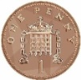 | 13. What is the value of the missing number?  8 - 5 = 3
14. Measure the length of the feet of everyone at home using small objects like Lego. Who has the longest? Answers will vary. | 15. Point to the dot to the left of the green one.  The red dot. | 16. Which is lighter? How do you know?    Penguin – it’s higher up on the scale. | 17. How many dots? How many empty?  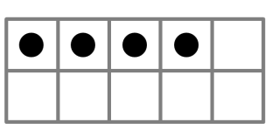  4 dots, 6 empty | 18. Colour one half of each shape:  Answers will vary. | 19. What are the next 3 numbers after 20?  21, 22, 23
20. What month comes after September? October | 21. How many 5p’s are in 10p?  2 | 22. What are the 3 numbers before 16?  15, 14, 13 | 23. Write seven as a number. 7 | 24. What is the number after 20? 21 | 25. If today is Tuesday, what day was yesterday? Monday
26. Double 3? 6 | 27. What’s the missing number in the sequence?  18, 17, 16, 15, 14, | 28. What time is this? 2 o’clock  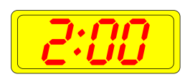 | 29. Which is the tallest tree?   | 30. How many sides does a square have? 4 | 31. Point to the fifth shape:

