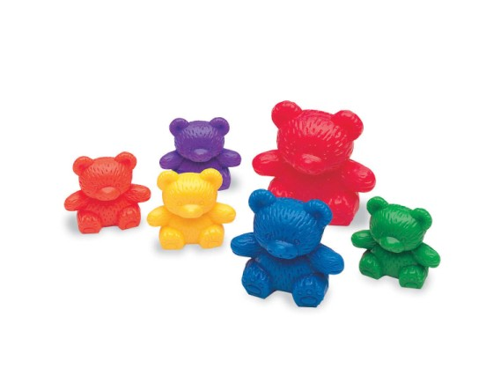
Find some toys or other objects from your house. Try to sort the objects by:

- Colour

- Size

- Shape

Can you think of any other ways to sort the objects?

