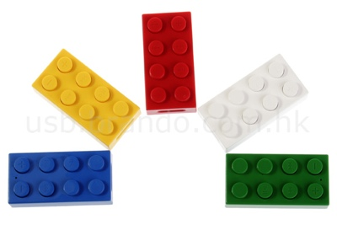
- Can you build a wall 10 bricks tall?

- Can you build a wall 20 bricks tall?

- How many blue bricks?

- How many red bricks?

- How many yellow bricks?

- How many green bricks?

- Can you build a tall tower?

- Can you build a short tower?

