May - Early Level Maths Calendar |  |  |  |  | 1. 9 - 5 =
2. What coin is this?  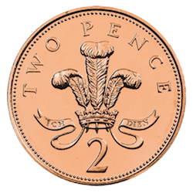 | 3. How many dots? (Without counting) | 4.Write these numbers in order from smallest to biggest:  29, 7, 12, 3, 19, 21 | 5. What day comes after Friday? | 6. What time is this?  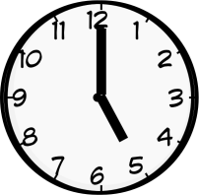 | 7. I have 2 tubs of 7 sweets. How many do I have altogether?
8. How many corners does a circle have? | 9. 6 + 5 = | 10. Write the number 10 in words. | 11. What is the number before 14? | 12. How much money do I have?  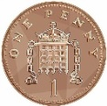 | 13. What is the value of the missing number?  8 - = 3
14. Measure the length of the feet of everyone at home using small objects like Lego. Who has the longest? | 15. Point to the dot to the left of the green one. | 16. Which is lighter? How do you know?   | 17. How many dots? How many empty?  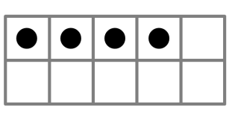 | 18. Colour one half of each shape: | 19. What are the next 3 numbers after 20?
20. What month comes after September? | 21. How many 5p’s are in 10p? | 22. What are the 3 numbers before 16? | 23. Write seven as a number. | 24. What is the number after 20? | 25. If today is Tuesday, what day was yesterday?
26. Double 3? | 27. What’s the missing number in the sequence?  18, 17, 16, ?, 14, | 28. What time is this?  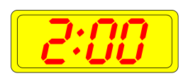 | 29. Which is the tallest tree?   | 30. How many sides does a square have? | 31. Point to the fifth shape:

