March - Early Level Maths Calendar ANSWERS |  |  |  |  | 1. 12
2. 10p | 3.  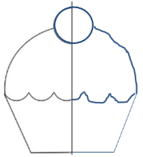 | 4.  3, 5, 9, 10, 12, 14 | 5. Thursday | 6. 4 o’clock | 7. 8 pencils
8. Triangle | 9. 9 | 10. six | 11. 15 | 12. 7p | 13. 2
14. 24 | 15.  The blue one. | 16. 8 – 2 = 6  5 – 1 = 4  6 – 4 = 2 | 17. half | 18. rectangle | 19. 19, 20, 21
20. April | 21. 5 | 22. 13, 12, 11 | 23. 9 | 24. Answer depends on who you measured – ask an adult. | 25. Thursday
26. £1 (or one pound) | 27. 12 | 28. 8 o’clock | 29. Which is the longest?  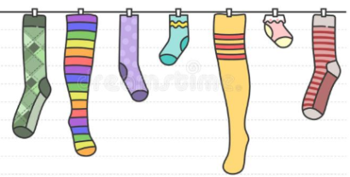 | 30. 4 corners | 31. Point to the fourth shape:

