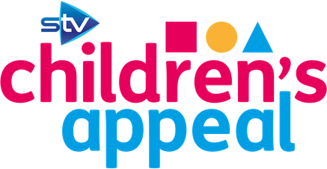

Dear Parents/Carers

After a very successful STV Children’s Appeal last year, we had no hesitations signing up to this year’s event! The theme this year is ‘The Big Scottish Breakfast’ and we will be hosting a community breakfast event that you will all be welcome to come along and take part in. The fun-filled morning will take place on Friday 5th October. More information will be sent to you very soon!

Each child has today been given a sponsor form for our Sponsored Pancake Race that will take place on the morning of the event. All funds raised will be given to the STV Children’s Appeal. The children have been reminded that they should only ask close family and friends to sponsor them and should not be knocking on the doors of people they do not know.

Any money raised should be sent in to the class teacher on or before the big event on Friday 5th October.

Dress up!
Also, on the day, children should come to school in a ‘breakfast’ themed costume. You may be as creative as you wish. You might want to decorate a T-shirt or make a fancy hat or even come to school dressed as a big fried egg! The choice is yours. Have fun thinking up your costume

Breakfast at Tiffany’s?
Does a VIP breakfast experience sound like an amazing way to start your morning? Well, for £1 per entry, you will be entered into a draw to win a VIP Breakfast at Tiffany’s dining experience on the morning of our big event! You and a friend will be waited on, and served a lovely breakfast in luxurious surroundings! You can enter as many times as you wish, £1 per entry! Please send all money for this competition to Mrs Sibbald in a sealed and named envelope. Winner will be announced Monday 1st October. You’ve gotta be in it to win it!!!

For more information about the STV Children’s Appeal, please check out the following places for information:
www.stv.tv/appeal/
Facebook: STV Appeal
We look forward to seeing you at our community breakfast event. Keep a look out for more information over the next couple of weeks. All information will also be posted on our school BLOG and our Facebook page.
Kind regards
Mrs Sibbald

