Back to School with Sean Batty

Dear Parents/Carers
I am delighted to share some exciting news with you of a special event happening in school on Thursday 5th October, 9.00-10.00am.
The boys and girls are invited to take part in a Sponsored Welly Walk around the school grounds – each class will have a 15minute slot between 9.00-10.00am. The Sponsor Form is attached. The funds raised will be given to STV Children’s Appeal 2017.
Also at this time, there will be a number of events running:
- A weather themed disco in the school hall.
- Children to dress up for the day in a weather theme, e.g. shorts and t-shirts, gloves and hats, or be as creative as you wish!
- A coffee morning and bake sale for our parents, friends and visitors.
The cost for dressing up and for the disco will be £1 and should be brought in on the day.

We would also like to invite our pupils and their families to ‘plant-up’ an old welly boot if you have them and enter them into our ‘Welly Planter Competition’. Children should make sure their welly planter is in before or on Thursday 5th October.

Now for the extra exciting part…
The one and only, Sean Batty, from STV News and Weather, will be joining our event for the morning. He will be taking part in the welly walk and I’m sure we will convince him to pop in to the disco and hopefully judge the Welly Planters.
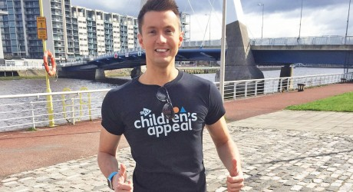

Attached to this letter is the consent form that must be completed for every child. Please return to the school by: Thursday 21st September. Please note that a photocopy will be taken of your consent form and given to your child’s teacher.
The sponsor form for the welly walk is also attached. Please remind children that they should not be approaching strangers and should only ask close friends and family to sponsor them.
We are all very much looking forward to this event and hope that you will come along and join us.
Kind regards
Mrs Sibbald

Sponsored Welly Walk

_____________________________ (Child’s name), and his/her classmates will be participating in a Welly Walk around their school grounds on Thursday 5th October for STV’s Children’s Appeal. Sean Batty will also be coming along to join in! Thank you for your sponsorship/donation.
Name | Address | Amount | Paid?

Total amount raised by ___________________________________ £______________

