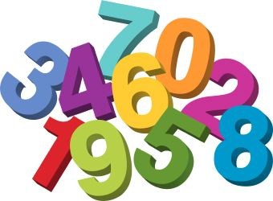
You are invited to
Stoneyburn Primary School
for our
Numeracy & Maths Open Morning!

Monday 28th September 2015
9am-10:30am

Tea & coffee & Welcome 9-9:30
Visiting classrooms 9:30-10:30
We would like to share with you how we teach Maths & numeracy at Stoneyburn- we hope you can come along!

