Monday | Literacy  Which famous sports star would you like to meet?  Write a letter to a famous sports star telling them all about yourself, why you really like them and why they inspire you. Add in some questions you would like to ask them.  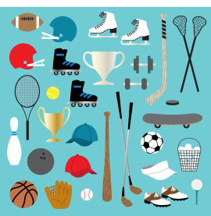  Spelling  Try today’s sumdog spelling challenge. How many can you answer correctly? | Maths  Draw numbers on the ground outside with chalk, or use paper to make number cards and place them on the ground. Ask an adult to ask you some questions e.g what is 5+9? Bounce the ball onto the correct answer. You could also have a go at asking the adult the questions and check to see if they get the right answer! | Basketball  Join in with these basketball drills  P3  https://www.youtube.com/watch?v=IjjU6LvhKHM  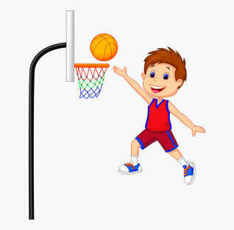 | Sun Safety  Create a video to teach other children about keeping safe in the sun.  Watch this video to learn the 5 sun safety rules and use it as inspiration for your own videos!  https://www.youtube.com/watch?v=vxAsoBXmCJk  Take notes from the video first then use these to create your own sun safety video.
Tuesday | Literacy  Poster  Create a poster about the importance of doing exercise.  Remember to include why exercise is important for your body and the impact it can have on a healthy lifestyle.  We have been learning about the skeleton too. Does exercise help your skeleton? | Maths  Outdoor Number line  Create a long line using chalk or a skipping rope or anything else suitable in your house.  Set a start and end number for your number line such as 0 and 20. Next use sticks, rocks or toys to plot values along the line, you might count by 1s, 2s, 3s 5s, 10s, Mix it up by changing the start and end number. For example, 0 to 100 or 40 to 60.  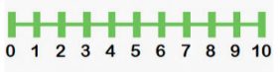  Multiplication  Try today’s multiplication challenge on sumdog. | Ways to take a break and relax  See 50 ways to take a break sheet attached and pick an activity. | Healthy Eating  Make a healthy smoothie  Here are some recipes to help you:  http://allrecipes.co.uk/recipes/tag-5685/kids-smoothie-recipes.aspx  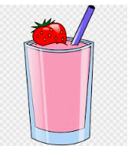
Wednesday  SPORTS DAY SCORES MUST BE IN BY 3PM TODAY | Literacy  Instructional Writing  Write a set of instruction on how you made your smoothie.  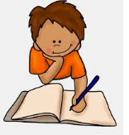  Remember to use ordering words – first, next, then, finally.  Grammar  Try today’s sumdog grammar challenge. How many can you answer correctly? | Maths  - Jump  - Hop  - Squat  - Mountain Climber  - Press Up  You will need 1 or 2 dice for this game.  Roll 2 dice and either add the 2 numbers together or multiply them. If you don’t have a dice, you could use a random number generator on the internet and set it to not go above 6.  Then using your answer, complete the first exercise on the list that many times. For example, if you rolled a 2 and then a 6 and added these 2 numbers together you would have to complete 8 jumps. Continue to roll the dice and do a sum for each exercise until you reach the bottom of the list of exercises.  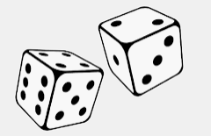 | Fitness  Can you cycle, walk, jog, run or scoot for;  15 minutes without stopping?  How far did you go?  Who completed it with you? | Dance  Choose one of Oti Mabuse’s dance classes to join in with:  https://www.youtube.com/results?search_query=oti+mabuse+dance+class+for+kids
Thursday | Literacy  Use a device of your choice to research a successful sports star! This can be any sport you are interested in.  Present the information you have found by creating a fact file about your sports star!  Try and find a minimum of 6 facts! | Maths  You will need a stopwatch for this task.  Set a timer for 60 seconds and see how many of the following you can do. Set a new timer for each new exercise and record your score on a piece of paper.  - Burpee  - Jump  - Mountain climber  - Hop  - Star jump  Can you challenge someone in your house to do it? Who managed to do more in 60 seconds? Can you work out the difference for each exercise?  Try today’s sumdog challenge. It is a mix of lots of different things we have covered this year! Good luck! | Healthy Eating  Create a healthy packed lunch box. Draw a picture of a lunchbox adding in all the healthy items you would like to have for your lunch.  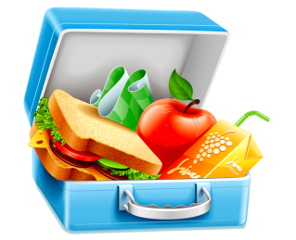 | BE THE TEACHER  What is your skill?  Can you teach someone in your family/house your skill?  For example; Sporting skill, karate, dance move.
Friday | Zumba  Take part in Zumba workouts.  https://app.gonoodle.com/channels/zumba-kids  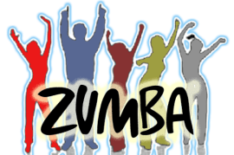 | You decide!  This is your last ever task for this year so we are letting you decide what that is. Choose something that makes you happy that does not involve technology.  You may choose to draw, build, play in the garden or play with your toys. | HAVE A GREAT SUMMER HOLIDAY!!  WE CAN’T WAIT TO SEE YOU ALL AGAIN IN AUGUST 😊

