Monday | Literacy (LIT 1-21a)  Spelling  Word wizards – temperature, increase, although, exercise, suddenly, middle, statement, continued  Masterminds – thought, young, country, become, notice, numeral, remember, questions  spelling stars – animal, think, picture, sound, because, sometime, without  Reading (ENG 1-17a)  Spot the silly word  Find the words in this passage that don’t make sense. Write them down in your jotter than try to think of words that should have been in the passage.  Elephants  Elephants are amazing plants. There are two different types of elephants- Asian and Labrador.  They suck up jelly into their backpacks and shoot it into their mouths.  They can dance up to 24 miles per hour.  Elephants juggle grass, small branches and bark from dogs. They really like cupcakes from the top branches.  They get the bark by scraping it with their strawberry tusks. | Numeracy  Number of the day  32  pick three hot, mild or spicy challenges and write down your answers  hot – write a word problem with this number, create a sum with this number as the answer  spicy – add 23, subtract 12, next odd number, next even number  mild – is it odd or even number, add 10, subtract 10, draw the number.  Shape  I have explored simple 3D objects and  2D shapes and can identify, name and  describe their features using appropriate  vocabulary.  MTH 1-16a  Discuss the words:  shape, 3D object, sphere, cube, cuboid,  cylinder, cone, pyramid, square-based pyramid,  triangular-based pyramid, prism, edge, face,  corner (vertices)  Find some objects around the house and decide which 3D shape they are. Example: cereal  and chocolate boxes, balls and oranges, tins of  soup or beans, ice-cream cones or cone-shaped  paper cups (those that can be found with  some water machines), a model of an Egyptian  pyramid and prism-shaped sweet packets.  Label the objects with their 3D shape names (cube,  cuboid, cylinder, sphere, cone, prism, square- or triangular-based pyramid) and label some of the 2D faces with the names of  their shapes.  Try these games:  Give me an example  Call out a property of a 3D object. Example: it has a flat face. It has eight vertices. Children try to think of an object with this property and write it down. Then discuss.  I have seen it  Name a 3D object then think of where you have seen it in everyday life.  Example This is a cube. I have seen a cube when I use a dice to play games.  This is a cuboid. I have seen a cuboid box of  sweeties in the shop.  Try this game  https://www.ictgames.com/mobilePage/shiftingShapes/index.html | Social Studies (SOC 1-04a)  Egyptians- Mummification  https://www.youtube.com/watch?v=D1ToNThT0DY  Watch this video. Once you have watched it write down some questions you would ask an Ancient Egyptian about mummification.  Play this game to have a go at mummifying an Ancient Egyptian.  https://oi-archive.uchicago.edu/OI/MUS/ED/mummy.html  Extension: Find out about the Afterlife. Present your information in any way you’d like (poster, video, pow erpoint…) | RERC (RERC 1-06b)  Jesus Heals the Sick  Wherever Jesus went, people would bring their sick to him to be healed. Jesus was a very kind and loving person and He wanted to bring relief to the suffering of the sick. These healing actions are called miracles.  Imagine what it would be like to be blind and never see people, animals, trees, colours, etc.  You would only know darkness in the world and in Jesus’ time you would be nothing more than a beggar, hoping others would show you compassion and give you money to buy food and clothes.  Watch this Bible story:  https://www.youtube.com/watch?v=Uo9ILFTVdhQ  Jesus helped strengthen the man’s faith, for his simple obedience is all Jesus required. All this man had to do was to trust in Jesus and obey his command.  Discuss or write your answers to these questions:  Can you imagine how the blind man felt when Jesus spoke to him? What did Jesus do? What did he tell the blind man to do?  How did the onlookers react?  Extension: Create a story board of Jesus healing the blind man.
Tuesday | Spelling (LIT 1-21a)  Chose 2 activities from active spelling grid.  Reading (LIT 1-14a)  Read the passage then create a detailed drawing of the character.  Remember to look at the describing words to help you.  Badjelly the Witch By Spike Milligan  The children looked down, and there, standing in a little door at the bottom of a tree was a teeny-weeny man! As tiny as a match stick.  He was wearing a butter-cup yellow jacket, black trousers with pink spots, and red shiny shoes with gold buckles and a white pointed hat with a sausage sewn on the front.  With him was a green grass-hopper which the little man had on a little dogs lead. “Who are you?” said the children. “My name is Binkle-bonk” he said.  . | Maths/Numeracy  Number of the day  75  Try some of the activities above  Shape  MTH 1-16a  Try there games:  20 questions  Hid and object then try to identify the hidden object by asking questions to which you may only answer yes or no.  Encourage them to use correct vocabulary and  to ask questions about the object’s properties.  Does it have any square faces?  Then they think of three sentences to describe the object for others to identify it.  Properties table  Draw a four-column table like this  faces edges corners  object  find objects around your house and complete the table.  Try this game:  https://www.topmarks.co.uk/Flash.aspx?a=activity20 | Social Studies (SOC 1-04a)  Ancient Egyptians- Mummification  Mummifying Fruit  Scan the QR code or click the link to learn how to mummify a tomato.  https://www.water.lancs.sch.uk/blog/?pid=80&nid=5&storyid=26  You could write your own set of instructions or you could make a video to show what you did. | Art (EXA 1-03a)  Look at this picture. It is called a ‘still life’. This is where artists draw or paint ordinary objects.  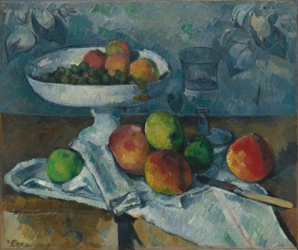  What do you like?  What do you dislike?  What do you notice?  Collect some objects you have at home (it could be food, toys or a mixture of objects you find interesting).  Have a go at creating your own still life.  Can you use what you have at home to create your own version?
Wednesday | Writing (LIT 1-22a)  Instructions for mummies  Use this website to help you write a set of instructions to help an Ancient Egyptian learn how to mummify a body.  http://www.primaryhomeworkhelp.co.uk/egypt/mummies.htm  Make sure you include:  What you will need.  Clear, numbered instructions for someone to follow.  Pictures that match your instructions. | Maths/Numeracy  Log on to Sumdog and play some games to practise your Numeracy skills.  Shape  MTH 1-16a  Today we are going to look more closely at 2D shape.  Go on a 2D shape hunt around your house. Look for circles, squares, triangles, rectangles, pentagons and hexagons.  Visualising shapes  To help children develop their visualisation  skills, ask them to close their eyes. Describe a 2D shape without saying its name and then ask  them to draw it. Example: My shape has four sides and four corners; two of the sides are longer than the other two. My shape has three sides, and they are all different lengths  Which 2D shape?  Describe the shape and then children decide which shape they think it is. Swap roles  Try this game:  http://www.learnalberta.ca/content/me3us/flash/lessonLauncher.html?lesson=lessons/14/m3_14_00_x.swf | Health and Wellbeing (HWB 1-11a)  Listen to this story called ‘Your Fantastic Elastic Brain’  https://www.youtube.com/watch?v=8QSPfnQCIY0  Write some positive phrases you could say to yourself when you are finding something difficult  e.g. when I don’t give up my brain stretches and that makes me happy.  You could turn your favourite positive phrase into a poster. | Science (SCN 1-12a)  The Skeleton  Watch this video to learn more about the Skeleton.  https://www.bbc.co.uk/bitesize/clips/zmptsbk  Make a poster about the skeleton using information you have learned from the video.  Extension: Make a model of the human skeleton out of twigs or stones outside.
Thursday | Literacy  Listening & Talking (LIT 1-05a)  Watch ‘Newsround’ and take some notes. Discuss what you watched with an adult, using your notes to help you.  Reading – Scots’ Language (Oor Wullie)  Please use this website to complete the task.  https://digital.nls.uk/oor-wullie/  Fantastic Mr Fox –  try 6 activities below  Matilda –  try 5 activities below  Charlie and Chocolate Factory -  try 5 activities below  BFG -  try 4 activities below  Esio Trot -  try 3 activities below  Read and Understand  - Why is Oor Wullie’s teacher stressed?  - Where does Oor Wullie live?  Connect 4  - Click on the ‘Audio Map’ link and listen to some of the pins on the map of Scotland.  Think about what you might like to say (in Scots) and write it down. You could record yourself speaking in Scots too.  Read and Understand  - Choose one of the 6 comic strips on the website to read yourself. Create a short summary of the story, including information about the plot, characters and setting.  Explore Some More  - Visit the ‘Glossary’ link and explore the Scottish word recordings.  What other Scots’ words could you add to the page? For each word you know, write a definition and use it in a sentence for others to learn.  Infer What’s Not There  - In the section about Robert Burns there is a photograph of a mouse statue. Why would they put this on a page about Robert Burns?  - How old is Oor Wullie? Why do you think this?  Reflect & Respond  - Oor Wullie is written in Scots. This means that non-Scots’ readers may choose not to read these comic strips.  Do you think it would be better if Oor Wullie became Our William so that more people could enjoy it?  Create Something  - Click on the ‘Activities’ link and then ‘Comic-maker’.Make your own comic, using the Scots speech bubbles.  - Now create your own short ‘Oor Wullie’ comics trip. It must have a title, at least 6 story boxes with speech bubbles. Remember all writing is to be in Scots. | Maths/Numeracy  Play Numtanga on Greg Tang Maths to practise your Numeracy skills.  Squares & Circles- Green Num Tanga levels 1,2,3  Triangles- Orange Num Tanga levels 1-6 OR Green Num Tanga levels 1 & 2 for extra challenge.  Shape  MTH 1-16a  Try these activities:  Odd one out  Draw a set of four or five shapes, all of which have something in common except one – the odd one out. For example, the set may consist of four-sided shapes and one five-sided shape, or all shapes with only straight sides but one has a curved side. Show the set to the children and ask them to discuss which shape is the odd one out and why.  2D pictures  Ask children to choose any scene, imagined or real. They draw it using just two kinds of shape, for example, circles and squares or triangles and rectangles.  Try today’s shape sumdog challenge. | RERC (RERC 1-06b)  Jesus Heals the Sick  Watch this video of Jesus healing Peter’s mother in law and answer the questions.  https://www.youtube.com/watch?v=TaBYU53e0_k  Who was ill?  What was she suffering from?  What did Jesus do?  What happened to Peter’s mother in law?  Jesus has healing hands and just the action of laying his hands on Peter’s mother- in -law cured her of the fever. This miracle shows us the faith of the people and the trust that they had in Jesus.  Extension: Draw around your hands and on each finger write down a way that you could help someone. Decorate when you are finished. | Technology (TCH 1-05a)  Everything we use at home are made of different materials.  When we recycle we need to separate materials before we bin them to help the environment.  Have a go at this game to learn how to sort rubbish into the correct bins.  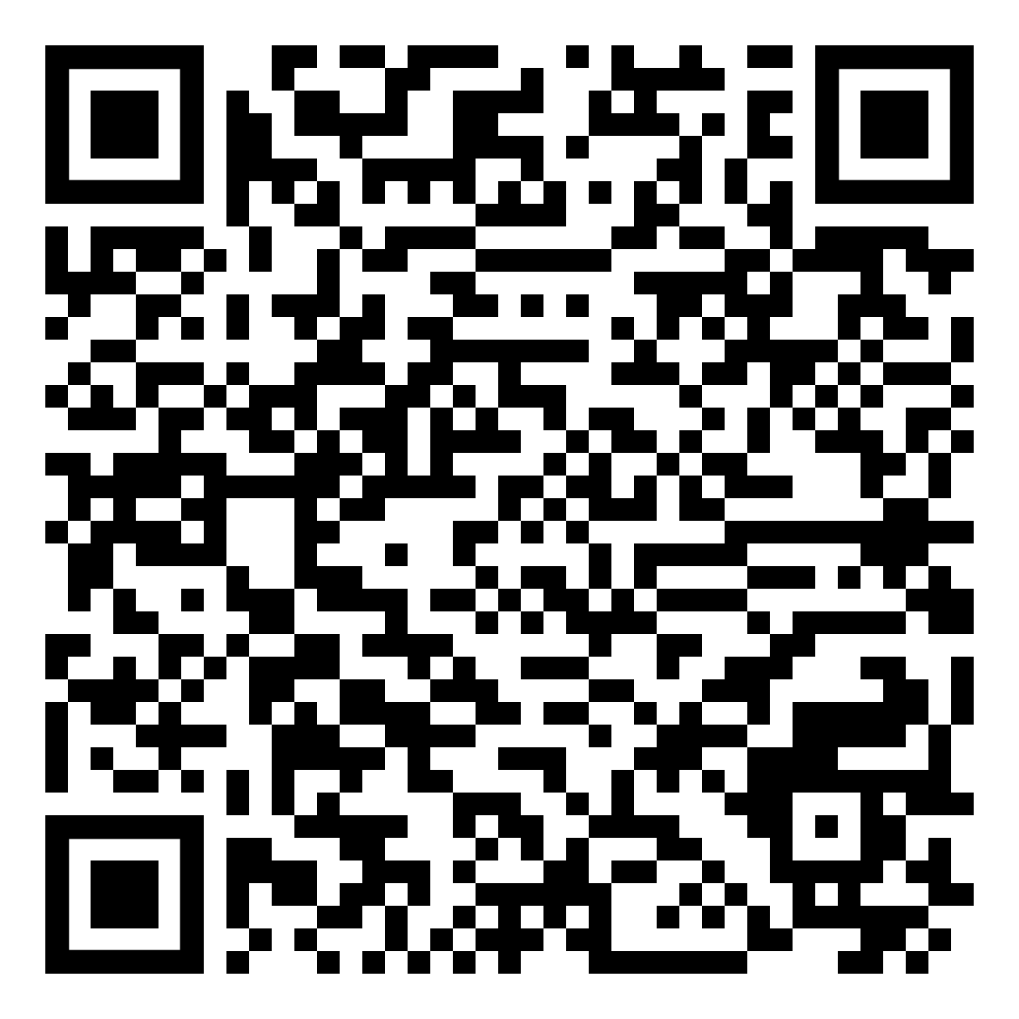  https://1c7951e0f713f82c10d3-9c5e6fbd2c9d828eb37b6bf0399bddd6.ssl.cf1.rackcdn.com/clean-green/index.html  Help your parents to do the sorting and recycling this week.  Find out what materials belong in the black, blue and brown bins
Friday | Literacy (LIT 1-15a)  Watch this episode of Author’s Live.  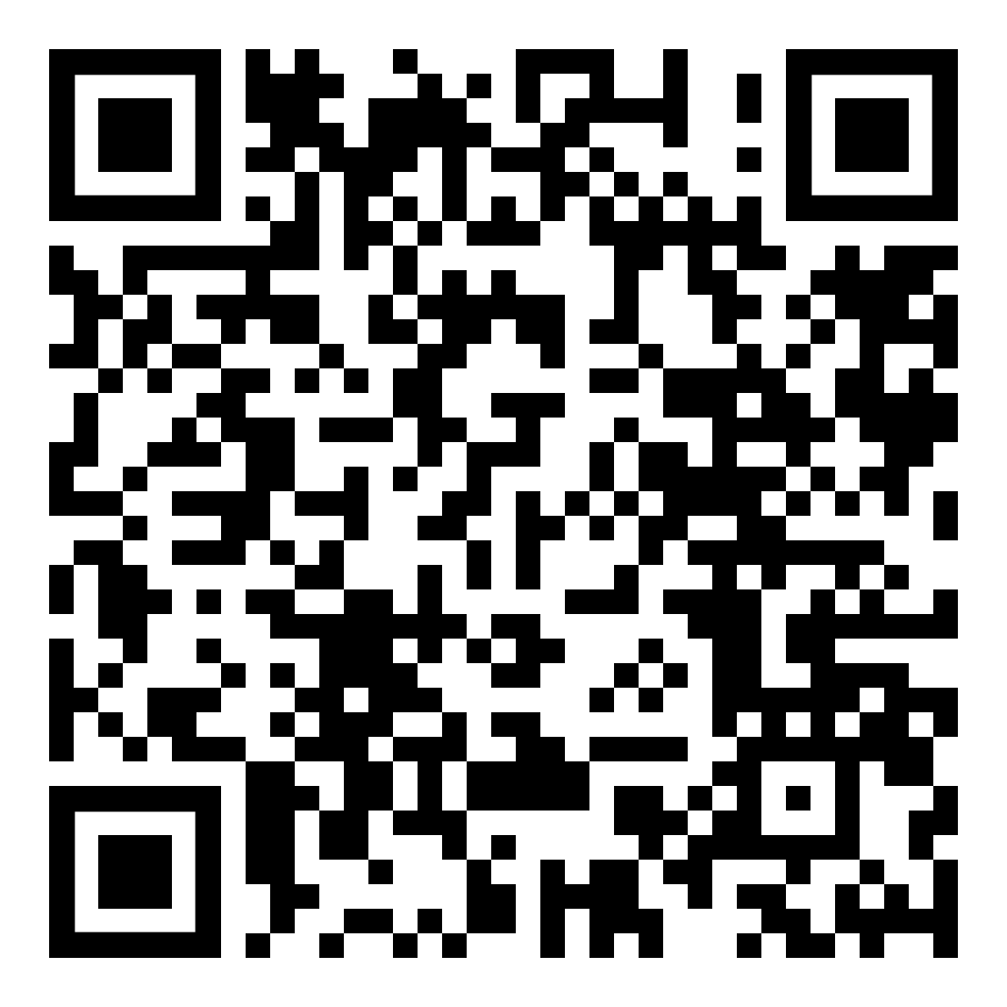  https://www.scottishbooktrust.com/authors-live-on-demand/cressida-cowell  ‘Free Writing Friday’  Spend 15 minutes today doing some free writing.  You can write about whatever you like, a story, a poem, a diary entry, letter, postcard… but you must do all of your writing before you draw pictures. | Numeracy  Play ‘Hit the Button’ or ‘Coconut Multiples’ on the Topmarks website to practise your tables.  (2,3,4,5 & 10).  Shape  MTH 1-16a  Create a poster about what you know about 2D and 3D shapes. Think about using the language corners (vertices), edges, sides etc.

