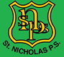P1- Home Learning (Week 9)
*WORKSHEETS DO NOT HAVE TO BE PRINTED. THE WORK CAN BE DONE IN JOTTERS OR ON PAPER*
Monday | Literacy  Writing  LIT 0-13a  LIT 0-31a  For literacy this week, you are going to plan a movie night with your family.  Your first task is to write a letter to your family that you live with and tell them why you would like to have a movie night together.  We have included a template below to show you how a letter should be laid out. | Numeracy  Money  MNU 0-09a  This week we will be learning more about money. Begin by discussing the following questions.  Why do we need money?  Where does money come from?  How do we spend money in the shops?  Use the coin strip below to revise the different coins with children. Print and cut up the coins (or even better use real coins) and have a go at sorting them into piles by colour and shape.  Practice ordering the coins from least to most valuable.  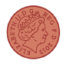 | Physical Education  HWB 0-21a  Use the games and activities section of this website to choose and play some fun games! These can be played within your home or outside in the sunshine!  https://www.joyofmovingresourcehub.co.uk/games-and-activities | R.E  RERC 0-11a  As we enter our last month of Primary 1 we would like you to reflect upon what has went well and what you would like to get better at in P2.  Think about what will be different when you are in P2 and what will be the same. Remember to share with your trusted adult at home if something is making you feel nervous.  Say the prayer ‘Our Father’ to share your worries with God. He will help to guide you through this change.
Tuesday | Literacy  Today you are going to think about what film you would like to watch at your movie night. It should be a movie that you think everyone in your family would like and one that you either have on DVD or one that your parents can easily access. Have a discussion with a parent about what films there are to choose from. In your jotter or on a piece of paper, write down the film you would like to watch and your reason for choosing this film. Show it to the rest of your family to make sure they all agree. | Numeracy  Money  MNU 0-09a  Use the game below to give children a go at sorting and ordering different coins!  Begin to discuss how you could make amounts that you don’t have a coin for e.g. 3p and 6p  https://www.topmarks.co.uk/money/coins-game | Physical Education  HWB 0-21a  Use the games and activities section of this website to choose and play some fun games! These can be played within your home or outside in the sunshine!  https://www.joyofmovingresourcehub.co.uk/games-and-activities | Topic  Tyrannosaurus Rex  SOC 0-01a  Today you are going to be investigating dinosaur diets.  Dinosaurs are split into 3 categories based on their diets which are :  Omnivore  Carnivore  Herbivore  Your job is to find out what each of these terms mean and write them on a piece of paper or in your jotter.  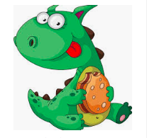
Wednesday | Literacy  LIT 0-14a  Today you are going to create tickets for your movie night.  Have a think about what should be on your movie ticket. You can use kiddle to research cinema tickets.  If you have scissors (and have checked with an adult that you are allowed to use them) then you can cut out your tickets after you have finished making them. | Numeracy  Money  MNU 0-09a  .  Today we are going to practice adding several coins together to pay for things. Remind the children that each coin has it’s own value and they are not counting each coin as 1 like they would with counters.  If your child is finding this difficult ask them first to use counters, stones or pasta to show you how many 1’s makes up each coin.  (this will give them a visual idea of how some coins are worth more)  Choose and complete one of the worksheets below. | Health and Wellbeing  Growth Mindset HWB 0-47a  Watch episode 3  https://www.youtube.com/watch?v=OFKVoCuwl2s  Complete the discussion and personal questions (both are below) with an adult.  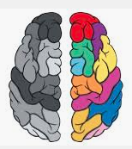 | Science  STEM  SCN 0-15a  Fill a bowl with water, and let it freeze overnight. Remove the ice from the bowl and place on a tray. Simply shake table salt over the ice and watch the magic happen.  Talk about what happened to the ice. Why do you think this happened? Carry out research to find out why.
Thursday | Literacy  LIT 0-13a  Today you are going to create a poster for your movie night. It should include the following:  - The name of the film  - What time it will start  - Pictures related to the film and/or pictures relating to films/cinemas  - If there will be any snacks available (check with a parent what snacks are in your house and what you are allowed.)  If you have colouring pencils/pens/paints then make your poster nice and colourful. | Numeracy  Money  MNU 0-09a  Please complete your groups Sumdog money challenge for this week!  It is great to see so many of you on here taking part. | Topic  SOC 0-01a  We are going to continue with dinosaur diets today.  We would like you to give us at least 1 dinosaur that was a herbivore, at least 1 who was a carnivore and at least 1 that was an omnivore. You can display this information in any way that you like i.e table, information leaflet, PowerPoint etc. | Art  EXA 0-02a  Go to https://www.youtube.com/watch?v=pbT2G9qGiqU  Follow the tutorial to draw an allosaurus.  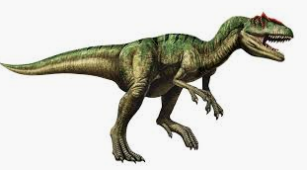
Friday | Literacy  Handwriting  LIT 0-13a  Please complete the next 3 lines in your handwriting booklet.  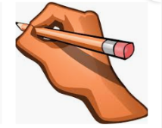 | Numeracy  Money  MNU 0-09a  Create a little pretend shop within your house. Decide what items you would like to sell and how much each item will cost. Through role play, have a go at being the shopkeeper and the customer using your coins to add up and pay for items!  Complete one of the ‘Toy Shop’ worksheets below.

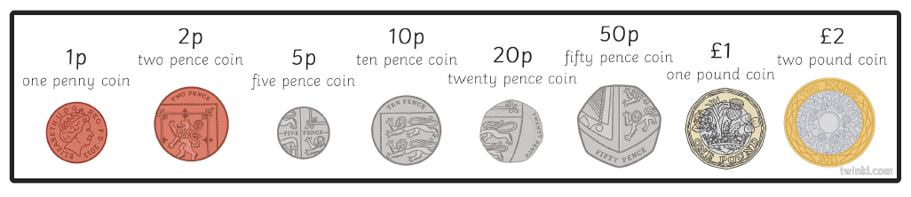

Mild
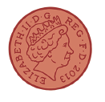
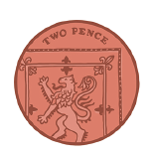

Spicy
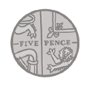

HOT
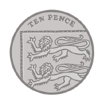

Toy Shop
You will need 1p and 2p coins.
Use the coins to make the correct amount for each toy in the shop. Draw the coins you used.
3p 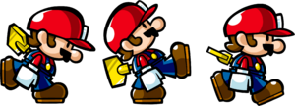
5p
2p 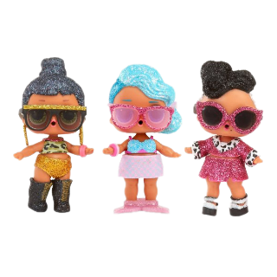
4p 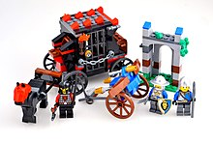

Toy Shop
You will need 1p 2p 5p & 10p coins.
Use the coins to make the correct amount for each toy in the shop. Draw the coins you used.
13p
9p
11p
7p

Growth Mindset
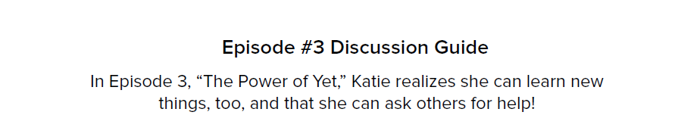
- What should you do if you are stuck on something?
- What does it mean when they say “yet”?
- Why is the word “yet” so powerful? Think of a “yet” moment in your life.

Personal Questions
- Have you ever been stuck and not asked for help?
- How can you improve the phrase “I can’t do this?”
- Think of a time when you just didn’t get “it”. What could you do in that situation?

Letter Template
