Monday | Literacy  ENG 1-12a  ENG 1-17a  Non Fiction Texts  Learn about the features of non-fiction texts https://www.youtube.com/watch?v=b1niEBj5NnI  There is also a poster attached with features. Choose a non-fiction book from home or online. Write down 3 interesting facts in your jotter. | Numeracy  MNU 1-07a  Fractions-Halves and quarters.  Please watch the video to learn about halves and quarters  https://www.youtube.com/watch?v=VMWa6dDoicc | Spanish  MLAN 1-03a  Months of the year/ Days of the week  Revise Days of the week and Months of the year  https://www.youtube.com/watch?v=C4fREj60Crk  https://www.youtube.com/watch?v=IKznbHvPFwc  Practise saying them to someone in your house. | HWB  HWB 1-02a  Challenge your mindset  Identify skills  and activities you want to get better at or do in the future. Write these in the balloon provided or complete this in your jotter.
Tuesday | Literacy  LIT 1-21a  Spelling  In rainbow writing practise your common words. Make sure you concentrate on the ones you are not confident in spelling. | Numeracy  MNU 1-07a  Fractions-Halves and quarters.  Please play the game  http://www.snappymaths.com/counting/fractions/interactive/halfquartersimm/halfquartersd.htm | Expressive Arts  EXA 1-14a  Drama  Listen to this video of Jack and the Beanstalk and join in yourself or with your family. https://www.bbc.co.uk/sounds/play/b03g6w2j | RERC  RERC 1-01a Mystery of God  Thanksgiving hymn. Please check online Psalm 65: 9‐13 and contemplate it whilst praying with your family. Say in your own words about good things that happened today. Thank God for this.
Wednesday | Literacy  ENG 1-31a  Writing  Pick your favourite book character. Write a character description for your character. Remember to use lots of adjectives to describe them. | Numeracy  MNU 1-07a  Fractions-Halves and quarters.  Log in to Sumdog to see the math’s challenge we have set up for you. | HWB  HWB 1-22a  PE  Use this link to complete Go Noodle workouts/ dances: https://www.youtube.com/results?search_query=go+noodle+exercises+for+kids | Science  SCN 1-03a  Plants  Learn about what plants need to be able to survive. If you have seeds in your house why don’t you plant one and keep a diary about how your plant growing.  https://www.youtube.com/watch?v=_RXVhiUnTA8
Thursday | Literacy  LIT 1-21a  Spelling  Use Doorway Speller (Speller 2) to practise your common words.  https://www.doorwayonline.org.uk/activities/speller/  or practise writing them outside with chalk or water and a paint brush. | Numeracy  MNU 1-07a  Fractions-Halves and quarters.  Please fill the worksheets below. | Science  SCN 1-01a  Mini-beasts  Watch this video about mini-beasts https://www.youtube.com/watch?v=LSp_meUwug4  Learn some facts about ants: https://www.youtube.com/watch?v=cXUCUvcscXs  Write 5 facts about ants your jotter and draw a picture. | RERC  RERC 1-03a Revealed Truth of God  Watch the video and talk to your parents about what happened. Draw a picture in your jotter about how God spoke to Moses. You can even write a few sentences.  https://www.youtube.com/watch?v=65KgsHvFKd4
Friday | Literacy  LIT 1-24a  Writing  Practise your handwriting in your jotter. Practise the new formations of e, g,j,v,w,x and y. Remember you have the formation sheet in your homework folder. | Numeracy  MNU 1-07a  Fractions-Halves and quarters.  Draw in your jotter a symmetrical house for your toys. Remember both halves of the house must be the same.
REMEMBER ALL WORKSHEETS CAN BE ANSWERED IN JOTTERS IF YOU ARE UNABLE TO PRINT THEM OUT

Monday
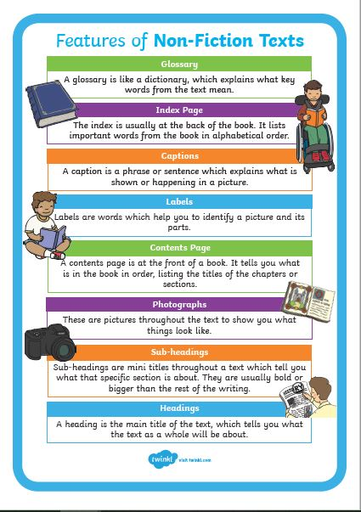

Monday
Challenge your mindset activity
Which shape is shaded less than half (½)?
L.O: To find one half of shapes.

Tick the shapes which are shaded less than half.

Which shape is split equally in half (½)?
quarter
quarter
half
quarter
half
half
half
quarter
half
L.O: To find one half of shapes.

Tick the shapes which are spilt equally in half.

Halving and Quartering
Colour the correct amount of squares.
quarter
quarter
half
quarter
half
half
half
quarter
half

