Monday | Literacy (LIT 1-21a)  Spelling  Word wizards – ough  though  brought  fought  bought  rough  tough  enough  Masterminds – ve  have  give  live  leave  believe  retrieve  starve  retrieve  Spelling stars – i_e  side  white  hide  smile  shine  dive  line  Reading (ENG 1-17a)  Spot the silly word  Find the words in this passage that don’t make sense. Write them down in your jotter than try to think of words that should have been in the passage.  Rainforests  Rainforests are big forests that get lots of chocolate. They are found in warm places.  A rainforest is made up of different jigsaw parts.  The sunlit zone has lots of snow and tall bouncy castles.  The canopy has trees where the leaves join up and make a kind of suitcase.  The understory is found under the blanket.  The forest floor is dark, damp and icy.  Rainforests are full of different kinds of teddy bears.  Most of the animals live in the canopy where it is pencil and dry.  Rainforests give us oxygen that we need to eat. | Numeracy  Number talks  friendly numbers  7 + 3  7 + 4 + 3  4 + 3 + 7 + 3  4 + 3 + 3 + 3 + 7  Volume  MNU 1-11a  I can compare and order the measurements of different objects using direct comparison and nonstandard  units – Capacity and volume  Watch this video:  https://www.youtube.com/watch?v=8B6a9O2rZ88  Discuss words linked to capacity - measure, compare, about, about the same as, full, empty, half full, half empty, deep, shallow, holds more/most, holds less/least  Gather different containers, bottles and tubs you might have at home.  Ask the children to  estimate which holds the least water and which holds the most. Put the containers in order of estimated capacity, from least to most. How can we find out if this is really the correct order?  With a jug of water  check by filling the containers with water,  then pouring the water into the jug, each time  marking on the jug the top of the water level  (and then emptying the jug again).  Draw the container  You will need: containers, tablespoon, substance for  pouring (e.g. water, sand, rice), paper  - Choose a container and say a number of tablespoons you want to try put in the container.  - Then draw a picture of the container and how full you think it will be with that number of tablespoons  - Then count their chosen number of tablespoons into the container and children compare this with their pictures.  - Repeat this anther 3 times.  - Then decide which estimate they think was closest to the real amount | Social Studies (SOC 1-04a)  Egyptians- Gods & Goddesses  Use the BBC Bitesize website to learn about the Ancient Egyptian Gods and Goddesses.  https://www.bbc.co.uk/bitesize/topics/zg87xnb/articles/z4m8pg8  - Watch the video.  - Scroll down to ‘learn more about the Gods’ and take some notes.  - Play the game at the bottom of the page and see if you can match the names and pictures. | RERC (RERC 1-06a)  Jesus and his Twelve Apostles  Watch the video of Jesus and his twelve apostles.  https://www.youtube.com/watch?v=1EzW-tnZ-Lw  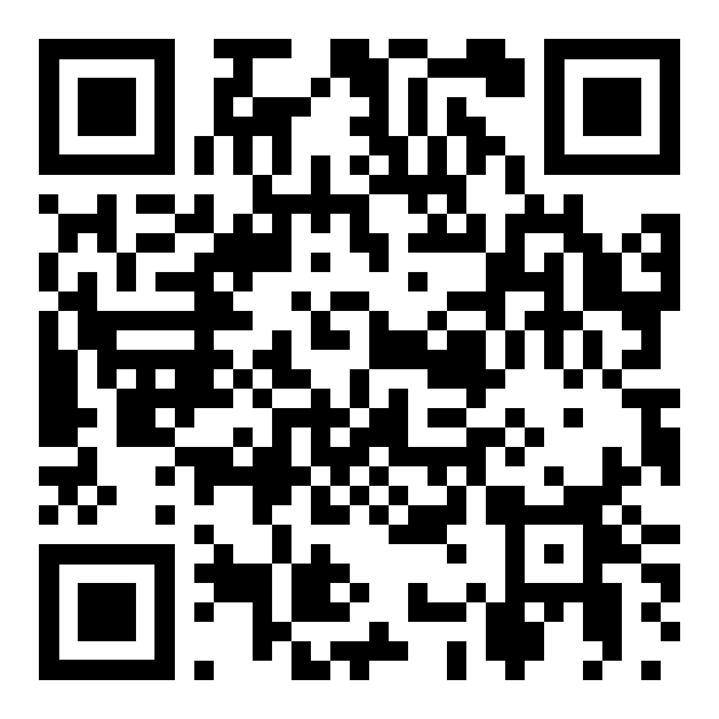  Draw a picture of Jesus with his twelve apostles. Make sure that you write their names above or below each person so you know who they are.
Tuesday | Spelling (LIT 1-21a)  Chose 2 activities from active spelling grid.  Reading (LIT 1-14a)  Read the passage at the bottom of the plan then create a detailed drawing of the setting.  Remember to look at the describing words to help you.  . | Maths/Numeracy  Number talks  friendly numbers  17 + 3  17 + 4 + 3  4 + 3 + 17 + 3  4 + 3 + 3 + 3 + 17  Volume  Some more practical activities for today to think about estimating.  Potatoes in the pan  You will need: pan, water, bowl,  potatoes (if don’t have potatoes can use something else you have at home – dominoes, toy figures, pasta etc)  Fill a pan with water. Ask children to predict  how many potatoes will fit in the pan before  the water overflows. One at a time, children  place a potato in the pan. Discuss the sizes of  the potatoes, and whether a big one makes the water level rise more than a small one.  How much water?  You will need: cups, bottle of water  Fill a bottle with water and think about how to share with between some cups (2/3/5/10)  A few people could have a full cup (how many people do they think?) or everybody could have a little.  Share the water, giving each cup about two  finger-widths – but ask children to wait before  drinking it in case there isn’t quite enough and  you need to make some adjustments. If there is  any water left in the bottle, talk about what to do with this. | Social Studies (SOC 1-04a)  Ancient Egyptians- Gods & Goddesses  Research task: Use this site to scroll down to the table.  http://www.primaryhomeworkhelp.co.uk/egypt/gods.htm  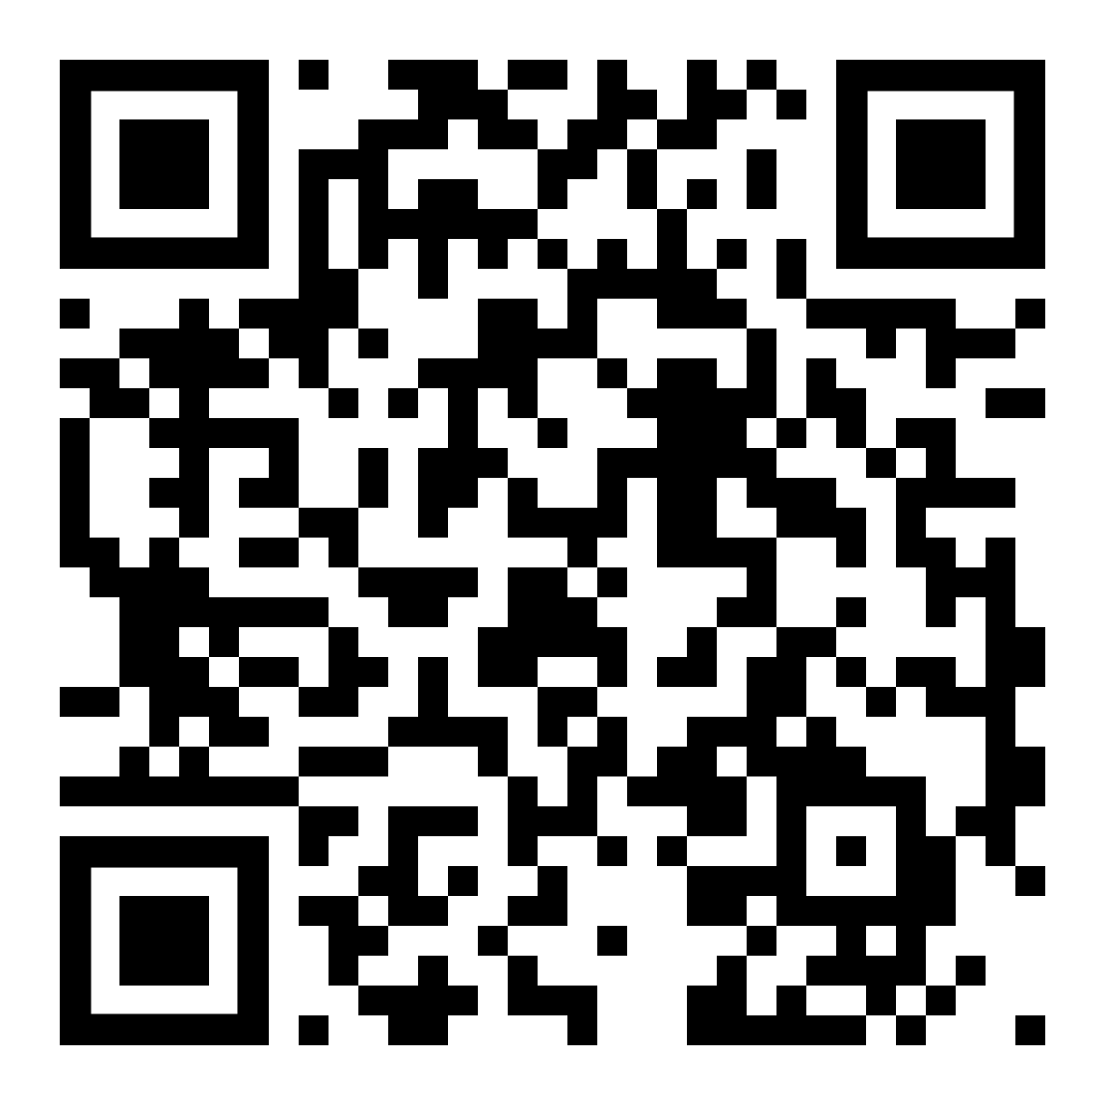  Use the table to answer these questions. Write in sentences in your jotter.  1.Who was King of the Gods?  2. What was Anubis the god of?  3. Which goddess had the head of a cat?  4. The Ancient Egyptians believed that earthquakes were which god’s laughter?  5. What was Hathor the goddess of?  6.Who had the head of a lioness?  7. Horus had the head of which animal?  8. Who was goddess of rain?  9. What was Thoth the god of?  10. Which god had the head of a crocodile? | Art (EXA 1-03a)  Look at this picture.  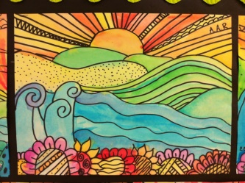  What do you like?  What do you dislike?  What do you notice?  Can you use what you have at home to create your own version?  Think about what you have learned about colour and pattern to help you.
Wednesday | Writing (LIT 1-22a)  watch this episode of Author’s Live  https://www.scottishbooktrust.com/authors-live-on-demand/alex-t-smith  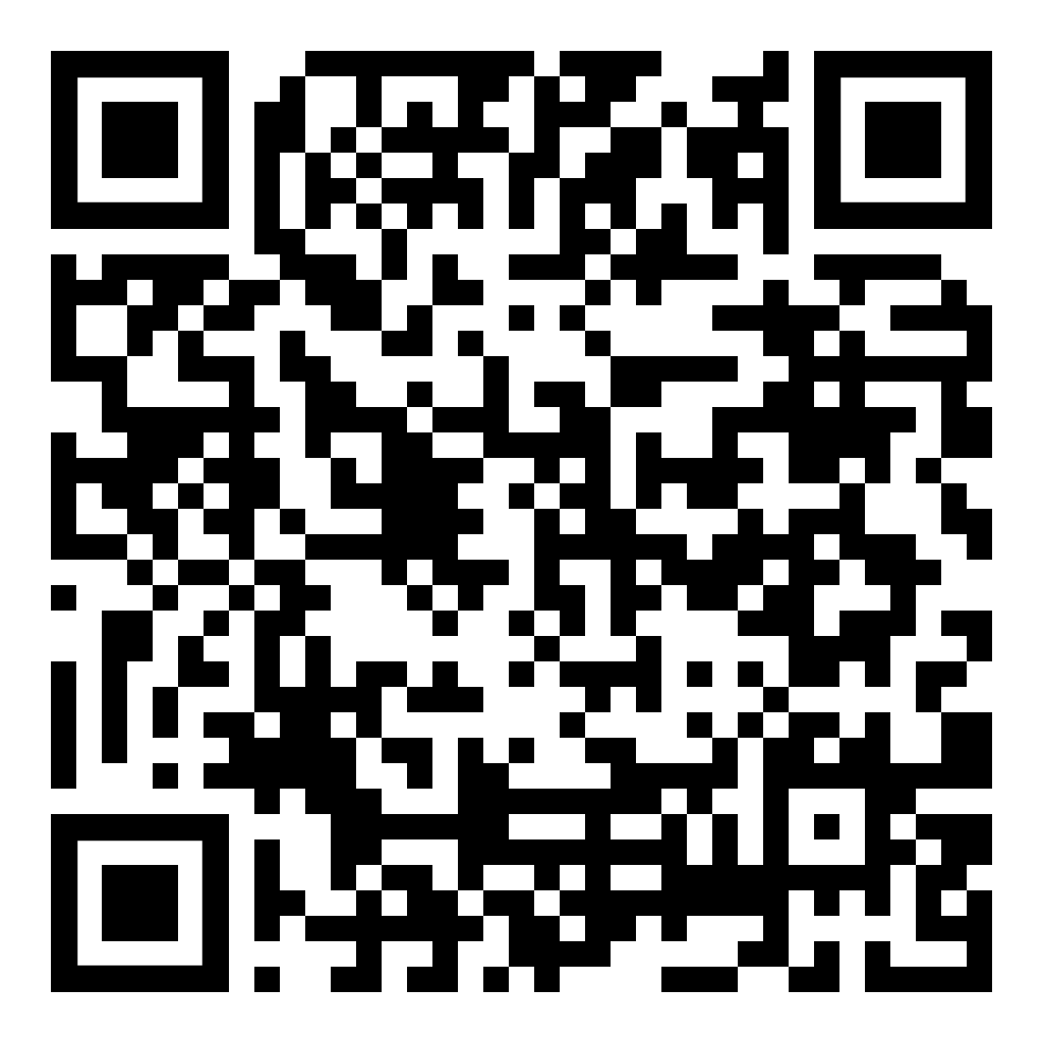  Write a new adventure story for Claude to go on.  What new and exciting adventure will Claude go on?  Who will he meet?  What surprises or problems will he come across?  How will he solve the problem in the story?  Remember punctuation and some adjectives. | Maths/Numeracy  Number talks  friendly numbers  6 + 4  6 + 4 + 3  4 + 3 + 6 + 3  4 + 3 + 3 + 4 + 6  Volume  I can estimate the amount a container holds, using everyday things as a guide, then measure it using appropriate instruments and units.  We are going to look at measuring using standard units – litres and millilitres.  Discuss the vocabulary - capacity, volume, empty, full, half empty/  full, more, less, litre, millilitre, ruler, scales,  measuring cylinder, measuring jug, estimate,  measure, roughly, approximately, nearly,  accurate  Look at this video (from 1 minute to 1minute 30 seconds):  https://www.bbc.co.uk/teach/supermovers/ks1-maths-capacity-volume/zj8njhv  Try these activities:  Containers  Children look for containers whose contents are measured in millilitres and record the container and amount. Look at milk bottles, yogurt pots, jars of sauces etc.  Sort them in order from the highest to the lowest volume.  More, less or the same you will need:  different-sized  containers, 1-litre measuring jug, water  Children sort the containers into three groups:  - Capacity of 1 litre  - Less than 1 litre  - More than 1 litre  Do this by filling each with water and then pouring the water into the measuring jug to check.  Estimates  you will need: containers of different capacities, measuring jug, water  Show children a collection of containers. They write down the name of each object and their estimate of its capacity in millilitres. Choose children to use a measuring jug to measure the actual capacity. How close is  their estimate? Repeat for different containers. | Health and Wellbeing (HWB 1-11a)  This term we are learning more about Growth Mindset.  Listen to this story:  https://www.youtube.com/watch?v=fwLiUCWCUrU  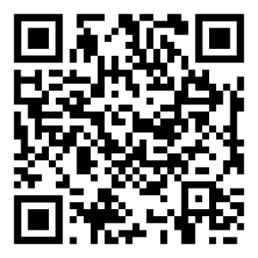  Take a piece of paper and fold it in half or draw a line across half a page in your jotter.  In one side write ‘I can do this’ at the top and draw a picture of something you are good at (either at school or at home).  On the other side write ‘I can’t do this yet’ at the top and draw a picture of something you can’t do yet.  Miss McCormack’s example would be:  I can drive my car.  I can’t run a marathon yet. | Science (SCN 1-14a)  Inheritance- Animal Classification  https://www.youtube.com/watch?v=ITrRMiQB8g4  Every animal in the world fits into an ‘animal family’. These are animals that share similar characteristics.  Watch the video clip and for each animal family create a poster that tells you the characteristics the animals share and draw some of the animals that fit into these groups.  You will see examples of these posters throughout the video. You can pause and copy the information if necessary.
Thursday | Literacy  Listening & Talking (LIT 1-05a)  Watch ‘Newsround’ and take some notes. Discuss what you watched with an adult, using your notes to help you.  Reading – non fiction  Ask an adult to help you google toy adverts on google images (print ads work best rather than videos)  Fantastic Mr Fox –  try 6 activities below  Matilda –  try 5 activities below  Charlie and Chocolate Factory -  try 5 activities below  BFG -  try 4 activities below  Esio Trot -  try 3 activities below  Reflect and respond  - What techniques are used on the poster to make people buy the toy?  - Do you think this toy is advertised on children’s television? Why?  Connect 4  - Imagine and describe in detail what you would design for your dream toy.  Read and understand  - What is your favourite toy? Who is the manufacturer and where do they make it?  Infer what’s not there  - Do you think the toy is aimed for boys, girls or both? Why? Why not?  Create something great  - Create a new toy. Come up with a name, logo, packaging and slogan.  - Draw a labelled diagram of your favourite toy.  Explore some more  - Make a list of effective words and phrases that are used on the advert that would make you want to buy the toy. | Maths/Numeracy  Number talks  friendly numbers  16 + 4  16 + 4 + 3  4 + 13 + 16 + 3  4 + 13 + 3 + 4 + 16  Volume  Today we are going to read the scale on a measuring jug.  Watch this video:  https://www.bbc.co.uk/teach/skillswise/capacity/zdhm92p  With a measuring jug practise filling it to different levels.  Squares and circles think about the fraction of one litre.  - 100 ml  - 250 ml (1/4 litre)  - 500 ml (1/2 litre)  - 1000ml (1 litre)  - 750 ml (3/4 litre)  - 600 ml  - 350 ml  - 800 ml  - 900 ml  - 450ml  Try this game:  http://www.ictgames.com/mobilePage/capacity/index.html  Triangles: litres and half litres  Circles: answers in 100ml  Squares: answers in 100ml and 50ml  Try volume challenge on sumdog | RERC (RERC 1-19a)  Patron Saints  A patron saint is a holy person who protects places and things.  Research the following saints and write 3 facts for each of them.  (Make sure you find out their feast date too).  You could draw a picture to go with your writing.  St. Andrew (Scotland’s patron saint)  St. Nicholas (our school saint)  St. John Cantius (our parish saint) | Technology (TCH 1-05a)  Technology- past and present  Discuss with your parents/grandparents the types of technology they had growing up.  Was it the same as what you have now?  Did they use something that we don’t use anymore?  What changes in technology have they seen over time?  Why do you think our technology has changed over time?  You could ask for their help to google some images of the technology they have talked to you about.
Friday | Literacy (LIT 1-15a/TCH 1-11a)  Read any book you have at home.  Create a mini flip book to retell the story.  Include detailed drawings and you could include speech bubbles to help with your retelling. | Numeracy  Number talks  friendly numbers  15 + 5  15 + 2 + 3  15 + 5 + 2 + 3  10 + 5 + 2 + 3 + 10  Volume:  Challenge and further investigation  Make your own scale  you will need: 2-litre plastic bottle, strip of paper, scissors, glue, marker, measuring cylinder, water  Challenge: children to make their own scale on a 2-litre bottle so it can  be used as a measuring device.  Discuss the amounts they should show on their scale and how much each interval should represent, e.g. 100 ml or 200 ml.  Then practise measuring  volumes of water. How accurate is the scale on  measuring bottle?  How could they check this?  Try these questions:  Triangles:  - Would litres or millilitres be better for measuring the amount of cough medicine in a teaspoon? The water in a swimming pool? Why?  Circles and squares:  - How could I use a 1-litre bottle to estimate how much water there is in a bucket?  - Which holds more lemonade, a full 500 ml bottle or a jug holding half a litre? How do you know?  Squares try this challenge: I have 750 ml of water in a bottle. How  much must I add to make it up to 1 litre?

Mr Peter’s house was old and run down. He had lived there for years and it was clear that he had never looked after it. The crooked gate hung off its hinges and made creaking noises in the wind, annoying the neighbours.
A winding garden path leading to a large, red door with a colourful window could just be seen in the overgrown garden, underneath the wet moss and tall, twisting weeds.
The house was in a sorry state. The crumbling walls looked ready to collapse seeming only to be held together by the thick green ivy which covered every dark space and corner. It crept all the up to the grey, tiled roof.
The dirty windows had long cracks which spread across every dusty pane. Silky spiders’ webs stretched across the filthy glass and groups of insects hung around the dark, dusty corners.

