Monday | Literacy  ENG 1-12a  ENG 1-17a  Reading  Pick a book on Oxford Owl. Before reading the book write a prediction about what you think is going to happen. Remember to use the front cover and blurb to help.  Read the book to see if your prediction was correct. | Numeracy  MNU 1-01a  Rounding  Watch the rounding video and try to round the age of the members of your family.  https://www.youtube.com/watch?v=33lJJnwWkGQ  Round to nearest 100 https://www.youtube.com/watch?v=CVXVsueBs5c | Spanish  MLAN 1-03  Numbers to 20  We are experts at saying our numbers in Spanish to 10. Watch the video below to help you practise saying numbers to 20:  https://www.youtube.com/watch?v=C58QilFeKow  Song: https://www.youtube.com/watch?v=h2Z_1voFJJo | HWB  HWB 1-02a  Growth Mindset  Watch the series of film clips on You Tube which  explore ‘Growth mindsets for students’ https://www.youtube.com/watch?v=2zrtHt3bBmQ  Discuss with your adult, what you have found out about the ability to learn, after watching the clips.
Tuesday | Literacy  LIT 1-21a  Spelling  Complete Sumdog Spelling Challenge. | Numeracy  MNU 1-01a  Rounding  Complete the Rounding worksheet below. | Expressive Arts  EXA 1-08a  Dance  Watch the video below and first try to copy the moves and later try to add your own choreography.  https://www.youtube.com/watch?v=u4qpSSwAAXI | RERC  RERC 1-14a  Encourage your child to sit quietly and pray to God, show your child how you are praying in your own words. Give an example of how you ask God for help, how you thank God, how you listen to God`s words (e.g. reading the Holy Bible). You can light the candle but remember about Health and Safety rules.
Wednesday | Literacy  ENG 1-31a  Writing  Write a character description for the character provided (see page 5) in your jotter. I have attached an example. Try to use as many adjectives as you can. | Numeracy  MNU 1-01a  Rounding  Please play the rounding game.  https://www.topmarks.co.uk/maths-games/rocket-rounding | HWB  HWB 1-22a  What is your name workout  Use the sheet provided on page 6 to complete a workout. Try to do your first and second name. | Topic/Science  SCN 1-02a  Watch the video to learn about the food chain: https://www.youtube.com/watch?v=hLq2datPo5M.  Discuss with your adult what have you learnt and draw an example of the food chain in your jotter.
Thursday | Literacy  LIT 1-21a  Spelling  Practise your spelling words. Use the 80 ways to practice spellings sheet that is in your homework folder to choose a way to practise these. | Numeracy  MNU 1-01a  Rounding  Roll 2 dice (one tens and one ones) or 3 dice (hundreds, tens, ones) Read the number and round it to the nearest 10 or 100. Write them in your jotter. | Topic/Science  Plants  Learn about the different parts of a plants by watching this video:  https://www.youtube.com/watch?v=p3St51F4kE8  Complete parts of a plant worksheet. | RERC  RERC 1-10a  On the 31.05.20, in the Catholic Church we are celebrating the Pentecost. Tell your child who Holy Spirit is (Holy Ghost). Explain to your children that the Holy Spirit helps us every day. Watch the video to understand better.  https://www.youtube.com/watch?v=CxZ0lz_z8PQ
Friday | Literacy  LIT 1-24a  LIT 1-24a  Writing  Practise your handwriting in your jotter. Practise your lower case letters and upper case letters. | Numeracy  MNU 1-01a  Rounding  Get someone at home to write down numbers in your jotter and round the numbers up or down to the nearest 10.Have fun
REMEMBER ALL WORKSHEETS CAN BE ANSWERED IN JOTTERS IF YOU ARE UNABLE TO PRINT THEM OUT

Spelling Words
Mrs Alexander’s Literacy group
Red and Blue Group | Purple Group
oa/ow  boat  goat  float  grow  blow  show | ai/ay  play  tray  stay  rain  hair  stair

Mrs Koziel’s Literacy group
Red and Blue Group | Yellow Group
igh  high  right  thigh  bright  might  light | ew  drew  flew  chew  grew  threw  blew

26.05.20
LI: to round any 2 digit number to the nearest 10
Check list: | Tick when you have done these:
Have I successfully rounded my numbers up or down?
Have I checked my answers?
How do you think you did today?

0 1 2 3 4 5 6 7 8 9 10
4 and below round DOWN 5 and above round UP

Circle the tens number you would round up or down to …

Round down | Starting number | Round up
70 | 73 | 80
20 | 21 | 30
30 | 39 | 40
40 | 44 | 50
80 | 81 | 90
80 | 89 | 90
70 | 75 | 80
30 | 31 | 40
60 | 66 | 70
80 | 82 | 90
40 | 45 | 50
10 | 12 | 20
0 | 6 | 10
90 | 99 | 100
Tuesday
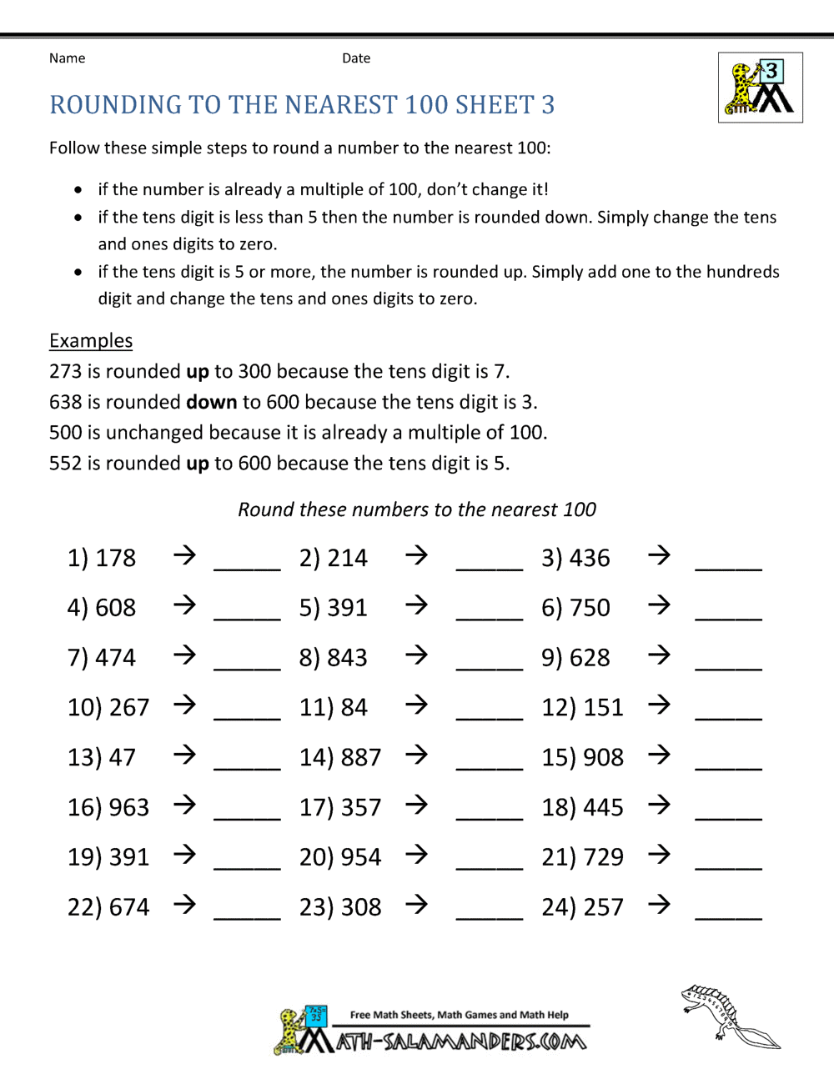
Wednesday
Character Description Example
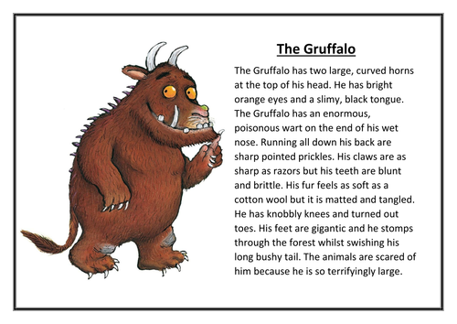
Character Description Activity
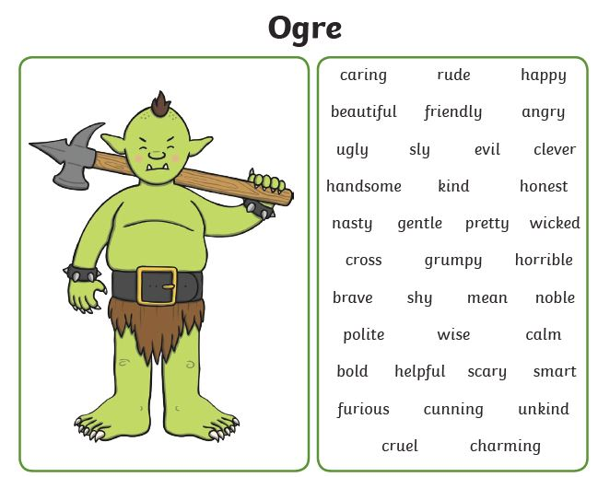

Wednesday
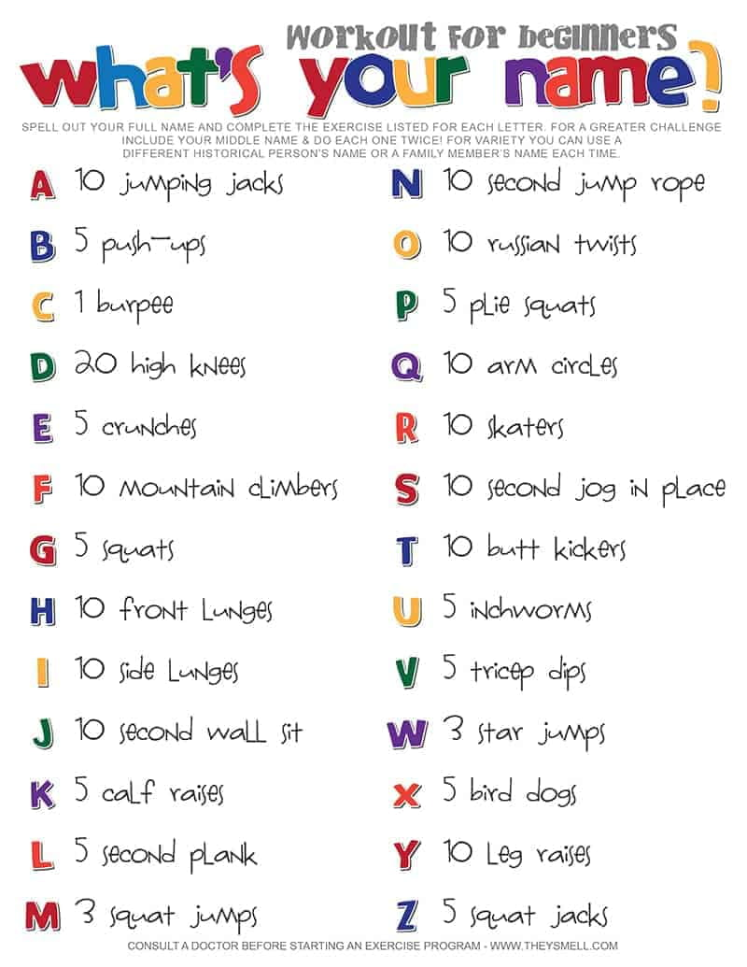

Thursday
