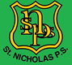P1- Home Learning (Week 8)
*WORKSHEETS DO NOT HAVE TO BE PRINTED. THE WORK CAN BE DONE IN JOTTERS OR ON PAPER*
Monday | Literacy  Writing  LIT 0-13a  LIT 0-31a  For the next few weeks we will be focusing on functional writing, beginning today with instruction writing.  Please spend some time discussing instructions with children and where they may be used.  Today we are going to write instructions for making some toast.  Your instructions will need:  - A title.  - A list of things you will need.  - Sequencing language to keep events in order e.g. firstly, next, then, lastly  I have attached a template below for you do your writing on or just use for reference.  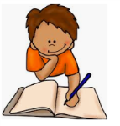 | Numeracy  Addition and Subtraction  MNU 0-03a  This week we are going to be looking at addition and subtraction.  With an adult, discuss the terms for + and – that you already know (e.g addition and subtraction) Can you find out anymore?  Split your paper in half, draw + on one side and – on the other and write down all the different terms you find for each symbol.  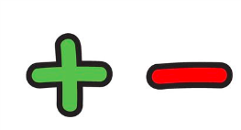 | Physical Education  HWB 0-21a  This week you are going to focus on your balancing skills.  Can you find a soft object that you are able to balance on your head (one around the size of a beanbag).  Practise walking around the garden/house with this on. Remember you are not allowed to hold it with your hands! How many steps can you take without dropping it?  Can you practise balancing on one leg at a time? Count how many seconds you can balance on each leg.  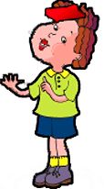 | R.E  RERC 0-11a  “I am aware of some Bible stories.”  Today we would like you to listen to the story of the Good Samaritan. If you have a kid’s bible at home you could find this story and read it.  https://www.bbc.co.uk/bitesize/clips/zy8dxnb  Discuss the following ideas:  What does it mean to be a good friend?  Who in the story shows the injured man true friendship?  Can you think of a time when someone showed you true friendship?  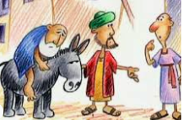
Tuesday | Literacy  Spelling Common Words  LIT 0-13a  Watch and listen to the song below to revise your common words:  https://www.youtube.com/watch?v=3zJJ1S6-rMc  Now complete your groups common word spelling challenge on Sum Dog. | Numeracy  Addition and Subtraction  MNU 0-03a  Please log into Sumdog and complete the challenge that has been set for you. | Physical Education  HWB 0-21a  We are going to be working on our balancing skills again.  Start off by practising walking around the garden/house with chosen item from yesterday on your head.  If you are finding this ok, you could make it a bit trickier by placing objects on the floor that you have to avoid.  Can you practise balancing on one leg again? Perhaps you could balance of one leg and balance your object on your leg at the same time? | Topic  Tyrannosaurus Rex  SOC 0-01a  https://www.bbc.co.uk/cbeebies/curations/dinosaur-facts  Go to this website and watch the Tyrannosaurus Rex video.  You may also want to use kiddle to conduct your own research.  In any way that you like, show us what you now know about the Tyrannosaurus Rex. You may want to make a poster/ create a fact file/ PowerPoint/ song.  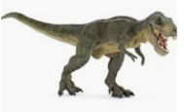
Wednesday | Literacy  Reading  LIT 0-14a  Please use the oxford owl account you created last week to select a suitable level fiction book for your child.  Use the blooms buttons comprehension questions below to gauge how well your child has understood the book they have read.  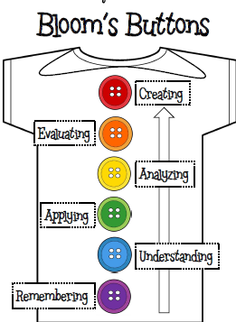 | Numeracy  Addition and Subtraction  MNU 0-03a  You are going to be solving some number word problems today. There are 2 different versions. Please choose the one that is best suited to your level.  The problems are down below and there is an example to show you what to do.  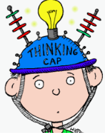 | Health and Wellbeing  Growth Mindset HWB 0-47a  Please watch video 2 https://www.youtube.com/watch?v=EoWLgWCcpWo  Complete the discussion and personal questions (both are below) with an adult.  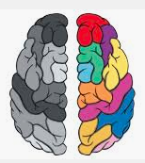 | Science  STEM  SCN 0-15a  Build a new bed for one of your toys using materials that you have in your house such as toilet roll, cereal boxes etc.  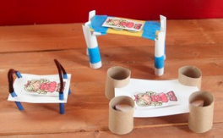
Thursday | Literacy  LIT 0-13a  Last week we were learning all about words that rhyme. Remember rhyming words have the same end sound.  Listen to the story below all about rhyming or use the interactive book to read it by yourself.  https://www.bbc.co.uk/bitesize/topics/zkvmjhv/articles/zfypxyc  Now have a go at this rhyming game. First choose which end sound you’d like to play with e.g. ‘og’ ‘at’ ‘it’ ‘an’. Write your end sound lots of times on a piece of paper and then try and find first sounds to put in front of it to make a word. You may want to play against a partner!  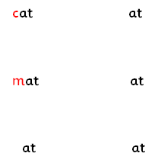 | Numeracy  Addition and Subtraction  MNU 0-03a  Go to https://www.topmarks.co.uk/maths-games/mental-maths-train and select the addition train and then select your level. Once you have played this game a few times then select the subtraction train and again select your level. | Topic  SOC 0-01a  https://www.bbc.co.uk/cbeebies/curations/dinosaur-facts  Go to this website and watch the Stegosaurus video.  You may also want to use kiddle to conduct your own research.  In any way that you like, show us what you now know about the Stegosaurus. You may want to make a poster/ create a fact file/ PowerPoint/ song  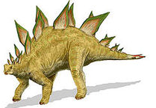 | Art  EXA 0-02a  Can you create a picture of a T-rex or a Stegosaurus? You can use any materials you have in your house such as pens, paper etc.  Get creative and use your imagination :)  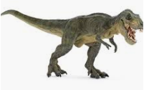
Friday | Literacy  Handwriting  LIT 0-13a  Please complete the next 3 lines in your handwriting booklet.  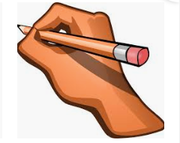 | Reflection  Take time to reflect upon your week. What have you enjoyed this week and why? It does not have to be a school activity. Write your answers in your jotter and draw a detailed picture.

Addition and Subtraction Word Problems
Within 10

The Problem | + or - ? | Write the sum and answer
EXAMPLE  I had 8 pens. 2 of them are now broken. How many do I have left? | - | 8-2=6  You might want to draw the problem to help you. For example draw 8 pens and cross 2 out.
I had 9 books. Mum gave 3 away. How many do I have left?
I bought 5 sweeties at the shop. My mum bought me another 3. How many do I have altogether?
We bought 10 apples at the shop. We ate 5. How many are left?
I got 4 presents from my Gran. My Auntie gave me 2 more. How many do I have altogether?
There were 7 balloons at my party. 4 balloons burst. How many balloons are left?

Addition and Subtraction Word Problems
Within 20
The Problem | + or - ? | Write the sum and answer
EXAMPLE  I had 18 pens. 2 of them are now broken. How many do I have left? | - | 18-2=16  You might want to draw the problem to help you. For example, draw 18 pens and cross 2 out.
I had 19 books. Mum gave 7 away. How many do I have left?
I bought 12 sweeties at the shop. My mum bought me another 4. How many do I have altogether?
We bought 17 apples at the shop. We ate 8. How many are left?
I got 8 presents from my Gran. My Auntie gave me 3 more. How many do I have altogether?
There were 14 balloons at my party. 9 balloons burst. How many balloons are left?

Template for Instruction Writing

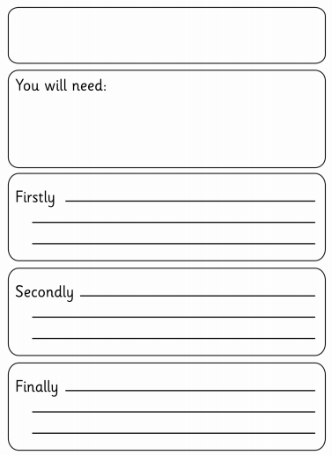

Blooms Taxonomy
Comprehension questions for reading books.

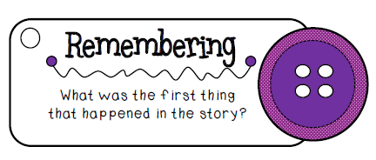
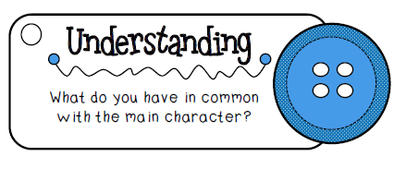
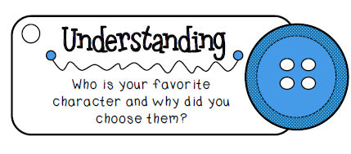
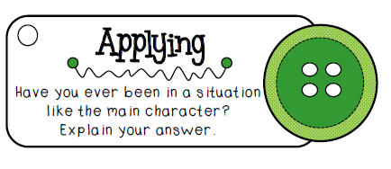
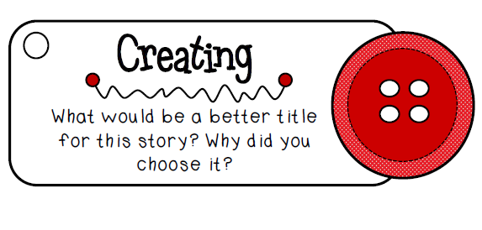

Growth Mindset
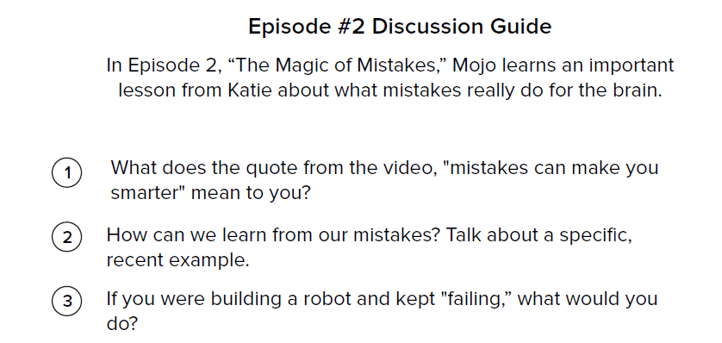
Personal Questions
