Monday | Holiday | Holiday | Holiday | Holiday
Tuesday | Literacy  ENG 1-12a  ENG 1-17a  Reading  Use Oxford Owl account and read a book of your choice aloud. Remember about your lovely expression  Answer the Blooms questions attached in your jotter. | Numeracy  MNU 1-03a  Addition  Play the game. https://www.topmarks.co.uk/addition/robot-addition  If you need to use e.g. pasta to help yourself solve the maths problems, please do. | Spanish  MLAN 1-01a  Learn about the weather in Spanish  Watch these videos to learn about the weather in Spanish  https://www.youtube.com/watch?v=S5zPd2Fy6-M  https://www.youtube.com/watch?v=g7mXGT-KkC8 | RERC  RERC 1-15a  May is the month of Mary. Discuss with your adult: Why do we honour Mary? How do we honour Mary? Do you know any bible stories about Mary?  If you are able to, please watch the video below.  https://www.youtube.com/watch?v=XiY7Kfy-lMc
Wednesday | Literacy  LIT 1-21a  Spelling  Practise your Spelling words in pyramid writing. Then log onto Sumdog and complete the spelling challenge set for you. | Numeracy  MNU 1-03a  Practising addition  Complete addition worksheet below. Chose one of them. | Technology  SCN 1-01a  TCH 1-02a  Living Things  Using the Internet find out the information about living things in our local Union Canal.  Have you seen any of them when you had your walk? | RERC  RERC 1-15a  Watch this Bible Beginners episode and then tell your parents all about what happened.  https://www.youtube.com/watch?v=MqJl0dzYYuA  Today please do something nice for your parents. You could do a wee tidy up in your room or living room or draw a picture expressing how much you love them.
Thursday | Literacy  ENG 1-31a  Writing  Write a poem. Do you remember when in the class you wrote a lovely poem? Let’s try a new one about Spring (Sense poem). What can you see, smell, touch, taste and hear? | Numeracy  MNU 1-03a Practising addition  Please see the Sumdog challenge:  Your challenge is on Sumdog to complete from 19.05-22.05.20 | Art  EXA 1-03a  Draw a picture of Spring. Look through the window and what you can see? Can you see trees? Or bushes?  Are they blossoming yet? Can you see any birds or maybe butterflies?  Do you like the Spring or do you prefer any different season? Talk to your adult about that. | HWB  HWB 1-10a  Who we are and what we are good at is not fixed.  Watch a video clip of a baby learning to crawl or walk (from your own family or from YouTube). Talk to an adult about what new skills you have learnt since you were a baby. Think what you are good at and what would you like to be better at?
Friday | Literacy  LIT 1-24a  Writing  Practise your handwriting in your jotter. Practise writing your home address. | Numeracy  MNU 1-03a  Practising addition  Choose an addition game: https://www.topmarks.co.uk/maths-games/5-7-years/addition-and-subtraction | Golden Time  Have a lovely long weekend!!!
REMEMBER ALL WORKSHEETS CAN BE ANSWERED IN JOTTERS IF YOU ARE UNABLE TO PRINT THEM OUT
Spelling Words
Mrs Alexander’s Literacy group
Red and Blue Group | Purple Group
ow  low  grow  blow  show  flow  snow | oi  boil  foil  coin  soil  join  spoil

Mrs Koziel’s Literacy group
Red and Blue Group | Yellow Group
ou  outside  ground  couch  pouch  sound  mouth | ow  shallow  follow  borrow  narrow  shadow  below

Monday

Read a book from Oxford Owl and answer these questions in your jotter:
Blooms questions: Remembering
- Who is your favourite character and why?

- What was the first thing that happened in your story?

- Can you recall a fact from the story?

- Name the main characters in the story. Are they good/bad?

Tuesday
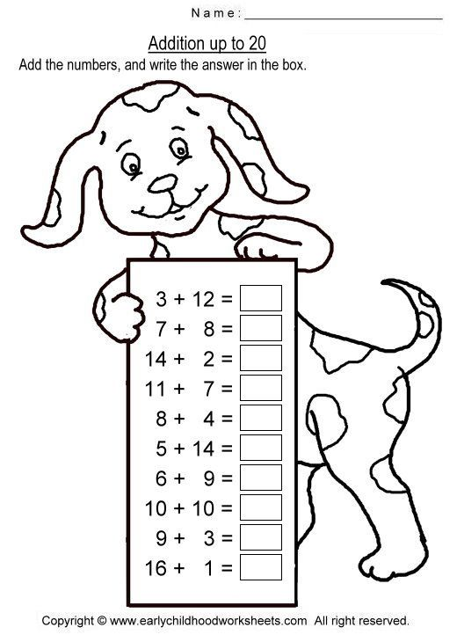

Tuesday

1 a. ___ + 6 = 14 | 1 b. 8 + ___ = 15
2 a. 9 + ___ = 17 | 2 b. ___ + 10 = 16
3 a. 5 + ___ = 15 | 3 b. 6 + ___ = 13
4 a. ___ + 7 = 15 | 4 b. ___ + 10 = 11
5 a. 4 + ___ = 14 | 5 b. ___ + 5 = 11
6 a. ___ + 7 = 13 | 6 b. ___ + 9 = 14
7 a. ___ + 4 = 13 | 7 b. ___ + 9 = 10
8 a. ___ + 9 = 13 | 8 b. 10 + ______ = 20

Powered by TCPDF (www.tcpdf.org)
Tuesday

