Monday | Holiday
Tuesday | Spelling  LIT 1-21a  Word wizards – se  cheese, noise, because, please, ease, pause, tease  Masterminds – g  giant, danger, magic, gentle, energy, germs, gym  Spelling stars – igh  high, right, thigh, bright, might, light  Writing  Write a diary entry about what you did with your day off school work yesterday.  Remember punctuation. | Numeracy MNU 1-03a  Play Sum dog to practise your skills.  Maths MNU1-10a  Look at the TV guide on your TV screen, newspaper or magazine.  Can you work with your parents to plan what you are going to watch this evening?  Circles & Squares: Can you work out how long each programme lasts? | Health and Wellbeing  HWB1-30b  .  Use recipe books or the internet to research and prepare a healthy breakfast, lunch or dinner for you and your family.  Think about what we learned in our ‘Healthy Bodies, Healthy Minds’ topic.  - What kinds of foods should we eat most?  - What kinds of foods should we eat least of?  You could even design a menu for your special meal | Science SCN 1-14a  Inheritance  When people or animals have babies they pass on characteristics (e.g. eye colour, hair colour). This is known as inheritance.  Watch this video to learn more  Have a look at pictures of you and discuss with an adult:  - what characteristics do you have?  - Look at pictures of your mum, dad, siblings and grandparents and discuss what characteristics you all have.  - Are there any characteristics that haven’t been passed on?
Wednesday | Literacy  Spelling – LIT 1-21a  Choose 2 activities from home spelling grid.  Comprehension ENG 1-17a  Go to Youtube and type ‘Awnie’s House’ into the search. Choose a story to answer some Blooms questions on.  Fantastic Mr Fox – 6 questions (one from each section)  Matilda – 5 questions  Charlie and Chocolate – 5 questions  BFG – 2 from each section of remembering, applying and understanding section  Esio Trot – 2 from each section from remembering and understanding  Optional task: Create a book cover for the story you listened to. Remember to include the title and the author’s name (you might need to research this). | Numeracy 1-03a  Practise counting in 2s, 3s, 4s, 5s, & 10s forwards and backwards on your fingers  Maths  Fantasy timetable Children imagine that they are their favourite celebrity.  They plan how they would spend their fantasy day out. They must include at least  six activities and log the start time and duration of each. They should account for each hour of the waking day, i.e. from  about 8:00 am to 8:00 pm. | RERC 1-14a  Did you know that the word Eucharist means “thanksgiving.”  Discuss things we should be thankful to God for.  Write your own prayer of thanks to God and decorate it. | Technology TCH1-10a  Engineers design things to solve problems.  Invent something that you could use to solve a problem in your home.  Draw a labelled diagram.
Thursday | Literacy  Spelling – LIT 1-21a  Choose 2 activities from home spelling grid.  Dictionary Skills  - If you have a dictionary at home try to look up 6 different words. These words can be anything you see in your house – eg chair, bath, window.  If you do not have a dictionary don’t worry, you can just do the activity below.  - Organise these words in alphabetical order:  Word wizards  - drag, apple, orange, jam, zebra, iron  - dog, frog, elephant, cat, dragon, crocodile  - different, dog, damp, dig, do, dart  - fright, fridge, frown, frog, food, fog  Masterminds  - cat, dog, zebra, ape, frog, toad,  - drag, apple, orange, jam, zebra, iron  - dolphin, dog, crocodile, ant, ape, rat  - elephant, dog, frog, cat, dragon, cheetah  Spelling stars  - apple, orange, banana, grape, strawberry  - lion, tiger, bear, ape, zebra  - pirate, dog, cat, snake, fish  - flower, iron, bottle, picture, light  Extension  Create a list of items and then ask someone at home to organise it alphabetically.  Did they do it correctly? | Numeracy  Length MNU 1–11a  Think about why it is important to have a unit of measure and not just use our hands/feet.  How many centimetres are in 1 metre?  How many centimetres are in half a metre?  Think about what sort of things would we measure in metres? What are some others? What  about centimetres?  What unit would I use?  Children  choose five objects at home (e.g. fork,  bath, table, shoe, length of living room)  and write them down. Beside each object  they record what tool and what unit they would use to measure it e.g. metre stick/ruler/tape measure.  Practise measuring things you have at home – this could be a book, jotter, door, toy etc.  Try to estimate what you think the length is before you measure the item.  Try to find items bigger than 1metre/smaller than 1metre/about 1 metre. Write then down in your jotter. | Egyptians SOC 1-04a  Hieroglyphics  The Ancient Egyptians had their own alphabet called Hieroglyphics. It was very different to ours! They used pictures and symbols instead of letters.  Learn more about them here:  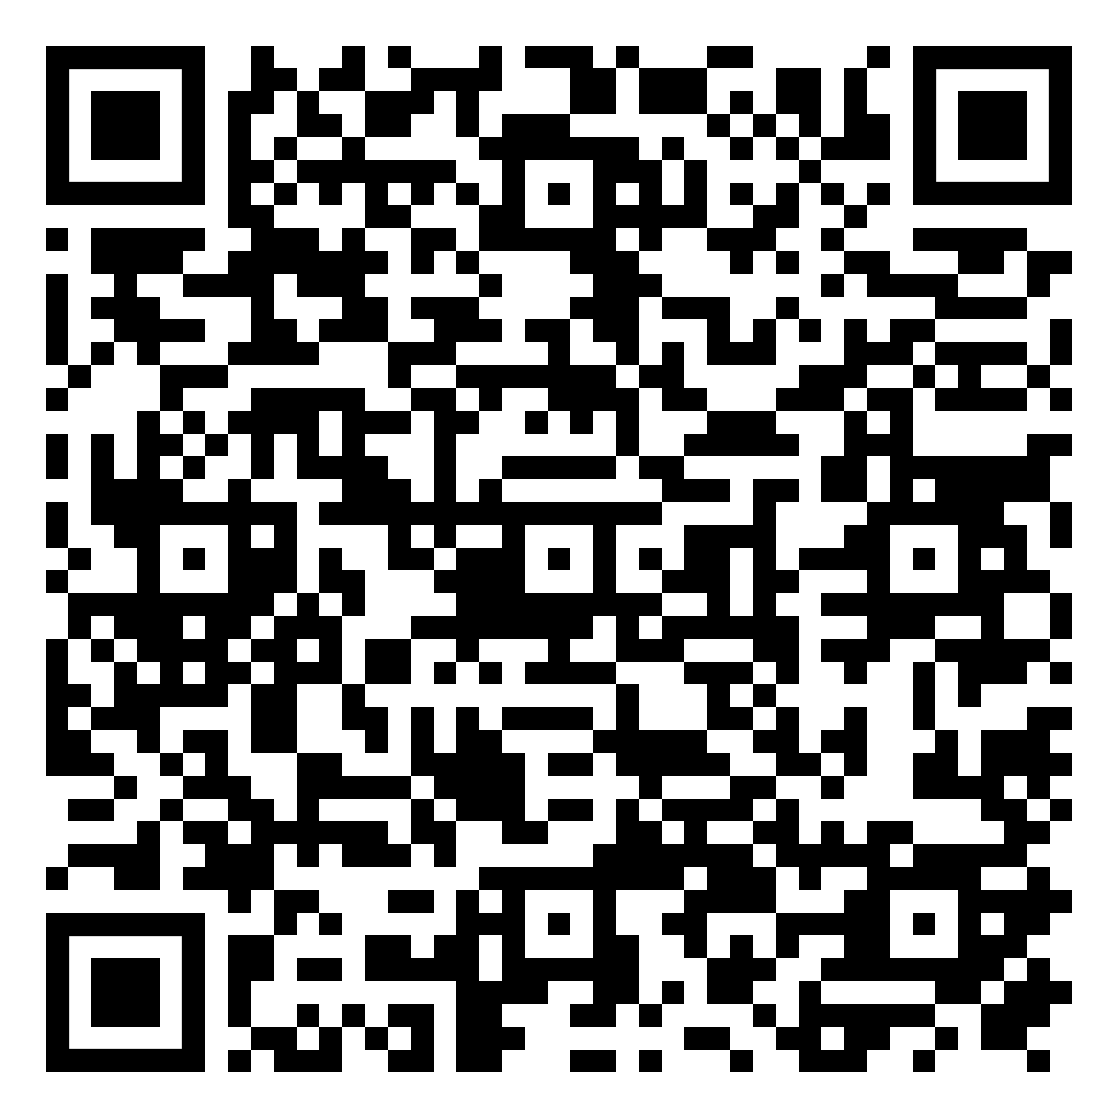  Have a go at writing in hieroglyphics. You could try your name; names of people in your family, signs for rooms in your house or you could even try and write a letter for someone in your family to crack! | Art EXA 1-03a/EXA 1-07a  Have a look at this picture:  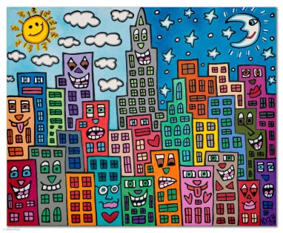  What do you like?  What do you not like?  Have you seen any other pieces of art that look the same?  We are going to have a go at creating our own city scapes inspired by James Rizzi.  Follow this video to help you:  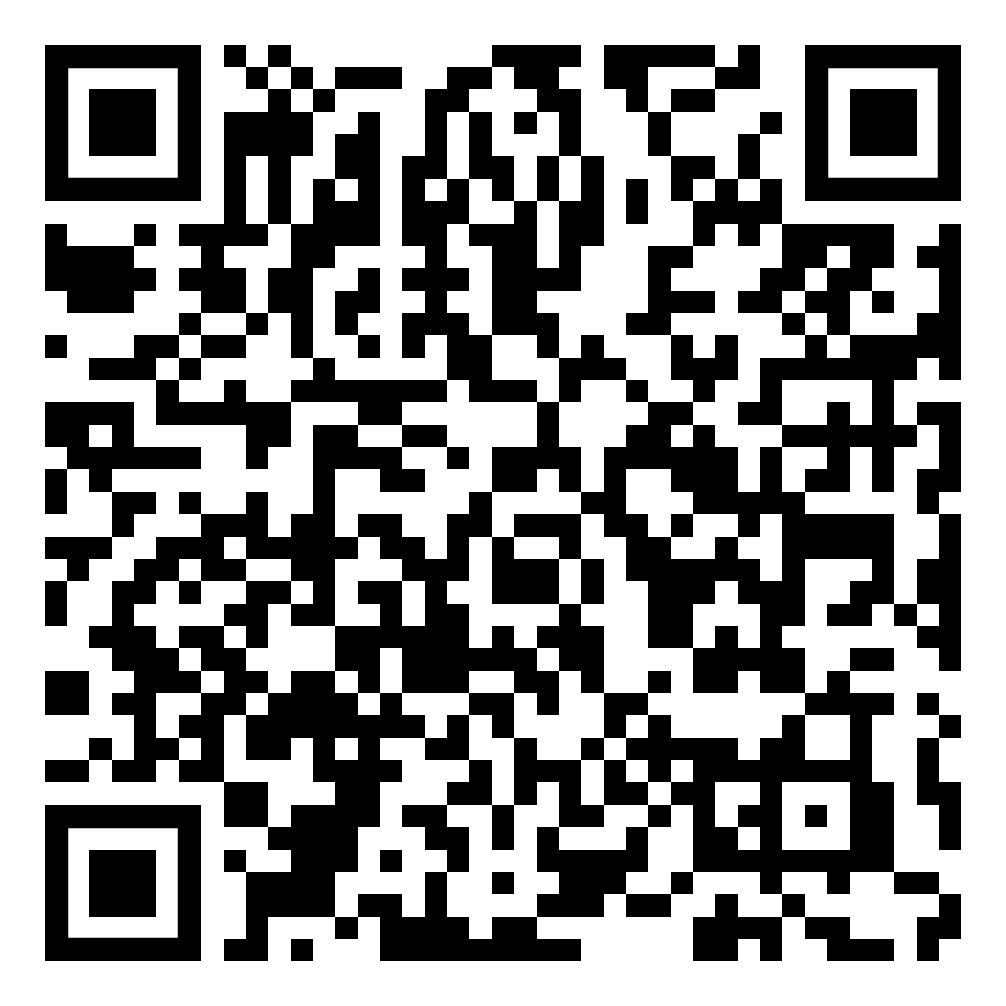  Use whatever you have at home to complete this task.
Friday | Literacy/Drama  LIT 1-05a  Watch Newsround.  Create a script for a story that you know well. For example the Three bears. Then try to act it out.  Example:  The Three Little Pigs – Play script  Characters: Narrator, Mother, Pig 1, Pig2, Pig3, Man, Wolf  Scene 1  Narrator:  Once upon a time three  pigs left their mother´s  home and went into the  world.  Three Pigs: Bye Mother.  Mother: Good-bye my  little sons.  Narrator: The three pigs  went different ways.  Soon pig 1 met a man  who was selling straw.  Pig 1: I need some  straw, would you sell it  to me?  Man: Of course. Take it.  Narrator: Pig 1 paid the  man and went to build  his house. Later, Pig 2  met a man who was  selling wood.  Pig 2:Please Sir, I need  some wood to build my  house. Would you sell it  to me? | Length MNU 1–11a  Try this game:  https://www.topmarks.co.uk/maths-games/measuring-in-cm  Try level 1  Play -  Measuring shapes You need a dice. Role the dice then draw a shape with the number of sides on the dice. Use a ruler. Try to make each side of the shape a different length.  Pass to someone at home and ask them to measure each side and writes the  measurement beside each side. Then check their answers.  Continue taking turns.

