P1- Home Learning (Week 7)
*WORKSHEETS DO NOT HAVE TO BE PRINTED. THE WORK CAN BE DONE IN JOTTERS OR ON PAPER*
Monday

Bank Holiday
Tuesday | Literacy  Writing  LIT 0-13a  For writing this week, we would like you to write about what you would like to do when lockdown ends. This might include visiting grandparents, playing at the park etc. Remember to draw a picture and colour it in if you have coloured pens/pencils/crayons in your house.https://www.youtube.com/watch?v=2zrtHt3bBmQ&list=PLqagjrsqz874M4bzIPDgTdU421jLGRGJy&index=2  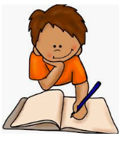 | Numeracy  Addition  MNU 0-03a  This week we will be revising addition and learning how doubles and near doubles can help us add.  Begin by listening to this song to revise double numbers: https://www.youtube.com/watch?v=Ik_-OAgzD-8&list=PLzUfcaQLWy3TxqA6-wQcxpcDCTm_wdmXf  Play the doubles game below to revise your doubles  Level1 or Level 2 if you need a challenge. You can count the pictures to help you if you get stuck or use counters/pasta/Lego or whatever else you have for counting at home. https://www.ictgames.com/mobilePage/archeryDoubles/index.html | Physical Education  HWB 0-21a  Use a stopwatch/timer on a phone to see how many of the following you can do in one minute:  -Starjumps  -Burpees  -Lunges  -Mountain climbers  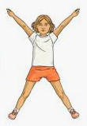 | Topic  Habitats  SOC 0-01a  Today you are going to research dinosaur’s habitats. The following video lets you see what some of them looked like  https://www.youtube.com/watch?v=fVPclPzRJk4.  You can also use kiddle to carry out your own research.  Create a picture of a dinosaur habitat. You can do this using any media you like. It could be outside with leaves and sticks, on a laptop/phone or on paper using paint/pens etc.  Send us a picture via the school email address, we would love to see them!  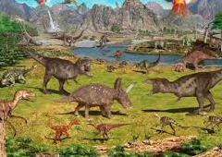
Wednesday | Literacy  Reading  LIT 0-14a  Go to https://www.oxfordowl.co.uk/ and create a free parent account. This will then give you a selection of Ebooks to choose from. There are many levels to choose from so please help your child to choose a book that is at their individual level.  Once you have read your book, discuss the book with an adult. Draw a picture and write a description of your favorite character from the book. Remember to write why they are your favourite. | Numeracy  Addition  MNU 0-03a  Watch the short video to learn about near doubles. These are two numbers that are almost the same.  https://www.youtube.com/watch?v=EAOIn8e8Pqc  Complete one of the near double butterfly worksheets below. Try and use your doubles to find the answer mentally. For example to help us find 5+6 we could use our doubles. We know that 5+5 is 10 so 1 more must be 11.  Use butterfly pictures to count if you get stuck and/or to check your answers. These sheets can be printed OR answers written in jotters. | Health and Wellbeing  Growth Mindset  HWB 0-47a  We are going to be revising growth mindset. Watch the following video  https://www.youtube.com/watch?v=2zrtHt3bBmQ&list=PLqagjrsqz874M4bzIPDgTdU421jLGRGJy&index=2  Complete the discussion and personal questions (both are below) with an adult.  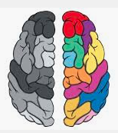 | Science  STEM  SCN 0-15a  Can you build a flotation device for one of your small action figures/dolls/small toys? Use whatever you have in your house to do this. Test it in the sink or bath with the help of an adult.  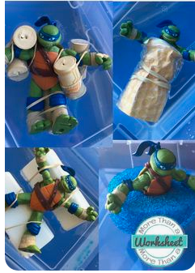
Thursday | Literacy  LIT 0-13a  Spelling-  Common words  the list is down below  Start with the first 20 words.  Ask your child to pick 5 words which they find tricky. there, was, said, they, you  Are all commonly misspelled if your child is not sure which ones to pick. You can also do a quick spelling test with your child to check which ones they need practise with. If they are confident with the first 20, then move onto the next 20 and so on.  Then choose at least 2 of the spelling tasks below for the 5 words you picked.  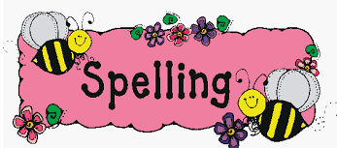 | Numeracy  Addition  MNU 0-03a  We have set up a Kahoot Challenge for doubles and near doubles. Click on the link below to access. You’ll have to enter your name to play!  https://kahoot.it/challenge/09433358?challenge-id=a29c8af5-7404-4754-bac7-c5eb57e9a7cf_1589476374112 | Topic  SOC 0-01a  You have learned this week about dinosaur habitats. We would now like you to think of at least 5 differences between where you live and where a dinosaur may live!  You can write this as a list in your jotter or fold a piece of paper in half and write/draw what your house has on one side and what a dinosaur house may have on the other. | RE  RERC 0-02a  “I can share my awareness of what makes me a unique child who has been given gifts from God.”  Discuss the meaning of the word unique and what makes you different from others. Why is it important that we are all different?  Draw an outline of yourself. (you may wish to draw a small version of this on paper or draw around your whole body with chalk outside)  Write and draw inside your outline some of the things that make you special and unique!
Friday | Literacy  Handwriting  LIT 0-13a  Please complete the next 3 lines in your handwriting booklet. | Numeracy  Addition  MNU 0-03a  Use what you have learned about doubles and near doubles to complete the addition worksheet below. This can be printed OR completed within jotter.

Optional Number Task: This episode of ‘Numberblocks’ is all about double numbers https://www.youtube.com/watch?v=kr3F3MjhDEw

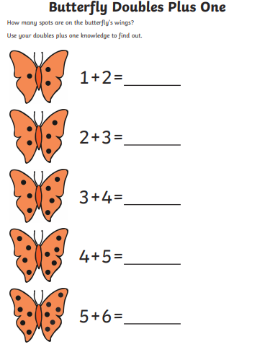

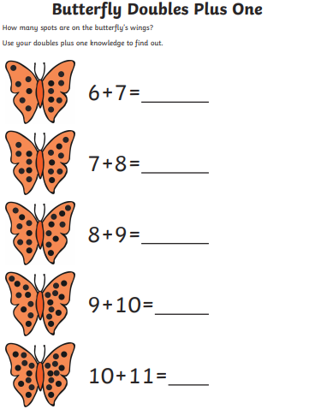

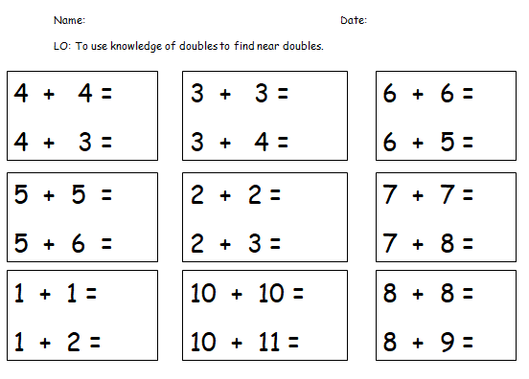

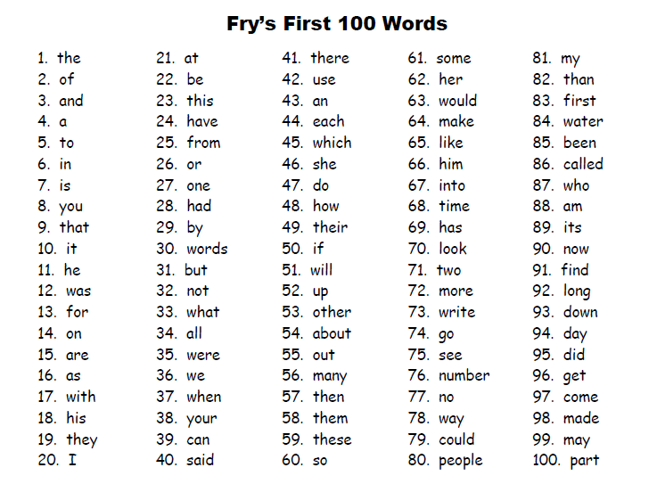

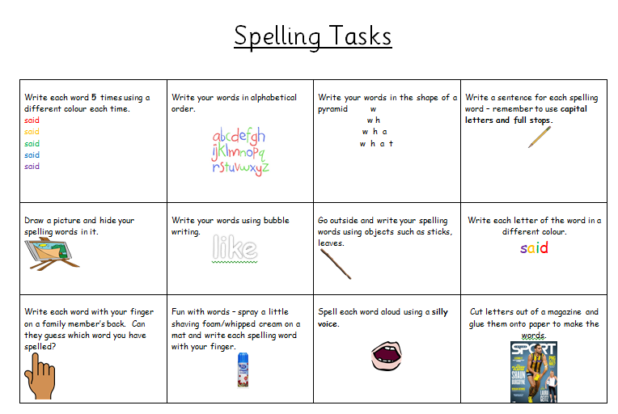

Growth Mindset
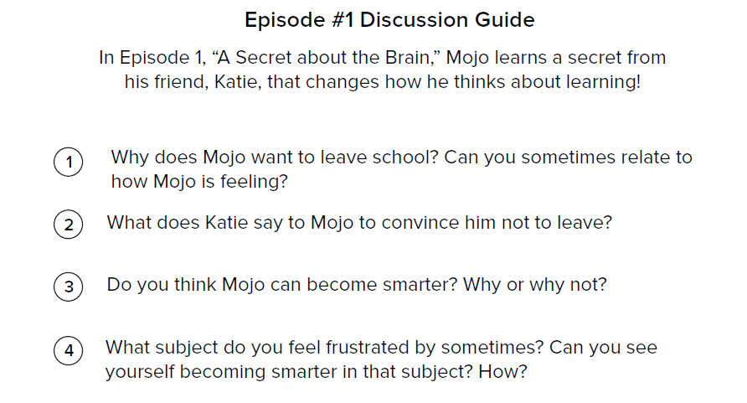
Personal questions
1.What was the biggest challenge you faced today?
2. How can you and I think about these challenges in a new way?
3. What can we do differently tomorrow if we face similar challenges?

