
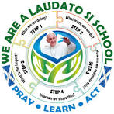
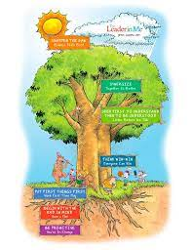

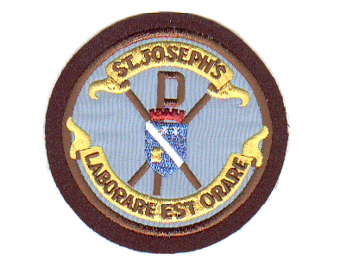
St Joseph’s Primary Spring Newsletter 2025
St Joseph’s Feast Day is on March 19th. Father Sebastian is arranging a visiting Priest to say Mass in the school as he will be in Rome with the Parish Pilgrimage
We are piloting the use of an electronic profile – My World of Work, for P4-7 pupils. Two pupils from each of these classes will be trained as champions to support their class. More information to come.
RNLI members will be in the school on 20th March to lead sessions on the role of their service and to support our science activities linked to the theme buoyancy.

The annual Rotary Quiz takes place at 6.45 pm on Thursday 20th March in Polkemmet Primary School.

The Book Fayre will be open to parents on Monday 24th March from 2.00 – 3.00 pm. Children can be collected from class to visit the Fayre with their parents. This will replace the session at the parental consultation on the of 3rd April
Pupils who took part in Pope Francis Faith Award and Sacramental Preparation will attend a Mass in Carfin on Monday 24th March

Parental Consultations will take place on Thursday 3rd April. The booking system will open two weeks before.
We are in discussions with the tour company about a visit to Manchester City FC and are waiting for confirmation of a date for the visit. More information will be sent.

Dates for Dairy
10th-14th March STEAM Week
19th March St Joseph’s Feast Day Mass in the school
20th March RNLI members will be in the school
Rotary Quiz 6.45 pm in Polkemmet Primary School.
24th March Mass in Carfin
24th March Parents’ session in Book Fayre 2.00 – 3.00 pm
April Trip to Manchester City date to be confirmed
3rd April Parental Consultations
4th April End of Term 12.20 pm

