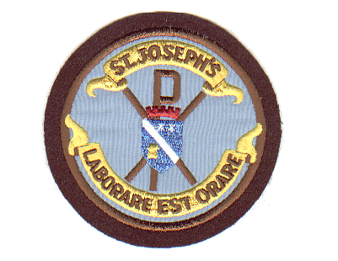
Dear parent/carer,

HM Inspectors from Education Scotland will be visiting us to conduct an inspection
during the week commencing 15th January 2024. You can find out more about inspection, from the Inspection and review documentation pages of Education Scotland’s website.

As part of the inspection, Inspectors gather the views of stakeholders via an online
survey which is available from
https://prod-es-onlineforms2.azurewebsites.net/11?lng=en&seed=5508827&t=1

I would like to encourage you to complete the survey. Inspectors will also be
meeting with groups of parents during the inspection so to be part of that discussion
you should complete the survey with additional links provided to indicate your interest in taking part.

You should complete the survey by 22nd December 2023 for one child or for each of your children in attendance.

Kind regards

Mrs F Burns
Headteacher

