******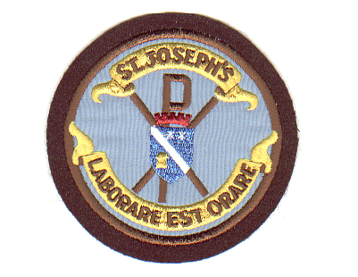**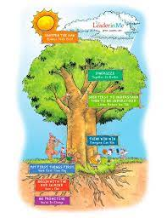

St Joseph’s Primary Autumn Newsletter

We are delighted how well our pupils have settled into the new school year, especially our Primary 1 pupils who are busily working in their classrooms. This promises to be a term filled with activities and events to promote learning. Please keep this newsletter handy to find information about everything planned until Christmas – so far!

Pupil Safety

To keep our pupils safe, please remember that dropping off and picking up children in the staff car parking areas is prohibited. Only staff vehicles and blue badge holders are permitted to use the car parks. Children are at risk from cars reversing as drivers cannot see them.

New signage has been put in place to remind everyone to park and walk. Please do not park on the zig-zags and yellow lines at the front of the school.

The small gate at the Infant playground will be lock at all times to prevent pupils from crossing the road at the front of the school. P3/4 – P7 pupils will be brought to the front of the school by their teacher and reminded to use the crossing.

School Holidays

The School and Early Learning Centre (ELC) will be closed on Friday 15th September for the September weekend and will re-open to pupils on Wednesday 20th September.

The school and ELC will close at lunchtime on Friday 6th October and re-open for pupils on Tuesday 17th October.

Parental Consultations

27th September 4.00pm – 8.00 p.m. Mr Neale’s P6 Parents’ Evening

5th October 4.00pm – 8.00 p.m. P1 – 7 Parents’ Evening

ELC Parent’s meetings will take place throughout the week beginning 5th October

27th September at 7.00 p.m. Parent Council Meeting

If you are interested in joining the Parent Council, please come along to an informal meeting to find out how you can become involved in school improvement activities and fund raising events. Meetings usually take place from 7.00 p.m. – 8.00 p.m. one evening per term to discuss and plan events to support our children’s learning.

27th September – 6th October Book Fayre will be in school. Pupils will able to visit with their class and slips will be sent home to allow parents to discuss their choices. Parents will be able to visit the Book Fayre on Parents’ Evenings

25th – 29th September Modern Languages Week

Pupils will take part in a range of activities to celebrate the diverse range of languages spoken in the school and ELC