Road Safety Week 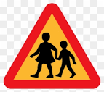

23rd – 27th October is Road Safety Week and pupils will be reminded on how to keep themselves safe when crossing the road. This is in preparation for the clocks going back 1 hour on Sunday 29th October.

Flu Vaccine

5th October – The Flu nasal spray will be given to pupils in school.

Hallowe’en

8.15am on 31st October will be the Big Spooky Read. Pupils can come to school wearing their Hallowe’en costumes and go to the hall to read a spooky story.

ELC children can come in dressed in their costumes in the morning for their party

P1-3 party will take place in the morning and P4-7 in the afternoon.

Please do not bring masks or weapons to school as it is frightening for some pupils 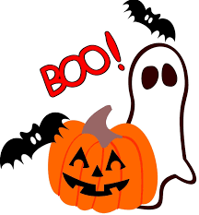

Holiday of Obligation

Children will attend Mass in St Joseph’s Church for the Feast of All Saints at 10am on the 1st of November

13th-18th November is Equity and Anti-Bullying Week

30th November is St Andrew’s Day, wear something tartan to school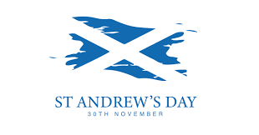

Head Lice

To help reduce the spread of head lice, please remember to ‘Once a week, take a peek!’

Christmas Events- more information to follow

1st December 10 a.m. School Christmas Fayre

11th – 15th December P4-7 Panto- details to follow

13th December Pupils’ Christmas Lunch in school

15th December Nativity

18th December A.M P1, P1/2 and P2/3 party. P.M. P3/4 and P4 party

19th December P1-3 Panto A.M. P5G and P5P party. P.M. P6, P6/7 and P7 party

20th December ELC party

21st December Nativity Mass in Church

22nd December End of Term



