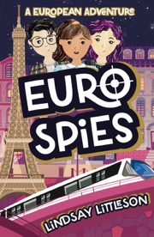
Children’s author Lindsay Littleson will be visiting
St Joseph’s Primary on the 21st of June to take part in the new library launch!
Lindsay’s books will be available for purchase at a discounted price, although there is absolutely no obligation to buy.
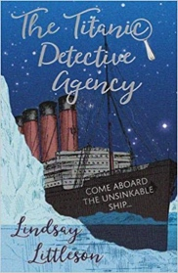
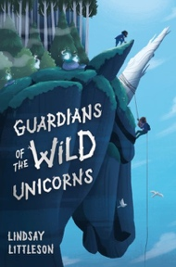
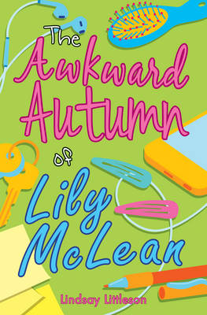
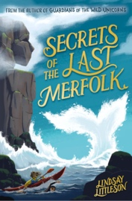
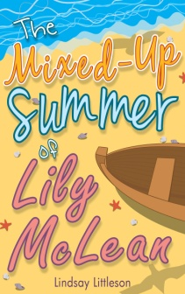
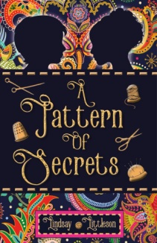
Euro Spies £7
The Rewilders £7
Guardians of the Wild Unicorns £7
Secrets of the Last Merfolk £7
The Titanic Detective Agency £6
A Pattern of Secrets £6
The Mixed-Up Summer of Lily McLean £6
The Awkward Autumn of Lily McLean £6

