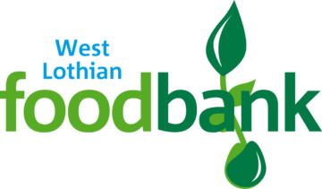CHRISTMAS APPEAL 2022

Monday 7th November 2022

Dear Parent/Carer,

As a school we are supporting the West Lothian Foodbank Christmas Appeal. This year, West Lothian Foodbank have asked for specific items from each class for our Christmas Appeal.

**Nursery** – Crackers or Oatcakes

**Primary 1** – Cup a Soup

**Primary 2/1** – Hot Chocolate

**Primary 2** – Sponge Pudding

**Primary 3** – Tinned Peas

**Primary 4/3** – Tinned Carrots

**Primary 4** – Tinned Potatoes

**Primary 5** – Cranberry Sauce

**Primary 6/5** – Stuffing Mix

**Primary 7/6** – Gravy Granules

**Primary 7** – Chocolate Biscuits

If you can, could you please donate the above itemto your child’s class collection by **Monday 28th November 2022.**

All donations are voluntary. Thank you for your support.

Kind Regards

Mrs F Burns