**Instructions for setting up Ipayimpact account**

**Enter the following address into your browser** [**www.ipayimpact.co.uk**](http://www.ipayimpact.co.uk) **This is the screen you should see. Next, you should click on the mygovscot tab at the bottom**

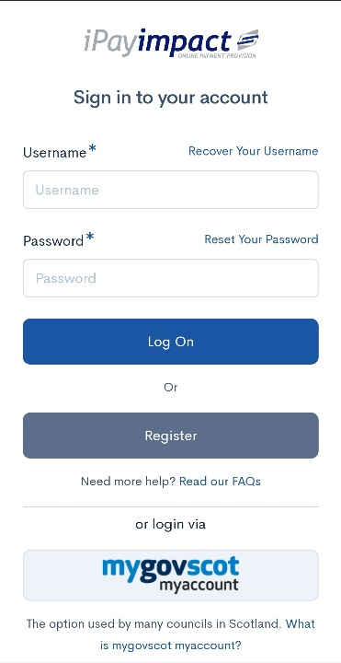

**Click create an account**

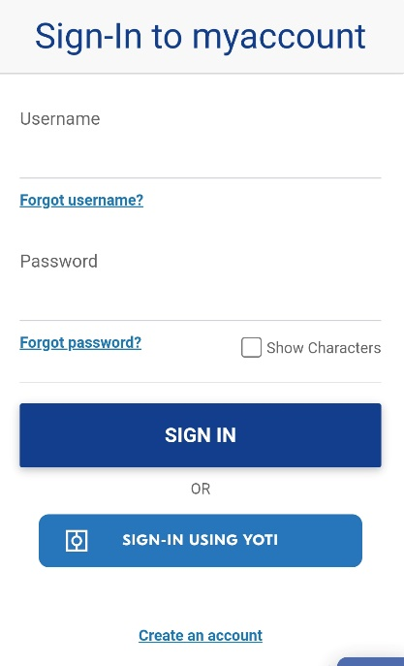

**Click register**

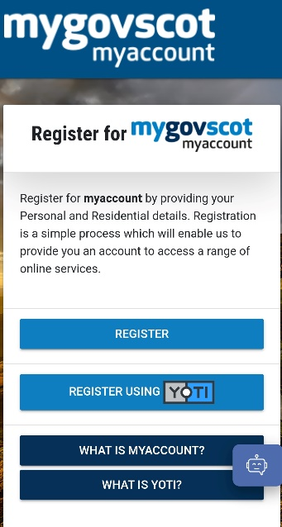

**Scroll down and click start button**

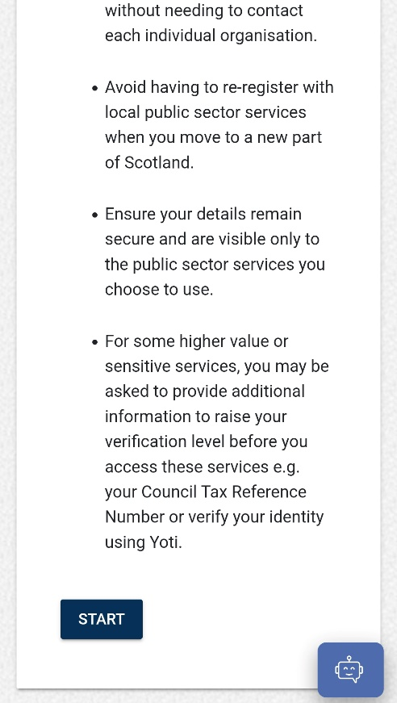

**Scroll down and fill in the details (this is your details and not your child’s) once filled in click next step**

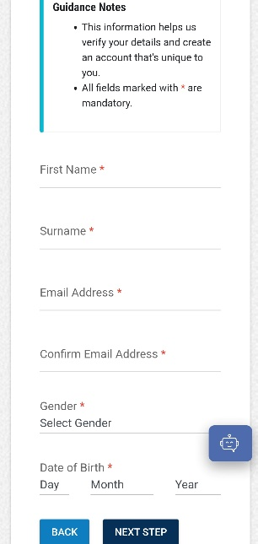

**Enter your home postcode and house number then click find address and select your address from the drop down. Once complete click next step**

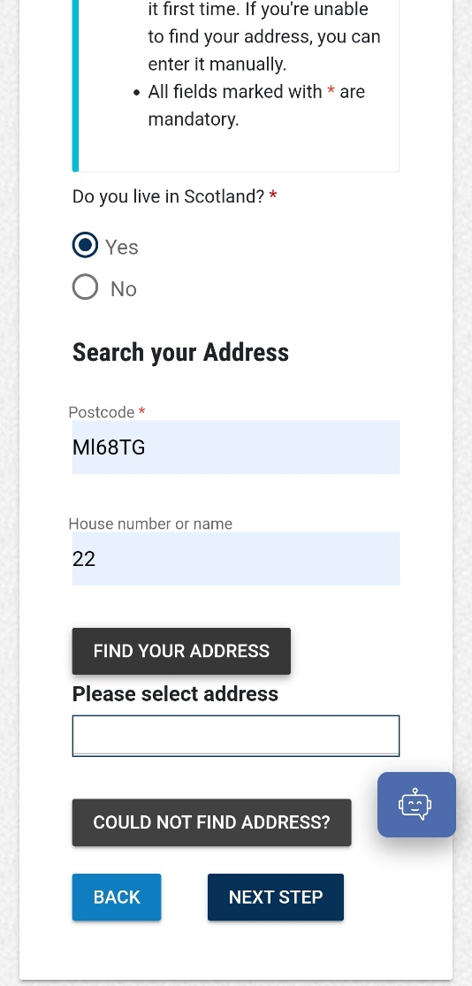

**Click use my email as my user name**

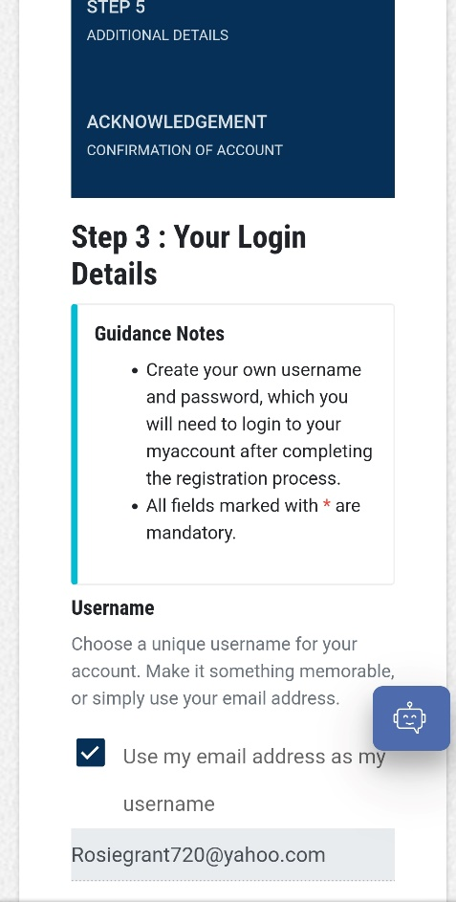

**You should create a password remembering to use the password hint below**

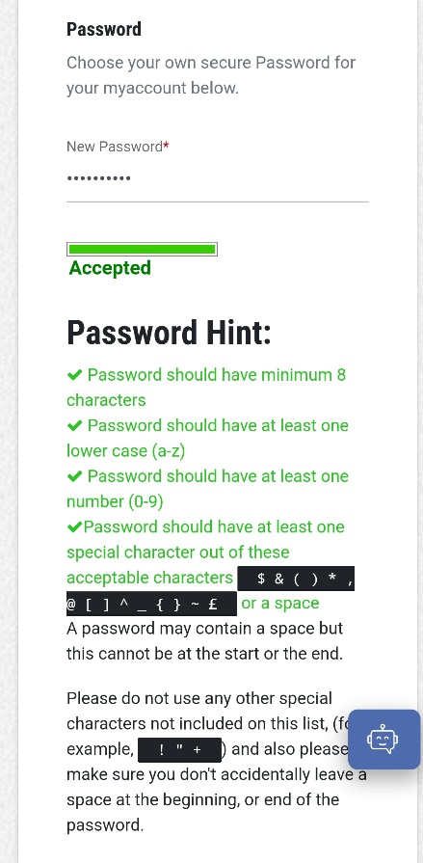

**You should now confirm your password then click next step**

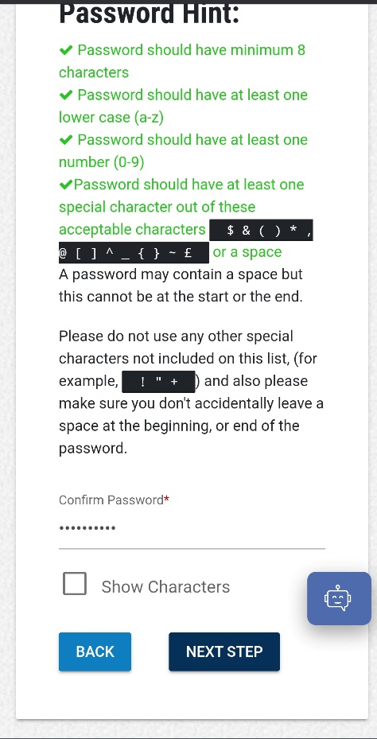

**Check all your details are correct**

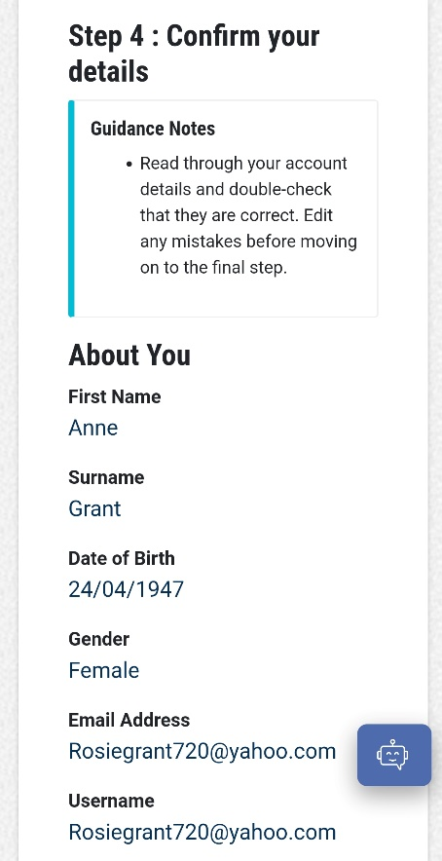

**You should then tick the terms and conditions then click yes my details are correct**

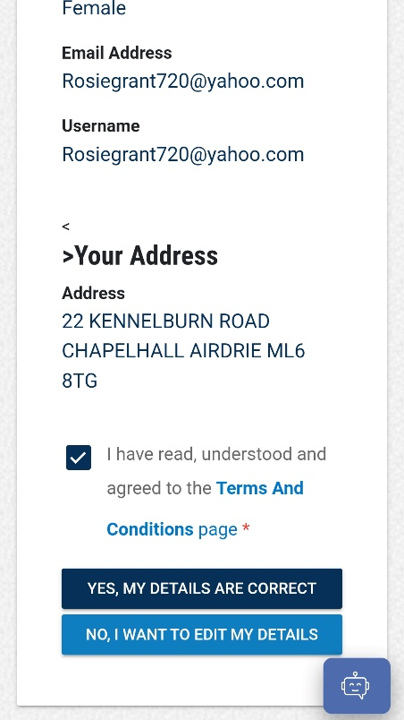

**Fill in additional details and click complete registration**

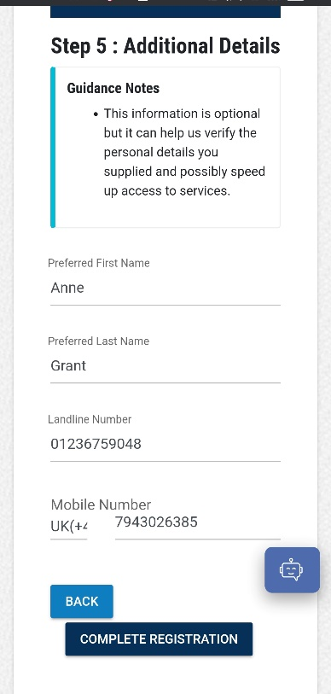

**You should then see this welcome message; you should now go to your email for the verification link**

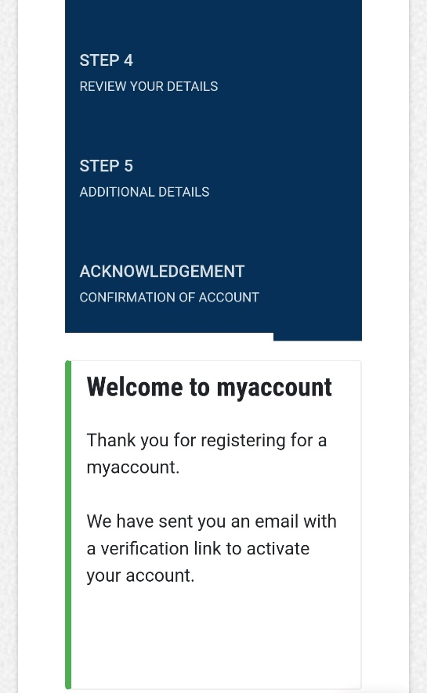

**Open the email and click the link below to activate your account**

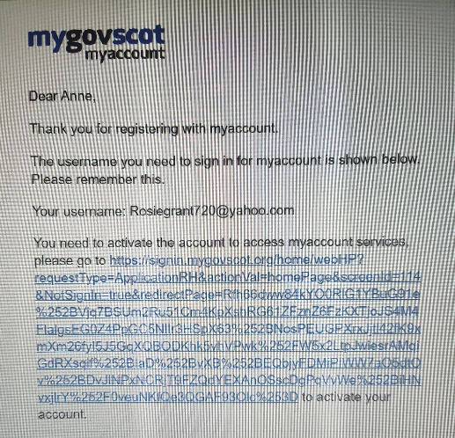

**You should now click here**

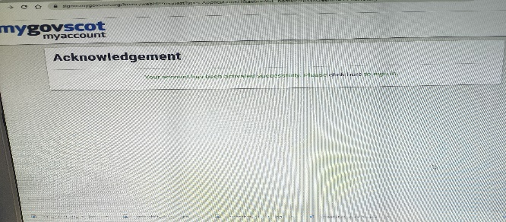

**Now use your email address and password to sign in**

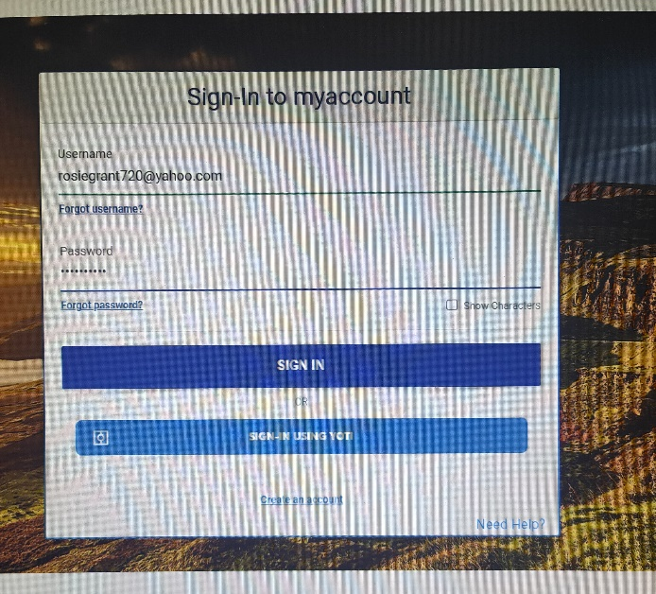

**Please accept the terms and conditions**

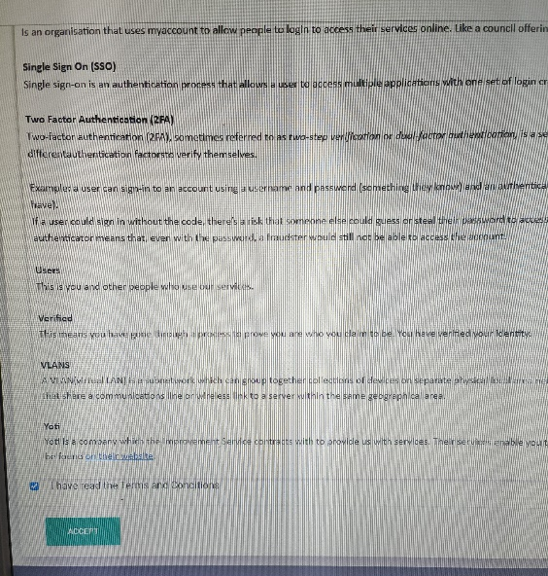

**Click yes take me there**

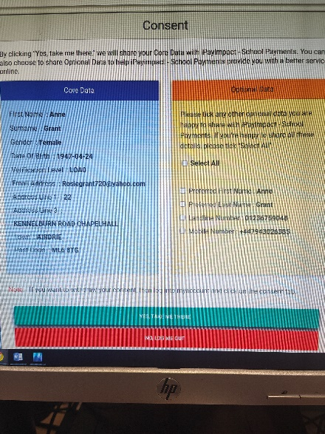

**Here is where you should enter the reference number provided by the school (this reference can be found on the ipay slip issued to parents)**

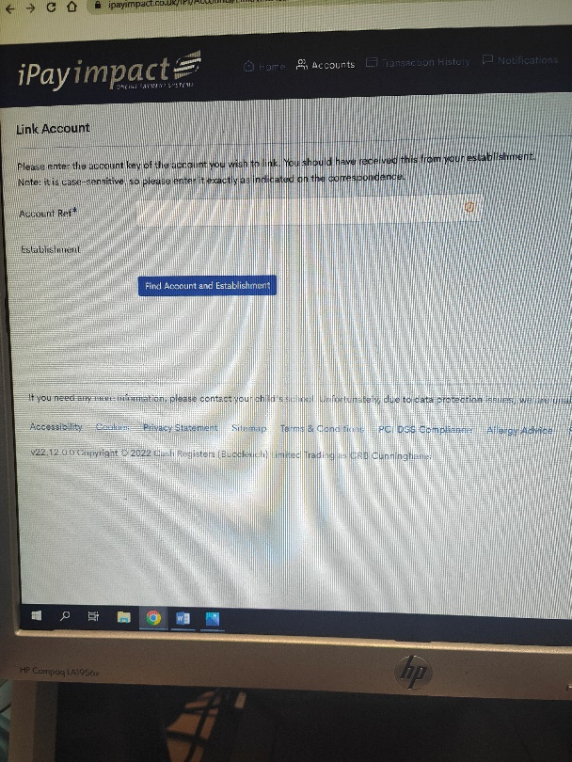

**You will now see you child’s name and school, please select the correct one.**

**Please remember when signing into your ipay account you must always go in through the mygov.scot tab**

