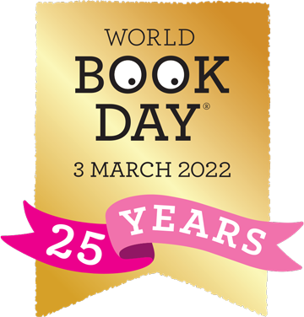

Thursday 3rd March is World Book Day. We will be celebrating in school with lots of fun activities and competitions.
Instead of dressing up the children can come to school wearing pyjamas and they can bring their favourite book to share with their class.
There are lots of ideas and fun things for families to do on the World Book Day website. Please have a look with your children.
https://www.worldbookday.com/families/
