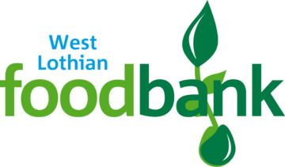CHRISTMAS APPEAL 2021

Monday 25th October 2021

Dear Parent/Carer,

This year, West Lothian Foodbank have asked for specific items from each class for our Christmas Appeal.

**Nursery** – Oatcakes

**Primary 1** – Cup a Soup

**Primary 2/1** – Instant Potatoes

**Primary 3/2** - Sponge Puddings

**Primary 3** – Tinned Custard

**Primary 4** – Crackers

**Primary 5/4** – Biscuits

**Primary 5** – Tinned Rice Pudding

**Primary 6D** – Long Life Juice (1 Litre Cartons)

**Primary 6K** – Plain Noodles

**Primary 7** – Tinned Potatoes

If you can, could you please donate the above itemto your child’s class collection by **Friday 12th November 2021**

All donations are voluntary. Thank you for your support.