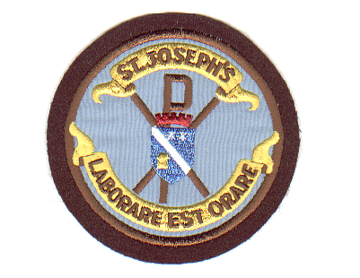

Dear Parent/Career,
We are all very excited to welcome your children to school for the start of the 2021/22 session. I attended a briefing session with senior managers today and can now share information regarding the safe return to school. All of the mitigations which were in place in June will remain in place until the end of September when the Government will review the situation. Pupils will be able to sit in groups in their classroom and mix with other classes outside. Resources will be provided in the classroom so please keep personal items at home.
Staffing
Due to funding from the Scottish Government we have been allocated an additional teacher for this session and welcome Mr Paton Day to Primary 5. Miss Coleman also joins the teaching team as the P2/3 class teacher. We send our thanks and best wishes to Ms Smith who leaves us to return to live in Australia. Mrs Thomson has left us to begin her maternity leave and we hope to hear some exciting news from her very soon.
As a result of having an additional teacher the structure of the classes has changed. P2-7 pupils will move on as whole classes, which means they will be with the same children they were with last session.
School Structure
P1 Miss McCullagh
P2/1 Mrs Warner
P2/3 Miss Coleman
P3 Mr Neale
P4 Mrs Strain
P4/5 Miss Graham
P5 Mr Paton Day
P6 Miss Duffy
P6 Mr Kildae
P7 Miss McCloskey
Support for Learning Mr Toner
PE/ Philosophy Mr Benyon
First Day
Primary 2-7 pupils should arrive at school tomorrow for 8.45 am and line up at the same place as last session. Due to the change of structure, pupils will be introduced to their teacher and taken to their classroom.
Primary 1 pupils should arrive at 9 am and enter the infant playground where staff will meet them and take them to their classroom. The pupils have met both teachers during their induction activities and additional support staff will be there to assist them. Unfortunately, the COVID regulations make it impossible to have parents inside the school just now, therefore photographs will be taken of the pupils at their desks and given home.
Uniform
Pupils should wear school uniform each day and bring PE Kit on PE days. Pupils will not be required to change shoes each day.

As the COVID virus is still around, please continue to follow NHS advice outside the school grounds at drop off and collection times.

Kind Regards
Mrs F Burns

