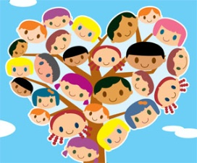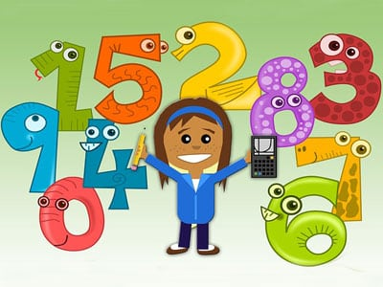

**Health and Well-Being**

* PE activities
* Understanding the importance of friendship
* Recognising the different emotions we experience and how to regulate our emotions and feelings.

**Numeracy**

* Adding and subtracting to 20
* Using number bonds to 10 to add and subtract multiples of 10.
* Adding and subtracting by 10.
* Names and properties of simple 2D shapes
* Names and properties of simple 3D shapes
* Using grid references to describe position.
* Using the 4 compass points to describe direction.

**Learning across the Curriculum**

* Hot and cold countries
* Vertebrates, invertebrates, adaptations of animals,

This is a general class overview for your child’s class this term.

All classwork is differentiated to suit the individual needs of all children.

**Literacy**

* Spelling- joined phonemes, common words, active spelling tasks
* Class book: Fiction and non- fiction and accompanying tasks.
* Writing – writing in sentences using capital letters, full stops and finger spaces. Applying knowledge from across the curriculum and writing about topic.

**Class Learning Overview**

**Class:** Primary 3

**Term:** 2