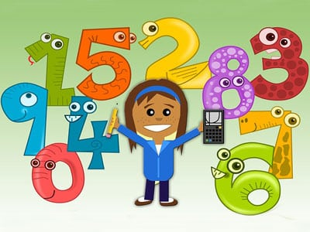

**Numeracy**

* Counting forwards and backwards to 30
* Adding crossing 10
* Subtraction crossing 10
* Recognising and naming two-digit numbers to 100
* Names and properties of simple 3D shapes

**Literacy**

* Phonics- ue, aw, oi, au, ew, ow
* Common words – how, where, now, too
* Weekly reading books in class
* Writing sentences using a capital letters, finger spaces and full stops

**Learning across the Curriculum**

* Recall the key events in the birth of Jesus
* Create a Christmas card
* Listening to and joining in with Christmas themed songs

**Health and Well-Being**

* How to keep ourselves safe and healthy
* Understand the importance of food as part of the celebrations at Christmas
* Sharing with others my favourite part of Christmas

**Class Learning Overview**

**Class:** Primary 2

**Term:** 2

This is a general class overview for your child’s class this term.

All classwork is differentiated to suit the individual needs of all children.