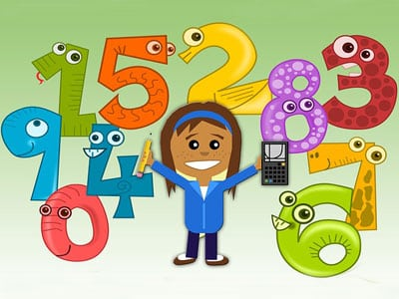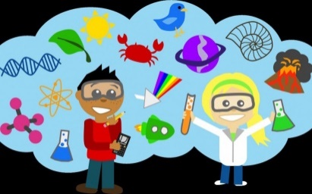

This is a general class overview for your child’s class this term.

All classwork is differentiated to suit the individual needs of all children.

**Class Learning Overview**

**Class:** Primary 3/4

Term 2

This term we have learning…

**Learning across the Curriculum**

* RE – Saints, the Ten Commandments, Adam and Eve and Christmas.
* Science – the Weather
* ICT – TEAMS and basic computer functions.
* Art – Topic related (Roald Dahl, Halloween and Christmas)

**Health and Well-Being**

* How to keep ourselves safe online
* Emotion Works Strategies.
* Maintaining friendships
* Understanding emotions, behaviours, triggers and ‘calm strategies’

**Literacy**

* New phonic sounds - learning a new sound each week.
* Reading – Exploring emotions within a text, beginning to ‘summarise’ texts, learning to use speech bubbles within stories. We also started to use dictionaries.
* Writing – created Halloween spooky stories, created ‘instructions’ and learned about letter writing.
* Grammar – we have been learning about sentences and using full stops.

**Numeracy**

* Addition and subtraction using 100 squares and numberlines.
* Using arrays to help with multiplication and division.
* Creating information tables.
* Creating and interpreting simple graphs.
* Names and properties of 2D shapes.