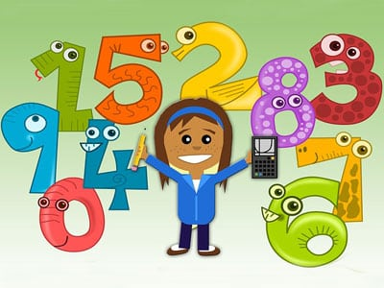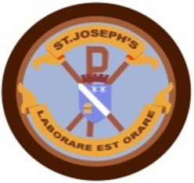

**Learning across the Curriculum**

* Inside Out (H&WB), The Victorians, A Christmas Carol
* Science - Space
* ICT – Coding
* Art – Rennie Mackintosh: Artist Study

**Literacy**

* Spelling phonemes – ae, ee, ie, oe and oo
* Reading - Developing comprehension skills; finding information, identifying the main idea, similarities and differences unknown words and sequencing
* Writing – Topic related creative writing
* Metaphors and Similes

**Health and Well-Being**

* How to keep ourselves safe online
* Bullying
* Maintaining friendships
* Knowing myself

**Numeracy**

* Addition, subtraction and multiplication (times tables)
* Negative numbers
* Measurement; length, weight and capacity
* Telling the time to 1 minute intervals plus durations of time

**Class Learning Overview**

**Class:** Primary 5M

**Term:** 2

This is a general class overview for your child’s class this term.

All classwork is differentiated to suit the individual needs of all children.