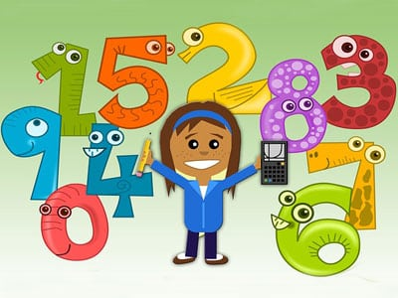

**Literacy**

* Phonics – single sounds from Colourful Consonants and the Vowel House or Phonemes.
* Stage 1 or Stage 2 Common/Tricky words.
* Weekly reading books – Focus on identifying the front cover, title, author, illustrator and blurb.
* Writing a sentence using a capital letter, finger spaces and full stop.

**Numeracy**

* Money – Using coins within £1
* Time – Days of the week, months of the year and daily routines.
* Christmas patterns.
* Christmas missing numbers or Addition and Subtraction within 20.

**Learning across the Curriculum**

* Toys – learning about toys from the past and the present
* Science – Inventions - Electricity and transport.
* The Nativity Story.

**Health and Well-Being**

* How to keep ourselves safe.
* Friendships and being kind to others.
* Random acts of kindness Advent Calendar.

**Class Learning Overview**

**Class:** Primary 2/1

**Term:** 2

This is a general class overview for your child’s class this term.

All classwork is differentiated to suit the individual needs of all children.