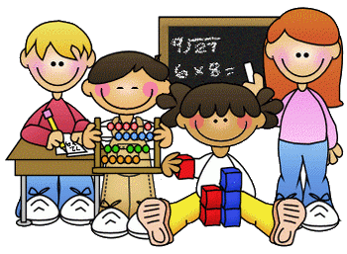
Primary 2 Homework – Week Beginning 30th November 2020

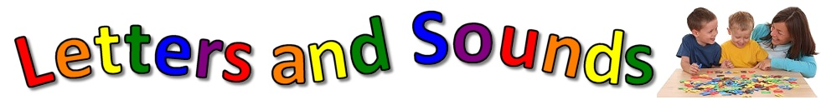
Literacy
Phonics
Revise the sounds ou (as in sound).
Write 3 words with your sound in them.

Common Words
round found wish men
Write words 3 times each then pick one word and write it in a sentence.

Reading
Read a book or a magazine that you have at home. Talk about the story with an adult. Write a sentence about your favourite part of the story and draw a picture of it.

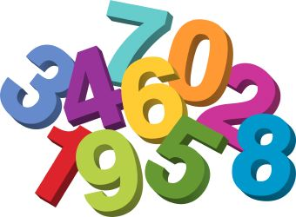
Maths
- Revise counting on and back within 30.
- Use Sumdog or Education City to play some number games.
- Pick an activity from the grid below. This grid will be posted for homework every week for the next few weeks so pick a different activity every week.

Estimating and Rounding  Write down the age of each person who lives in your house, you can also add in family members who don’t live with you as well. Estimate what you think the total of all the ages would be if you added them up. Then add them up to check how close you were. Now look again at each person’s age and round it to the nearest 10. | Let’s Get Tiling  Find five different 2D shapes in your house. Then, use those shapes to tile an area if you can, firstly on their own and secondly using two of them at a time. Have a think what you could use your tiling pattern for e.g. pattern for an ornament etc. | Time Me  Play with a family member or a friend. Find a timer device and set it to 30 seconds. Take it in turns to time each other doing different activities such as star jumps, seeing how high you can count up, jumping up and down a stair. Record your results and see who wins in the end.
Symmetry Hunt  Go on a symmetry hunt around your house, make a list of all the objects you find that have at least one line of symmetry. Make a note of how many lines of symmetry each object has. | Estimating & Weighing  Pick 10 small everyday items in your house. Estimate how heavy you think they are in grams or kilograms. Then weigh them to see how accurate your estimations were. | Get Surveying  Create a questionnaire and gather data about your family and/or friends about their favourite meals, snacks and drinks. You could present your data in a graph.

Health & Wellbeing
We have been talking about kindness in class and ways that we can be kind to others. We have made a Random Acts of Kindness Advent Calendar. Carry out a random act of kindness for someone at home.
Examples
- Help your parents making dinner.
- Tidy your bedroom without being asked.
- Do the washing up.
- Make your bed.

