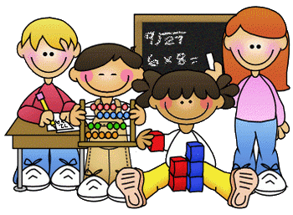
Primary 1 Homework – Week Beginning 30th November 2020

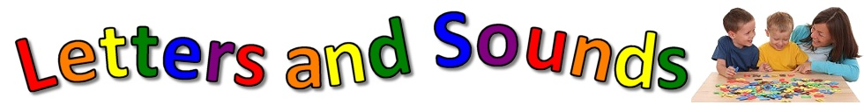
Literacy
Phonics
We have been learning the following sounds in class. Write each sound 3 times. Please use the formation sheets sent home previously to help.
b
Common Words
on for it
Please make new flash cards for these new words to add to the ones that you already have. Use these to go read your words every night and play Tic-Tac-Toe!
Draw a picture and write your words in it. Give your picture to someone at home to see if they can spot your words.

Spelling words!
We have been learning CVC words in class. Can you write them using the correct colours for each sound? Our words to practice this week are:
bin bat ban bet
Reading
Pick a book or magazine that you have at home and read it with an adult. Talk about your favourite character in the story and say why they are your favourite. Can you spot our new sound ‘f’ in your story book?

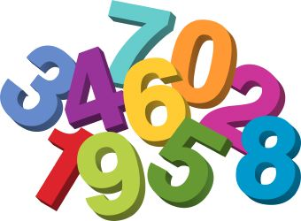
Maths
- Count on and back to 20.
- Practice writing the numbers from 0 to 10.
- Pick an activity from the grid below. This grid will be posted for homework every week for the next few weeks so pick a different activity every week.

Size Ordering  Ask an adult for three items and put them in order from the smallest to largest. Then, ask for a different three items to put into order.  For an extra challenge, try to order five items | Size Ordering  Ask an adult for a selection of objects such as hair clips, socks or toys. Then sort the items by size. Once you have finished, try sorting the items a different way, e.g. by colour, pattern, shape, etc. | Sharing  During a meal, help an adult to share the food between all the plates – one plate per person. Make sure you are fair when sharing. Everyone should get the same amount. | Counting  Get six items such as small toys. Roll a dice then select that amount from your pile, Challenge -roll two dice and count the total number of dots before counting out your items. | Money  When shopping with an adult, help to pay for an item. Your adult will tell you which coins to select and then you can give them to the shop assistant
Adding  Roll a die twice and add the two numbers together to make an addition sum.  Do this 5 times and write down all of your sums. | Number Snap  Make some snap cards with the numbers from 1 – 20 on them. Play snap with someone in your house. | More & Less  Count the number of teaspoons you have in the kitchen.  Write the number down. Write down one less than that number and then write one more than that number. | Addition  How many doors are in your house?  How many rooms are in your house?  Add the 2 numbers together and write them down. | Number Code  If the letters a=1, b=2, c=3 and so on, write them all down then use your code to write your name.
Seasons  With an adult’s help, create a picture for each of the seasons: winter, spring, summer and autumn. Draw some activities that take place in each of the seasons. | Measure  Measure the length of five items. Use paper clips, coins, pens or something similar to measure the items. Count how many things it took to measure each item. | Pattern  Using items that you can find outside, create a pattern. Try leaf, stone, leaf, stone, etc. or stick, stone, grass, stick, stone, grass. | 2D Shapes  Find four different 2D shapes in your house. Tell an adult about each one using its name, how many sides it has and how many corners it has. | Time  Draw a picture of something that you do in the morning before you come to school and something that you do before you go to bed at night.

Health & Wellbeing

We have been talking about kindness in class and ways that we can be kind to others. We have made a Random Acts of Kindness Advent Calendar. Carry out a random act of kindness for someone at home.
Examples
- Help your parents making dinner.
- Tidy your bedroom without being asked.
- Do the washing up.
- Make your bed.

