Primary 2 Homework – Week Beginning 30th November 2020

Literacy
Phonics
Revise the sound ow (as in owl).
Write 3 words with the sound in them.

Common Words
how where now too
Write words 3 times each then pick one word and write it in a sentence.

Reading
Read a book or a magazine that you have at home. Talk about the story with an adult.

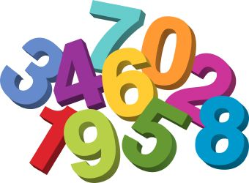
Maths
Revise counting on and back within 30.
Use Sumdog or Education City to play some number games.
Do you know the shape names of these objects?
