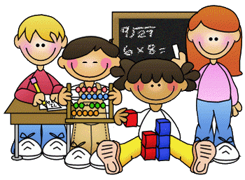
Primary 2 Homework – Week Beginning 23rd November 2020

Literacy
Phonics
Revise the sounds ow (as in crown).
Write 3 words with each of your sounds in them.

Common Words
round found wish men
Write words 3 times each then pick one word and write it in a sentence.

Reading
Read a book or a magazine that you have at home. Talk about the story with an adult. Write a sentence about your favourite part of the story and draw a picture of it.

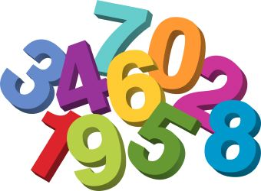
Maths
- Revise counting on and back within 30.
- Use Sumdog or Education City to play some number games.
- Time – We have been learning about time in class. Ask someone at home to help you to see how many times you can do the things below in 1 minute.
- We have been learning about the months of the year and the 4 seasons. Listen to Jack Hartman – 12 Months of the Year on Youtube.
https://www.youtube.com/watch?v=omkuE6Wa5kQ

Draw a picture of each season - Spring, Summer, Autumn and Winter.

Health & Wellbeing

We have been learning about SHANARRI and focusing on the S which stands for Safe! We have been learning about what is safe and what is unsafe. Look at the picture below and count how many dangers you can find and talk with an adult on ways you can stay safe at home in the kitchen!
