Primary 2 Homework – Week Beginning 23rd November 2020

Literacy
Phonics
Go over some of the sounds we have look at in the last 2 or 3 weeks.
Words using the sound ‘oi’ (as in boil), ‘au’ (as in sauce) and ‘ew’ (as in flew).
Write 3 words with the sound in them.

Common Words
Go over some of the common words we have look at in the last 2 or 3 weeks.
Test yourself. See how many you can spell!

Reading
Read a book or a magazine that you have at home. Talk about the story with an adult.

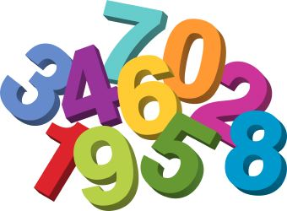
Maths
Revise counting on and back within 30.
Use Sumdog or Education City to play some number games.
Answer these sums in your jotter:
