Primary 1 Homework – Week Beginning 16th November 2020

Literacy
Phonics
We have been learning the following sounds in class. Write each sound 3 times. Please use the formation sheets sent home previously to help.
e
Common Words
was went his
Make new flash cards for these new words to add to the ones that you already have. Use these to go over your words every night. Write your words out 3 times using rainbow writing.

Reading
Pick a book or magazine that you have at home and read it with an adult. Talk about your favourite character in the story and say why they are your favourite character.
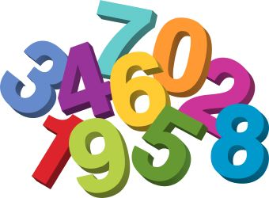
Maths
- Count on and back to 20.
- Practice writing the numbers from 0 to 10.
- We have been learning about time and the days of the week. Listen to Jack Hartman – Days of the Week Rap Back. https://www.youtube.com/watch?v=NscOFmaWSz0
- Put the days of the week in the correct order.
Saturday
Wednesday
Sunday
Friday
Monday
Thursday
Tuesday

Health & Wellbeing

We have been learning about being a good friend. Design a poster that shows someone how to be a good friend.

