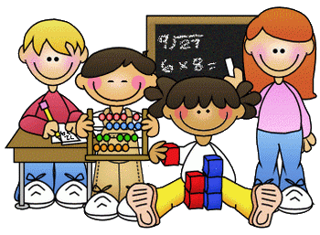
Primary 1 Homework – Week Beginning 9th November 2020

Literacy
Phonics
We have been learning the following sounds in class. Write each sound 3 times. Please use the formation sheets sent home previously to help.
o
Common Words
can into we
Make new flash cards for these new words to add to the ones that you already have. Use these to go read your words every night. Write your words out 3 times using shaving cream
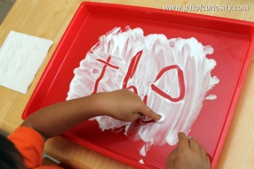
Name Writing
Write your name 3 times. Ask an adult to write your name and then use a bingo dabber or finger paint to go over it! 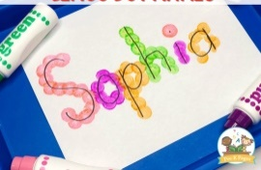
Reading
Pick a book or magazine that you have at home and read it with an adult. Talk about your favourite character in the story and say why they are your favourite character.
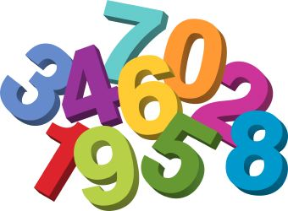
Maths
- Count on and back to 20.
- Practice writing the numbers from 0 to 10.
- How many in the group? How many if there was one less?

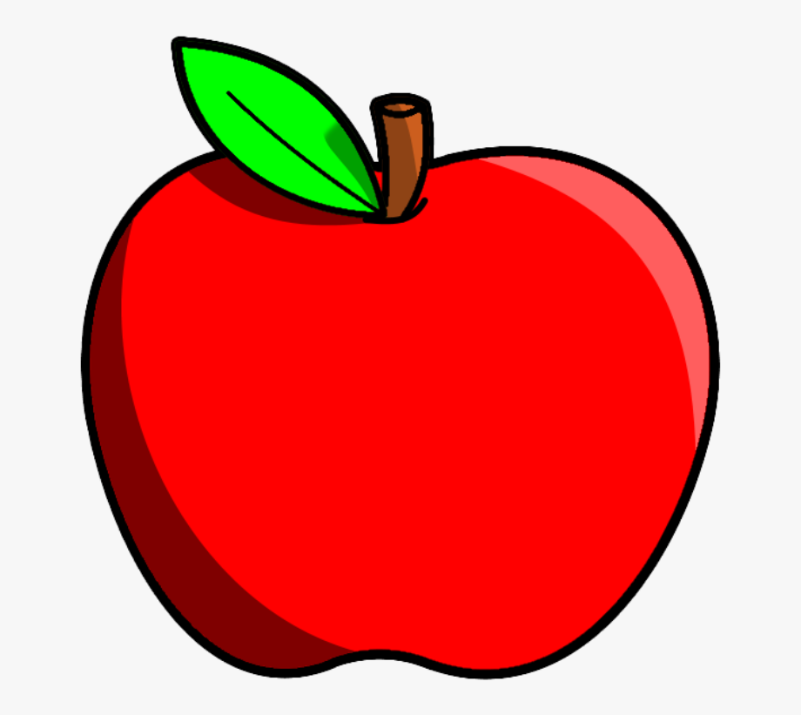

How many rockets?
How many if there was 1 less?
How many apples?
How many if there was 1 less?

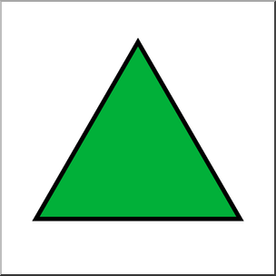

How many rainbows?
How many if there was 1 less?
How many triangles?
How many if there was 1 less?
Health & Wellbeing

We have been learning the importance of washing our hands and how this helps to keep us safe! Can you draw a picture of dirty hands and then clean hands.
Explain to someone at home how to clean your hands and why it is important to keep our hands clean!
