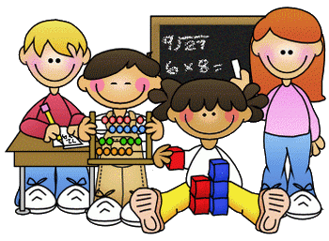
Primary 2 Homework – Week Beginning 2nd November 2020

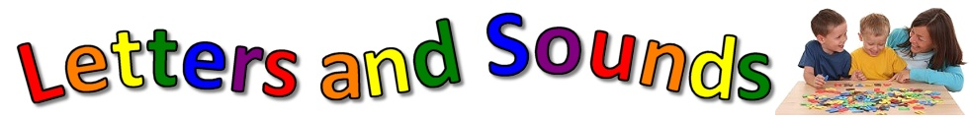
Literacy
Phonics
Revise the sounds au (as in haunted).
Write 3 words with each of your sounds in them.

Common Words
their some them last
Write words 3 times each then pick one word and write it in a sentence.

Reading
Read a book or a magazine that you have at home. Talk about the story with an adult. Write a sentence about your favourite part of the story and draw a picture of it.

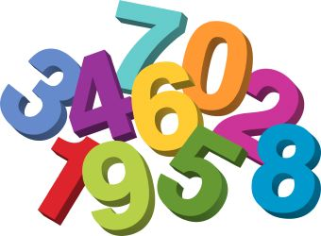
Maths
- Revise counting on and back within 30.
- Use Sumdog or Education City to play some number games.
- Money –
Can you draw the coins that would make each of the amounts below?

15p

24p

18p

36p

21p

33p

Health & Wellbeing

We have been learning the importance of washing our hands and how this helps to keep us safe! Can you draw a picture of dirty hands and then clean hands.
Explain to someone at home how to clean your hands and why it is important to keep our hands clean!

