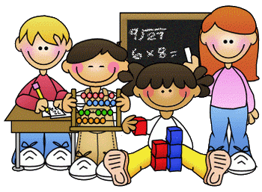
Primary 2 Homework – Week Beginning 9th November 2020

Literacy
Phonics
Revise the sound au (as in haunted).
Write 3 words with the sound in them.

Common Words
their some them last
Write words 3 times each then pick one word and write it in a sentence.

Reading
Read a book or a magazine that you have at home. Talk about the story with an adult.

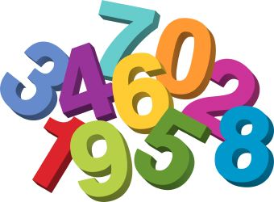
Maths
Revise counting on and back within 30.
Use Sumdog or Education City to play some number games.
Can you draw the coins that would make each of the amounts below?

15p

24p

18p

36p

21p

33p

