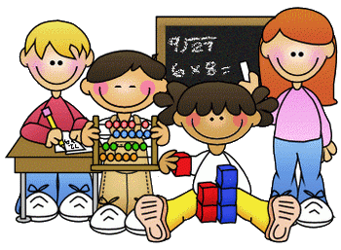
Primary 1 Homework – Week Beginning 2nd November 2020

Literacy
Phonics
We have been learning the following sounds in class. Write each sound 3 times. Please use the formation sheets sent home previously to help.
k ck

Common Words
did as he
Make new flash cards for these new words to add to the ones that you already have. Use these to go read your words every night. Write your words out 3 times.

Name Writing
Write your name 3 times. Then try writing it again this time in rainbow colours.
Reading
Pick a book or magazine that you have at home and read it with an adult. Talk about your favourite part of the story.
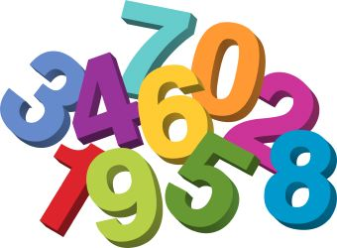
Maths
- Count on and back to 20.
- Practice writing the numbers from 0 to 10.
- More or less – in each section circle the group that has fewer.

Health & Wellbeing

We have been learning how to be a good friend in class. Draw a picture of a friend then talk about this friend with someone at home. Tell them why they are a good friend.

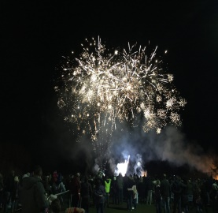
Bonfire Night Craft
Create a picture of some colourful fireworks bursting in the sky.

