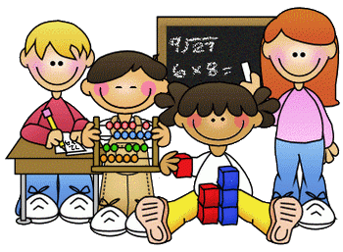

Primary 2 Homework – Week Beginning 26th October 2020



Literacy

Phonics

Revise the sounds aw (as in saw).

Write 3 words with each of your sounds in them.

Common Words

their some them last

Write words 3 times each then pick one word and write it in a sentence.

Reading

Read a book or a magazine that you have at home. Talk about the story with an adult.

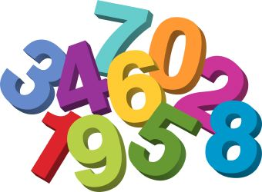

Maths

1. Revise counting on and back within 30.
2. Use Sumdog or Education City to play some number games.
3. We have been learning about Symmetry. Find something at home that has at least one line of symmetry. Draw a picture of it and then write what it is.



Health & Wellbeing

We have been learning about our feelings and reading the Colour Monster.

You can listen to the story again here.

<https://uk.video.search.yahoo.com/search/video;_ylt=AwrJQ5y3.GpfrlYA7CkM34lQ;_ylu=Y29sbwNpcjIEcG9zAzEEdnRpZANDMDQ1M18xBHNlYwNzYw--?p=the+colour+monster+story&fr=mcafee#id=1&vid=5ae20550e5ebc4b94b18477270b66575&action=view>

C:\Program Files (x86)\Microsoft Office\MEDIA\CAGCAT10\j0305493.wmf 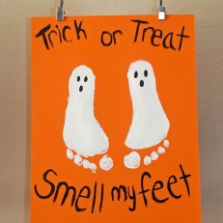 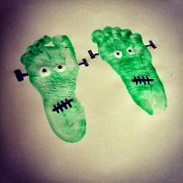

Halloween Craft!

Why not try some foot or hand painting for some Halloween fun!